GOVERNMENT OF KERALA
GROUNDWATER DEPARTMENT

GROUNDWATER LEVEL MONITORING REPORT – JULY 2021

Wateris a replenishable natural resource which is essential for the existence of all living beings. In the past, the demand of water is mostly limited to domestic and in the agricultural sector. Due to the developments in agricultural and industrial sector the demand of water is increasing many folds since last few decades. Surface water resource alone couldn’t meet the increasing demand and hence persuaded to depend on groundwater resource during the past few decades made stress on groundwater regime. In order to sustain the groundwater resources, proper groundwater management practices are needed.
Rainfallis the primary source for groundwater recharge and has a vital role in the sustainability of groundwater resource in the state. Groundwater level fluctuation results from the seasonal availability of rainfall. Kerala state experiences four distinct seasons namely winter (January-February), Pre-monsoon (March-May), Monsoon (South-West) June to September and Post-monsoon (North-East) from October to December. Average annual precipitation in the state is nearly 3000 mm. The rainfall in the State is controlled primarily by the South-West and North-East monsoons. About 90% of the rainfall occurs during six monsoon months (South-West monsoon contributes major portion of rainfall (65-70%) and about 16% from the North-East) and remaining from summer showers.
Actual Southwest monsoon Rain fall received in the state during 2020 (1June to 30September) is 2227.9mm which is 9% more than the Normal rainfall during the period.

Actual Southwest monsoon Rain fall received in the state during 2021(1June to 30September) is 1718.8 mm. It is -16% deficient from the Normal rainfall during the period which is 2049.2mmand the percentage departure comes under Normal category. All the districts received less Actual rain than the normal rain fall exceptPathanamthitta District which received 4% more rain than the Normal rain. Percentage departure of rain in Kannur, Malappuram, Palakkad, Thrissur, and Wayanad fallin Deficient category and all other districts comes in Normal category.

Fig:1. Comparison of actual rainfalloccurred during June-August 2021wrt 2020

Fig:2. Comparison of actual rainfall occurred during June-August2021wrtNormal Rainfall

Geology: Kerala, the southernmost state of Indian peninsula, is having a geographical area of 38863 km². The land area extends between latitude 8ᵒ17’30” and 12ᵒ27’40” and longitude 74ᵒ51’57” and 77ᵒ24’47”. Physiographically, Kerala state is sandwiched between Western Ghats on the east and Arabian Sea on the west. Being the part of the southern Indian peninsula, the peninsular geological formations exist in the state. The major geological formations in the state comprises crystalline rocks of Archaean Age, sedimentary rock formations of tertiary age and sub recent to recent rock formations of quaternary age.
Occurrence of Groundwater resource: Groundwater occurs under phreatic, semi-confined and confined conditions, Groundwater in unconfined aquifer is mainly utilized through tube wells in sedimentary terrain and through bore wells in hard rock areas.
Groundwater monitoring network:Short term and long term changes in the climatic conditions influence the groundwater scenario of an area. Groundwater level data are the principal information required for assessing the groundwater status and groundwater resource estimation.
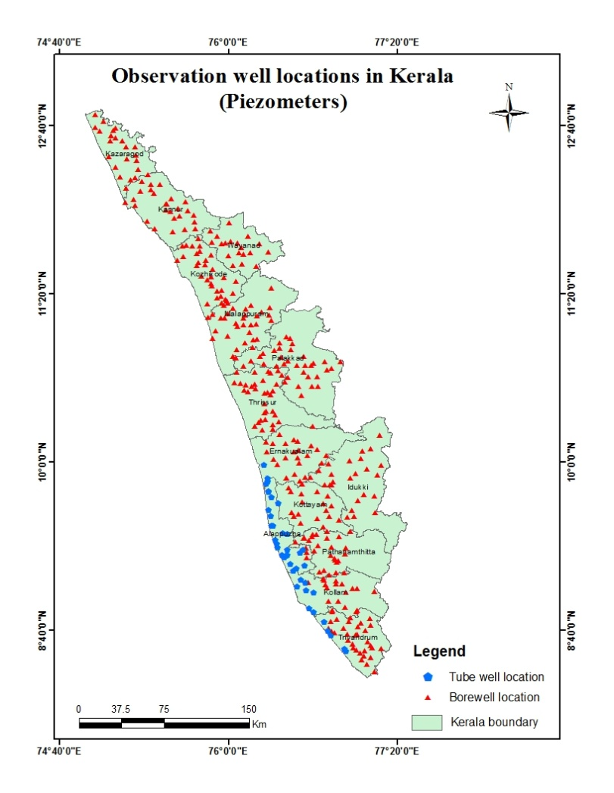
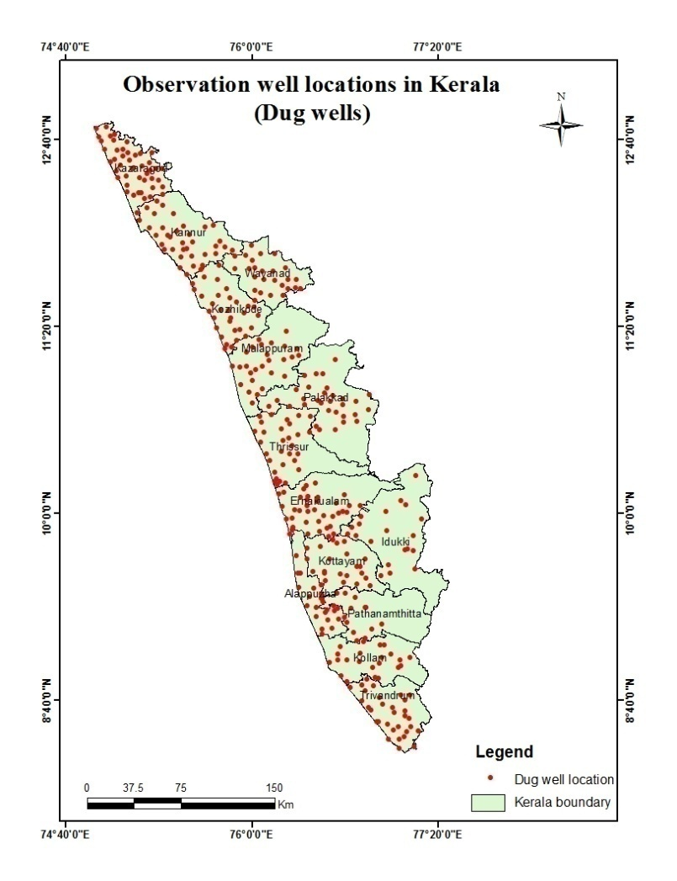
Groundwater Department is maintaining a network of observation wells throughout the state representing various hydrogeological units. Observation wells includes dug wells (owned by public and private) and purpose built piezometers (bore wells and tube wells). Water level data has been collected monthly and water samples collected and analysis done periodically.
Fig:3. Location map of observation dug wells and piezometers (bore wells & tube wells)
Analysis of Groundwater level data – July 2021
During the month of July 2021, groundwater level in 393 dug wells and 379purpose built piezometers (bore wells- 340 and tube wells – 39) has been monitored. The data collected from the observation wells during the month of July 2021has been compared with previous year’s corresponding month data and also with respect to decadal mean data of the corresponding month to assess the groundwater scenario in the state.
I.Depth to Groundwater level during July 2021
Dug wells:-The depth to groundwater level in the observation dug wells during the month of July 2021ranges from a minimum of -0.8 m in open well no OW16 in Chirayikeezhu, Thiruvananthapuram and OW-15,Chengannur, Alappuzha to a maximum of 16.16mbgl in KNR-POW-C8 open well.Taliparamba, Kannur. Out of 393dug wells monitored water level in 30% of dug wells shows a depth to water level ranges from 0-2 m, 34% ranges between 2-5 m, 31% ranges between 5-10 m and 5% dug wells recorded depth to water level ranges between 10-20 mbgl. Dug wells in Kollam,Pathanamthitta, Alappuzha, Kottayam, Idukki, Ernakulam,Thrissur and Palakkad show water level below 10 mtrs.None of the wells in the state show water level above 20m. Table showing well frequency during July 2021 is appended. (Annexure-I)

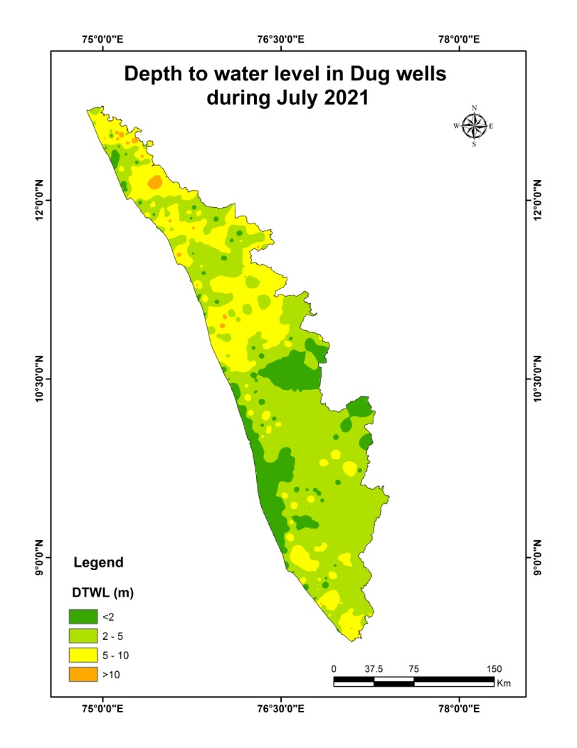

Fig:4.

Depth to water level in Dug wells during July2021

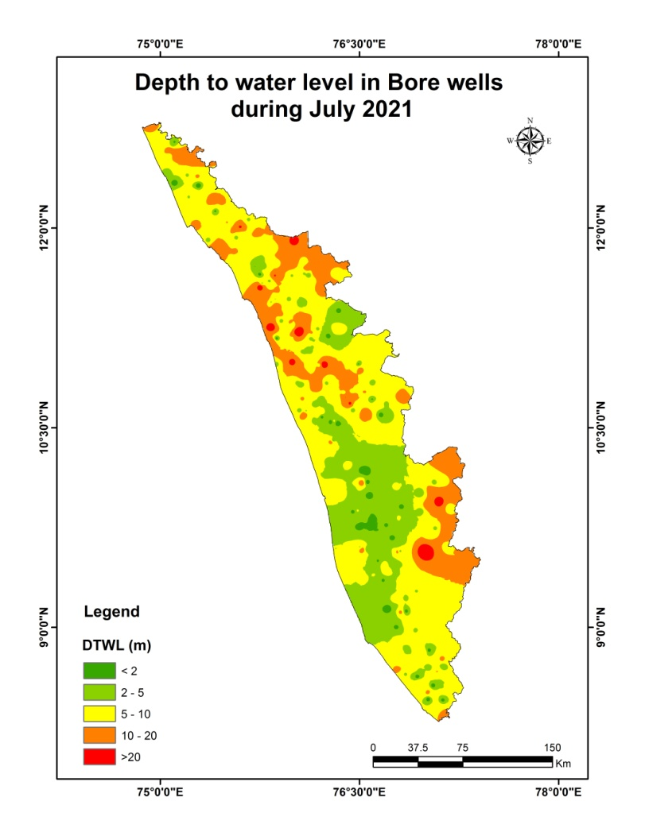
Borewells (hardrock terrain):- The depth to groundwater level in the observation bore wells during the month of July2021 ranges from a minimum of -1.1m in BW noPTA/19 at Erathu, Pathanamthitta to a maximum of 46.03mbgl inMPM174, Areekode, Malappuram. Out of 340borewells monitored, water level in 13% of bore wells shows a depth to water level range from 0-2 m, 29 % ranges between 2-5 m, 35% ranges between 5-10 m, 19% of borewells ranges between 10-20 m, and 4% ranges more than 20 m .Borewells in Thiruvananthapuram, Kollam, Pathanamthitta,Alappuzha ,Kottayam Ernakulam, Palakkad and Kasargoddistricts show water level below20 mbgl. Table showing well frequency during July2021 is appended. (Annexure-I)

Fig:5. Depth to water level in Bore wells during July 2021
Tubewells (coastal sedimentary terrain):- The depth to groundwater level in the observation tubewells during the month of July 2021ranges from a minimum of -0.5 m in tube well no32 at Chandirur ,Alappuzha to a maximum of 33.82mbgl in tube well no KLM/29 at Sasthamkotta, Kollam. Out of 39 tube wells monitored in the state, water level in 33 % of tube wells rangesbetween 0-2m, 31 % of tube wells ranges between 2-5 m,20% ranges between 5-10 m and8%ranges between10-20 and 8% ranges more than 20m.Table showingtube well frequency is appended.(Annexure-I )
II.Comparison of Groundwater level in July2021 with respect toJuly 2020
Comparison of the groundwater level in July 2021with respect to the corresponding month in the previous year, indicates that 43 % of observation dug wells(169 out of 393) show a fall in water level and 57% (224 out of 393) of the wells shows no remarkable change /marginal rise in water level.Out of 43% of the dugwells shows a falling trend, 35%(59 nos)recorded fall in water level less than 0.5m, 18 % of dug wells show fall in the range between 0.5-1m,17% of dug wells show fall in the range between 1-1.5 m, 10% of dug wells show a fall in the range between 1.5 -2m and 20%dug wells (34 nos) show a fall in water level more than 2m. Table showing water level comparison of dug wells during July 2021with respect to July2020is appended. (Annexure-II).
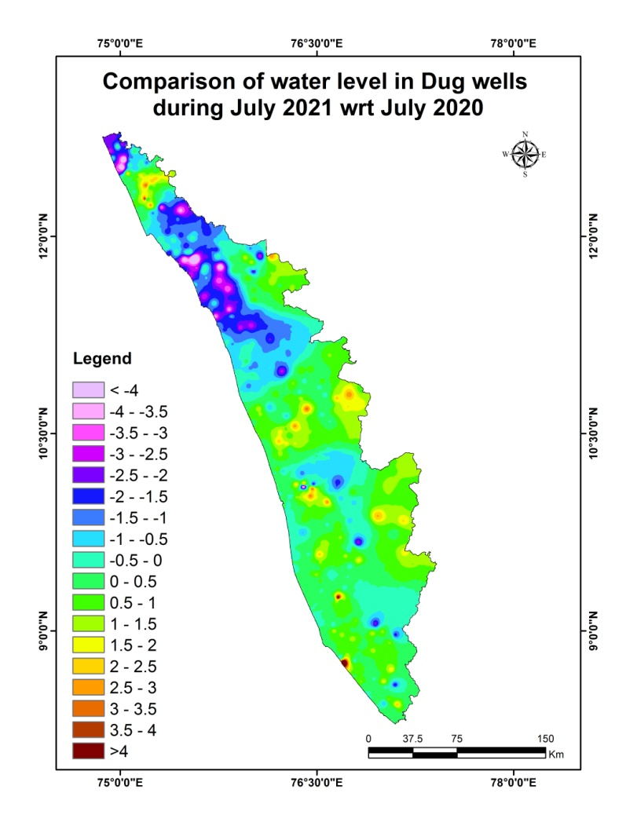

Fig:6. Comparison of water level in Dug wells during July 2021wrtJuly2020

Comparison of the 339 water levelin observation bore wells(hard rock terrain in midland and high land areas) in July 2021with that of the previous year, it has been noticed that40% of bore wells (136nos out of 339) show fall in water level and 60% of the wells(203 out of339) shows no remarkable change/marginal rise in water level.Out of 40 % of the borewells shows a falling trend, 29% of the bore wells (29 nos) recorded fall in water level less than 0.5m, 23 % show fall in the range between 0.5 - 1m, 11% of bore wells show fall in the range between 1 - 1.5m, 13% of bore wells show a fall in range between, 1.5-2m, 24% of bore wells show a fall inwater level more than 2m. Table showing water level comparison of bore wells during July 2021with respect toJuly2020 is appended. (Annexure-II)
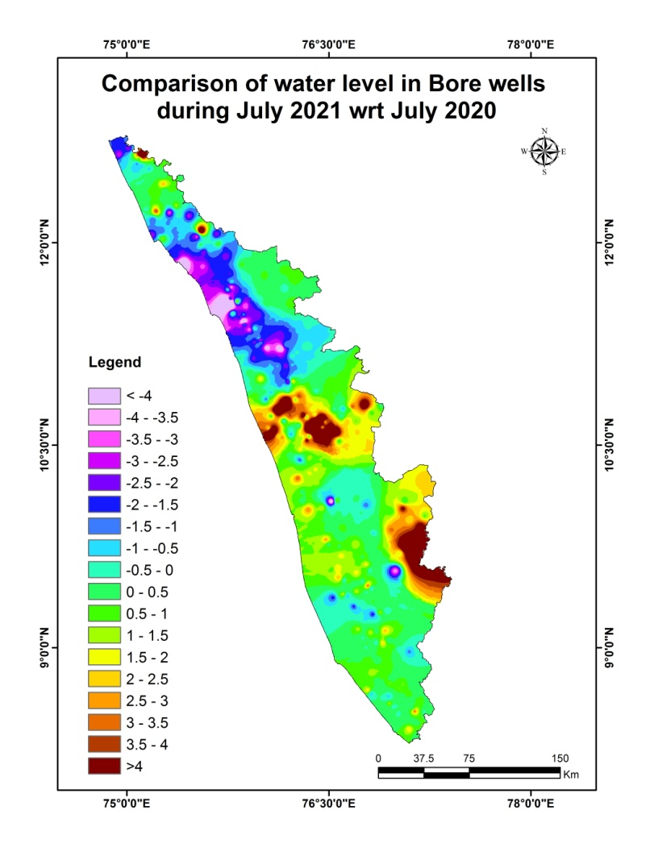

Fig:7. Comparison of water level in Bore wells during July 2021 wrtJuly 2020

Comparison of the water level (38 data) in observation tube wells (in the coastal sedimentary areas)during July 2021 with that of the previous year reveals that 13 % of tube wells(5nos) recorded a falling trend and 87 % of the wells(33nos) shows no remarkable change /marginal rise of water level.Out of 13% of the tube wells showing a falling trend,all the 5nos of wells recorded fall in range between 0 to 0.5m and no wells show a fall in water level above0.5m.Table showing comparison of water level during July 2021 with respect to July 2020is appended. (Annexure-II)

III.Comparison of Groundwater level in July 2021 with respect to Decadal mean(2011- 20)
Comparison of the water level in July 2021 with respect to the decadal mean, it has been noticed that 49% of observation dug wells (191 out of391)recorded a fall in water level and 51% of the wells (200 out of391) shows marginal rise /no remarkable change in water level.Out of 49% of the dugwells show a falling trend, 40% of the dug wells(76 nos) recorded fall in water level less than 0.5m,24% show fall in the range between 0.5-1m, 10% of dug wells show fall in the range between1-1.5m, 10% of dug wells show a fall in range between 1.5-2m and16% of dug wellsshow a fall in range more than 2m.Table showing water level comparison of dug wells during July 2021 with respect to decadal mean is appended. (Annexure-III)
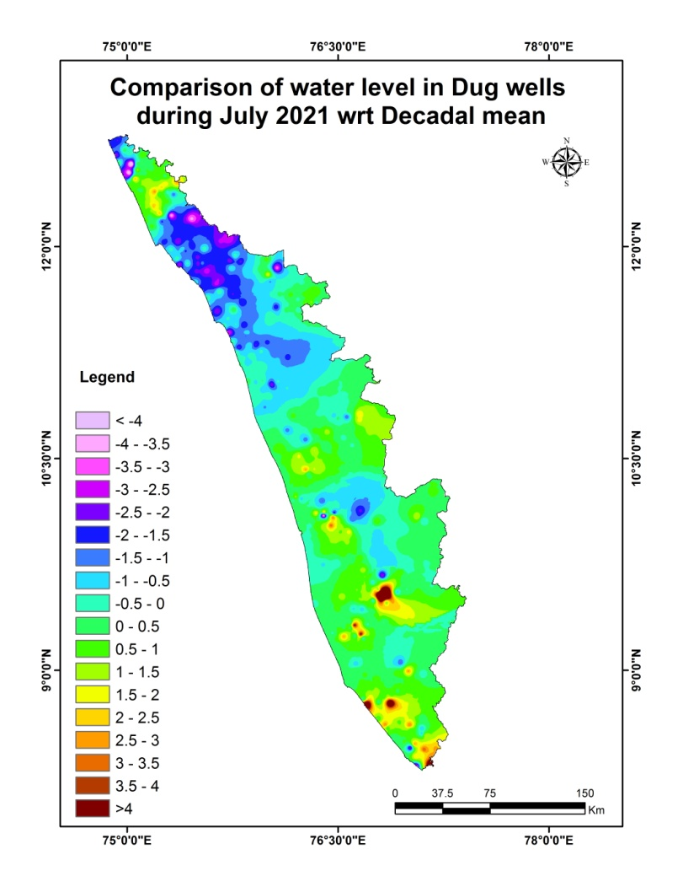

Fig:7. Comparison of water level in Dug wells during July2021wrt Decadal mean

Compared water level in the observation bore wells during July2021 with that of the decadal mean. It has been noticed that 54% of bore wells (182 out of 340) show fall in water level, and 46% of the wells (158 out of 340)shows marginal rise,no remarkable change in water level.Out of 54 % of the bore wells shows a falling trend , 36 % shows(67nos) a fall in water level less than 0.5m, 20 % show fall in the range between 0.5 - 1m, 18% show fall in the range between 1-1.5 m, 7% of wells show a fall in range between 1.5 - 2m,19% show a fall in water level more than 2 m.Table showing water level comparison of bore wells duringJuly 2021with respect to decadal mean is appended. (Annexure-III)

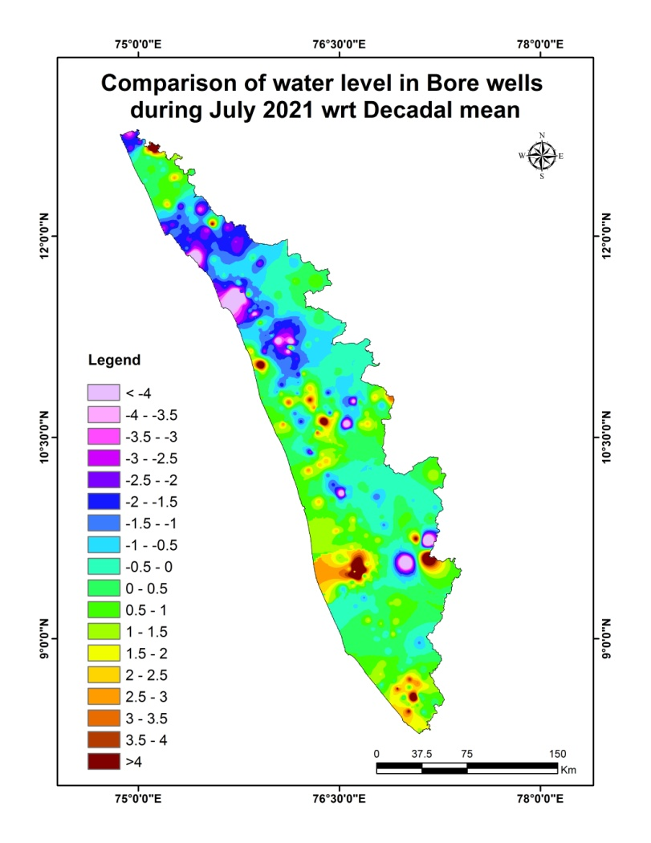

Fig:8. Comparison of water level in Bore wells during July 2021wrt Decadal mean

Comparison of the water level in the observation tube wells during July 2021 with that of the decadal mean reveals that 31 % of tube wells (12 out of 39) recorded a falling trend and69 % of the tube wells (27 out of 39) show marginal rise/no remarkable change in water level.Out of 31 % of the tube wells shows a falling trend, 75% of the tube wells (9 nos) show fall in water level less than 0.5m and17% of wells show fall in the range0.5-1 m and 8% show a fall in water level more than 2 m.Table showing water level comparison of tube wells during July 2021with respect to decadal mean is appended. (Annexure-III)

Summary
Rainfall
- Actual Southwest monsoon Rain fall received in the state during 2020 (1June to 30September) is 2227.9mm which is 9% more than theNormal rainfall during the period .

- Actual Southwest monsoon Rain fall received in the state during 2021 (1June to 0September) is 1718.8 mm .Eventhough it is -16% deficient from the Normal rainfall during the period which is 2049.2mm the percentage departure comes under Normal category (+19 to-19).

Groundwater level
- The depth to groundwater level in the observation dug wells during the month of July 2021 range from a minimum of -0.8 m to a maximum of 16.16mbgl, in bore wells -01.1 m to a maximum of 46.03mbgl and in the tubewells -0.5m to a maximum of 33.82mbgl.
- Comparison of the water level inJuly2021 with respect to the previous year, reveals that 43 % of observation dug wells(169 out of 393), 40% of bore wells(136 out of 339) and 13% of tube wells (5 out of 38) recorded a falling trend. Total 310 wells out of 770 show fall in water level.33%of the observation wells with falling trend (103 out of 310) show decline in water level less than 0.5 m.

- Comparison of groundwater level in July 2021with respect to the decadal mean reveals that 49% of observation dug wells(191 out of 391),54 % of bore wells(182 out of340) and 31% of tube wells (12 out of39) recorded a falling trend. Total 385 wells out of 770 show fall in water level. 39%of the observationwells with falling trend(152 out of 385)show decline in water level less than 0.5 m.
- Open wells showing decline of water level more than 2m is shown in AnnexureIV.Maximum Fluctuation from July2020 water level(-7.78m) is noted inopen well at Koothuparamba, Kannur(KNR-MOW179).Total 35 wells show more than 2m fall.Maximum Fluctuation from Decadal mean water level(-5.183m) isnoted in open well at Kasaragod, Kasaragod(206).Total 33 wells show more than 2m fall . 6 wells in Kannur ,5 wells each in Kasaragod and Kozhikkode districtsand 1 well each in Kottayam,Ernakulam and Wayanad districts showmore than 2m fall from both 2020 july water level and decadal meanwater level.District officers should take necessary recharge measures like artificial recharge through rainwater harvesting to recharge the wells with fall in water level more than 2m to raise the water level.

Districtwise Observation well Frequency on July 2021 Annexure I
District | Well Type | No. of WL measured | DTWL(mbgl) |  | Location |  | Depth range of wells (mts)
 |  |  | Min | Max | Min | Max | 0 to 2 | 2 to 5 | 5 to 10 | 10 to 20 | >20
Thiruvananthapuram | Dug well | 30 | -0.80 | 11.28 | TVM OW28, Kazhakkoottam | TVM OW22, Perumkadavila | 6 | 9 | 13 | 2 | 0
 | Bore well | 34 | -0.68 | 17.62 | 13, Nedumangad | 43, Vamanapuram | 5 | 7 | 16 | 6 | 0
 | Tube well | 4 | 2.93 | 8.23 | 36, Chirayinkeezhu | 37, Chirayinkeezhu | 0 | 2 | 2 | 0 | 0
Kollam | Dug well | 25 | 0.61 | 9.85 | KLM OW 23, Ochira | KLM OW 24, Chittumala | 6 | 8 | 11 | 0 | 0
 | Bore well | 16 | 0.56 | 8.79 | KLM/6, Kottarakkara | KLM/07, Pathanapuram | 1 | 4 | 11 | 0 | 0
 | Tube well | 8 | 2.48 | 33.82 | KLM/17 ,Mughatahala | KLM/29, Sasthamkotta | 0 | 2 | 2 | 1 | 3
Pathanamthitta | Dug well | 13 | 1.20 | 7.53 | PTAOB34A,Kozhancherry | PTA OW, Mallappally | 4 | 8 | 1 | 0 | 0
 | Bore well | 23 | -1.10 | 12.73 | PTA/19,Parakkode | PTA/20, Adoor | 4 | 8 | 10 | 1 | 0
Alappuzha | Dug well | 20 | -0.80 | 9.74 | OW-27 Chambakkulam | OW-02 Kattanam | 17 | 1 | 2 | 0 | 0
 | Bore well | 2 | 2.28 | 4.22 | 36 Punthala | 35 Pennukkara | 0 | 2 | 0 | 0 | 0
 | Tube well | 26 | -0.50 | 17.24 | 08 Thrikkunnappuzha | 04 Charumoodu | 13 | 8 | 3 | 2 | 0
Kottayam | Dug well | 20 | 0.14 | 8.26 | KTM-OW-11, Erattupetta | KTM-OW-4_, Pallom | 10 | 7 | 3 | 0 | 0
 | Bore well | 22 | -0.12 | 16.21 | 10,Uzhavoor | 20, Pallom | 8 | 11 | 1 | 2 | 0
Idukki | Dug well | 20 | 0.48 | 7.69 | 73, Udumpanchola | 71, Kattappana | 6 | 10 | 4 | 0 | 0
 | Bore well | 23 | 1.16 | 36.88 | SO415,Elamdesom | SO428,Azhutha | 2 | 9 | 5 | 5 | 2
Ernakulam | Dug well | 36 | 0.01 | 7.00 | E85, Kochi corporation | GWE-09, Amballur | 12 | 17 | 7 | 0 | 0
 | Bore well | 21 | -0.29 | 15.98 | BW101,Asamannur | BW100, Rayamangalam | 4 | 11 | 5 | 1 | 0
 | Tube well | 1 | 9.70 | 9.70 | TW 01, Kochi corporation | TW 01, Kochi corporation | 0 | 0 | 1 | 0 | 0
Thrissur | Dug well | 31 | 0.00 | 9.44 | TSROW16, Thalikkulam | TSROW12,Chowwannur | 15 | 8 | 8 | 0 | 0
 | Bore well | 37 | -0.59 | 23.28 | TSR124, Puzhakkal | TSR122, Vadakkethara | 5 | 15 | 10 | 4 | 3
Malappuram | Dug well | 26 | 0.73 | 12.90 | MPM.OW.18, Kondotty | MPM.OW23, Vengara | 4 | 9 | 10 | 3 | 0
 | Bore well | 30 | 0.48 | 46.03 | MPM169, Wandoor | MPM174, Areekode | 3 | 8 | 12 | 4 | 3
Palakkad | Dug well | 31 | 0.23 | 9.22 | PKD S-2, Alathur | PKD S-10, Sreekrishnapuram | 10 | 10 | 11 | 0 | 0
 | Bore well | 32 | 0.49 | 18.95 | 154,Mannarkad | 136, Pattambi | 3 | 7 | 14 | 8 | 0
Kozhikkode | Dug well | 33 | 0.51 | 11.43 | QKKDO49, Kozhikkode | QKKDO60, Thodannur | 4 | 18 | 8 | 3 | 0
 | Bore well | 33 | 0.17 | 30.49 | Kozhikkode, KKDPZ 197 | KKDPZ 202, Perambra | 3 | 9 | 10 | 8 | 3
Wayanad | Dug well | 26 | 0.25 | 11.50 | SOW-10, Poothadi | SOW-4, Nenmeni | 6 | 7 | 12 | 1 | 0
 | Bore well | 19 | 1.64 | 23.70 | WYD2c16,Muttil | WYD223, Thirunelli | 1 | 2 | 6 | 9 | 1
Kannur | Dug well | 36 | 0.60 | 16.16 | KNR-POW-C23, Koothuparamba | KNR-POW-C8, Thaliparamba | 8 | 7 | 18 | 3 | 0
 | Bore well | 27 | 1.12 | 22.37 | KNRPz239,Thalipparamba | KNR-Pz228, Irikkur | 1 | 3 | 13 | 8 | 2
Kasaragod | Dug well | 46 | -0.04 | 14.55 | 199, Kanhangad | 200, Karadka | 10 | 14 | 14 | 8 | 0
 | Bore well | 21 | -0.40 | 18.25 | PZKGD241,Parappa | PZKGD242,Karadka | 4 | 3 | 7 | 7 | 0

Comparison of Water level July2021 with respect to July 2020 Annexure II
District | Well Type | No. of WL Measured | Water level | Total | 0 - 0.5 m | 0.5 - 1 m | 1-1.5m | 1.5 - 2 m | >2 m
 |  |  |  |  | No. | No. | No. | No. | No.
Thiruvananthapuram | Dug well | 30 | Rise | 23 | 15 | 2 | 2 | 1 | 3
 |  |  | Fall | 7 | 5 | 0 | 1 | 0 | 1
 | Bore well | 32 | Rise | 24 | 13 | 3 | 5 | 0 | 3
 |  |  | Fall | 8 | 6 | 1 | 1 | 0 | 0
 | Tube well | 4 | Rise | 4 | 2 | 2 | 0 | 0 | 0
 |  |  | Fall | 0 | 0 | 0 | 0 | 0 | 0
Kollam | Dug well | 24 | Rise | 16 | 6 | 2 | 7 | 1 | 0
 |  |  | Fall | 8 | 4 | 1 | 1 | 1 | 1
 | Bore well | 16 | Rise | 9 | 2 | 5 | 1 | 0 | 1
 |  |  | Fall | 7 | 6 | 0 | 1 | 0 | 0
 | Tube well | 8 | Rise | 6 | 1 | 3 | 0 | 1 | 1
 |  |  | Fall | 2 | 2 | 0 | 0 | 0 | 0
Pathanamthitta | Dug well | 13 | Rise | 6 | 4 | 2 | 0 | 0 | 0
 |  |  | Fall | 7 | 6 | 1 | 0 | 0 | 0
 | Bore well | 23 | Rise | 11 | 4 | 2 | 3 | 1 | 1
 |  |  | Fall | 12 | 5 | 4 | 0 | 3 | 0
Alappuzha | Dug well | 21 | Rise | 18 | 16 | 0 | 1 | 0 | 1
 |  |  | Fall | 3 | 3 | 0 | 0 | 0 | 0
 | Bore well | 2 | Rise | 2 | 2 | 0 | 0 | 0 | 0
 |  |  | Fall | 0 | 0 | 0 | 0 | 0 | 0
 | Tube well | 25 | Rise | 23 | 22 | 0 | 0 | 0 | 1
 |  |  | Fall | 2 | 2 | 0 | 0 | 0 | 0
Kottayam | Dug well | 20 | Rise | 14 | 2 | 5 | 5 | 2 | 0
 |  |  | Fall | 6 | 3 | 1 | 1 | 1 | 0
 | Bore well | 23 | Rise | 20 | 8 | 1 | 3 | 4 | 4
 |  |  | Fall | 3 | 1 | 2 | 0 | 0 | 0
Idukki | Dug well | 20 | Rise | 15 | 4 | 6 | 1 | 2 | 2
 |  |  | Fall | 5 | 3 | 2 | 0 | 0 | 0
 | Bore well | 22 | Rise | 19 | 6 | 2 | 2 | 1 | 8
 |  |  | Fall | 3 | 1 | 1 | 0 | 0 | 1
Ernakulam | Dug well | 38 | Rise | 22 | 7 | 6 | 3 | 1 | 5
 |  |  | Fall | 16 | 7 | 3 | 2 | 3 | 1
 | Bore well | 23 | Rise | 17 | 11 | 2 | 2 | 1 | 1
 |  |  | Fall | 6 | 2 | 2 | 1 | 0 | 1
 | Tube well | 1 | Rise | 0 | 0 | 0 | 0 | 0 | 0
 |  |  | Fall | 1 | 1 | 0 | 0 | 0 | 0
Thrissur | Dug well | 31 | Rise | 26 | 9 | 6 | 5 | 3 | 3
 |  |  | Fall | 5 | 2 | 3 | 0 | 0 | 0
 | Bore well | 37 | Rise | 32 | 5 | 3 | 8 | 6 | 10
 |  |  | Fall | 5 | 1 | 2 | 1 | 0 | 1
Malappuram | Dug well | 25 | Rise | 2 | 2 | 0 | 0 | 0 | 0
 |  |  | Fall | 23 | 6 | 8 | 6 | 1 | 2
 | Bore well | 29 | Rise | 3 | 1 | 0 | 0 | 2 | 0
 |  |  | Fall | 26 | 6 | 8 | 2 | 3 | 7
Palakkad | Dug well | 31 | Rise | 25 | 7 | 8 | 6 | 1 | 3
 |  |  | Fall | 6 | 6 | 0 | 0 | 0 | 0
 | Bore well | 32 | Rise | 28 | 4 | 7 | 3 | 2 | 12
 |  |  | Fall | 4 | 3 | 1 | 0 | 0 | 0
Kozhikkode | Dug well | 33 | Rise | 0 | 0 | 0 | 0 | 0 | 0
 |  |  | Fall | 33 | 3 | 6 | 8 | 5 | 11
 | Bore well | 33 | Rise | 3 | 2 | 0 | 0 | 1 | 0
 |  |  | Fall | 30 | 4 | 5 | 4 | 6 | 11
Wayanad | Dug well | 26 | Rise | 23 | 7 | 9 | 4 | 2 | 1
 |  |  | Fall | 3 | 0 | 0 | 1 | 0 | 2
 | Bore well | 19 | Rise | 17 | 12 | 5 | 0 | 0 | 0
 |  |  | Fall | 2 | 2 | 0 | 0 | 0 | 0
Kannur | Dug well | 36 | Rise | 8 | 8 | 0 | 0 | 0 | 0
 |  |  | Fall | 28 | 7 | 2 | 6 | 5 | 8
 | Bore well | 28 | Rise | 7 | 3 | 1 | 2 | 0 | 1
 |  |  | Fall | 21 | 1 | 2 | 4 | 4 | 10
Kasaragod | Dug well | 45 | Rise | 26 | 12 | 5 | 0 | 0 | 9
 |  |  | Fall | 19 | 4 | 4 | 2 | 1 | 8
 | Bore well | 20 | Rise | 11 | 6 | 2 | 0 | 0 | 3
 |  |  | Fall | 9 | 1 | 4 | 1 | 1 | 2

Comparison of Water level July 2021 with respect to 10 yrs mean Annexure III
District | Well Type | No. of WL Measured | Water level | Total | 0 - 0.5 m | 0.5 - 1 m | 1 - 1.5 m | 1.5 - 2 m | <2 m
 |  |  |  |  | No. | No. | No. | No. | No.
Thiruvananthapuram | Dug well | 31 | Rise | 24 | 4 | 6 | 2 | 4 | 8
 |  |  | Fall | 7 | 3 | 2 | 0 | 0 | 2
 | Bore well | 31 | Rise | 23 | 3 | 6 | 6 | 6 | 2
 |  |  | Fall | 8 | 8 | 0 | 0 | 0 | 0
 | Tube well | 4 | Rise | 4 | 2 | 2 | 0 | 0 | 0
 |  |  | Fall | 0 | 0 | 0 | 0 | 0 | 0
Kollam | Dug well | 25 | Rise | 19 | 12 | 6 | 0 | 0 | 1
 |  |  | Fall | 6 | 3 | 2 | 0 | 1 | 0
 | Bore well | 16 | Rise | 7 | 4 | 2 | 0 | 1 | 0
 |  |  | Fall | 9 | 6 | 2 | 1 | 0 | 0
 | Tube well | 8 | Rise | 5 | 2 | 0 | 1 | 0 | 2
 |  |  | Fall | 3 | 2 | 1 | 0 | 0 | 0
Pathanamthitta | Dug well | 13 | Rise | 5 | 4 | 1 | 0 | 0 | 0
 |  |  | Fall | 8 | 6 | 2 | 0 | 0 | 0
 | Bore well | 22 | Rise | 13 | 8 | 0 | 4 | 1 | 0
 |  |  | Fall | 9 | 7 | 0 | 2 | 0 | 0
Alappuzha | Dug well | 17 | Rise | 12 | 8 | 1 | 0 | 0 | 3
 |  |  | Fall | 5 | 5 | 0 | 0 | 0 | 0
 | Bore well | 2 | Rise | 0 | 0 | 0 | 0 | 0 | 0
 |  |  | Fall | 2 | 1 | 1 | 0 | 0 | 0
 | Tube well | 26 | Rise | 18 | 11 | 3 | 2 | 0 | 2
 |  |  | Fall | 8 | 6 | 1 | 0 | 0 | 1
Kottayam | Dug well | 20 | Rise | 15 | 3 | 5 | 6 | 0 | 1
 |  |  | Fall | 5 | 2 | 2 | 0 | 1 | 0
 | Bore well | 23 | Rise | 20 | 4 | 3 | 6 | 4 | 3
 |  |  | Fall | 3 | 1 | 1 | 0 | 0 | 1
Idukki | Dug well | 20 | Rise | 8 | 6 | 1 | 1 | 0 | 0
 |  |  | Fall | 12 | 7 | 5 | 0 | 0 | 0
 | Bore well | 23 | Rise | 8 | 2 | 3 | 1 | 0 | 2
 |  |  | Fall | 15 | 7 | 5 | 1 | 0 | 2
Ernakulam | Dug well | 38 | Rise | 22 | 5 | 8 | 4 | 2 | 3
 |  |  | Fall | 16 | 7 | 3 | 1 | 3 | 2
 | Bore well | 23 | Rise | 14 | 9 | 2 | 1 | 1 | 1
 |  |  | Fall | 9 | 5 | 0 | 2 | 1 | 1
 | Tube well | 1 | Rise | 0 | 0 | 0 | 0 | 0 | 0
 |  |  | Fall | 1 | 1 | 0 | 0 | 0 | 0
Thrissur | Dug well | 31 | Rise | 25 | 12 | 6 | 3 | 3 | 1
 |  |  | Fall | 6 | 2 | 2 | 2 | 0 | 0
 | Bore well | 37 | Rise | 23 | 5 | 6 | 2 | 2 | 8
 |  |  | Fall | 14 | 3 | 6 | 2 | 2 | 1
Malappuram | Dug well | 26 | Rise | 2 | 2 | 0 | 0 | 0 | 0
 |  |  | Fall | 24 | 6 | 12 | 4 | 1 | 1
 | Bore well | 30 | Rise | 6 | 3 | 0 | 0 | 1 | 2
 |  |  | Fall | 24 | 2 | 4 | 9 | 3 | 6
Palakkad | Dug well | 30 | Rise | 20 | 10 | 5 | 3 | 1 | 1
 |  |  | Fall | 10 | 8 | 1 | 1 | 0 | 0
 | Bore well | 32 | Rise | 18 | 2 | 4 | 1 | 3 | 8
 |  |  | Fall | 14 | 5 | 3 | 3 | 1 | 2
Kozhikkode | Dug well | 33 | Rise | 5 | 5 | 0 | 0 | 0 | 0
 |  |  | Fall | 28 | 8 | 7 | 2 | 5 | 6
 | Bore well | 33 | Rise | 4 | 1 | 0 | 1 | 1 | 1
 |  |  | Fall | 29 | 8 | 8 | 4 | 2 | 7
Wayanad | Dug well | 26 | Rise | 10 | 3 | 5 | 1 | 1 | 0
 |  |  | Fall | 16 | 8 | 4 | 2 | 0 | 2
 | Bore well | 19 | Rise | 7 | 5 | 1 | 1 | 0 | 0
 |  |  | Fall | 12 | 7 | 3 | 1 | 0 | 1
Kannur | Dug well | 36 | Rise | 0 | 0 | 0 | 0 | 0 | 0
 |  |  | Fall | 36 | 8 | 2 | 5 | 8 | 13
 | Bore well | 28 | Rise | 2 | 1 | 0 | 0 | 0 | 1
 |  |  | Fall | 26 | 3 | 2 | 7 | 3 | 11
Kasaragod | Dug well | 45 | Rise | 33 | 12 | 9 | 4 | 2 | 6
 |  |  | Fall | 12 | 3 | 1 | 2 | 1 | 5
 | Bore well | 21 | Rise | 13 | 4 | 5 | 1 | 0 | 3
 |  |  | Fall | 8 | 4 | 1 | 0 | 0 | 3

Annexure IV July 2021
Water Level Data & Fluctuation
SNo | District | Block | GP/Municipality/Corporation | WellNo | Well_Type | Latitude(°) | Longitude(°) | Jul-2021 | Jul-2020 | Decadal Avg(2011-2020) | Fluctuation in Jul-2021 wrt.
 |  |  |  |  |  |  |  |  |  | WL | Jul-2020 | Decadal Avg
1 | Thiruvananthapuram | Nedumangad | Vellanad | TVM OW09 | Dug Well | 8.58833 | 77.09666 | 4.970 | 2.910 | 4.085 | -2.060 | -0.884
2 | Thiruvananthapuram | Neyyattinkara | Athiyannur | TVM OW02 | Dug Well | 8.32167 | 77.05334 | 9.720 |  | 6.744 |  | -2.976
3 | Thiruvananthapuram | Thiruvananthapuram | Nemom | TVM OW05 | Dug Well | 8.45028 | 77.01334 | 5.180 | 4.120 | 2.830 | -1.060 | -2.350
4 | KOLLAM | Pathanapuram | Piravanthoor | KLM OW 18 | Dug Well | 9.05503 | 76.94386 | 4.190 | 1.630 | 2.626 | -2.560 | -1.564
5 | Kottayam | Meenachil | Erattupetta | KTM-OW-11 | Dug Well | 9.67222 | 76.81445 | 2.960 | 0.320 | 0.351 | -2.640 | -2.609
6 | ERNAKULAM | Koovappady | Rayamangalam | GWE-02 | Dug Well | 10.09583 | 76.39778 | 6.640 | 1.350 | 2.208 | -5.290 | -4.431
7 | ERNAKULAM | Kothamangalam | Pindimana | E97 | Dug Well | 10.12779 | 76.65895 | 3.470 | 1.590 | 1.255 | -1.880 | -2.215
8 | Malappuram | Ernad | Wandoor | MPM.OW.14 | Dug Well | 11.21528 | 76.14167 | 10.160 | 8.050 | 8.450 | -2.110 | -1.710
9 | Malappuram | Perinthalmanna | Perinthalmanna | MPM.OW.9 | Dug Well | 10.97500 | 76.23361 | 6.190 | 3.500 | 5.192 | -2.690 | -0.998
10 | Malappuram | Tirurangadi | Vengara | MPM.OW23 | Dug Well | 11.02361 | 76.02917 | 12.900 | ###### | ###### | -1.520 | -2.492
11 | Kozhikode | Badagaru | Thodannur | QKKDO60 | Dug Well | 11.54444 | 75.64250 | 11.570 | 8.670 | 9.109 | -2.900 | -2.461
12 | Kozhikode | Kozhikode | Balusseri | KKDOW 014 | Dug Well | 11.50139 | 75.89139 | 2.560 | 0.530 | 1.201 | -2.030 | -1.359
13 | Kozhikode | Kozhikode | Koduvally | QKKDO53 | Dug Well | 11.36972 | 75.84444 | 2.320 | 0.270 | 0.731 | -2.050 | -1.589
14 | Kozhikode | Kozhikode | Kozhikode(corporation) | QKKDO63 | Dug Well | 11.28528 | 75.79556 | 11.360 | 9.660 | 9.166 | -1.700 | -2.194
15 | Kozhikode | Kozhikode | Kunnamangalam | KKDOW 158 | Dug Well | 11.30583 | 75.91528 | 6.300 | 3.320 | 4.170 | -2.980 | -2.130
16 | Kozhikode | Kozhikode | Kunnamangalam | KKDOW 159 | Dug Well | 11.32194 | 75.99722 | 7.630 | 4.790 | 5.971 | -2.840 | -1.659
17 | Kozhikode | Quilandi | Balussery | QKKDO55 | Dug Well | 11.44472 | 75.83056 | 5.460 | 1.680 | 3.409 | -3.780 | -2.051
18 | Kozhikode | Quilandi | Panthalayani | QKKDO62 | Dug Well | 11.39306 | 75.72833 | 4.530 | 0.810 | 1.537 | -3.720 | -2.993
19 | Kozhikode | Quilandy | Perambra | KKDOW 016 | Dug Well | 11.59806 | 75.82056 | 4.810 | 1.280 | 2.945 | -3.530 | -1.865
20 | Kozhikode | Vadakara | Kunnummal | KKDOW 017 | Dug Well | 11.66389 | 75.75278 | 4.830 | 1.400 | 2.792 | -3.430 | -2.038
21 | Kozhikode | Vadakara | Thuneri | KKDOW 020 | Dug Well | 11.76861 | 75.76361 | 10.710 | 6.040 | 8.840 | -4.670 | -1.870
22 | Kozhikode | Vadakara | Thuneri | KKDOW 177 | Dug Well | 11.70167 | 75.53472 | 6.690 | 3.810 | 4.794 | -2.880 | -1.896
23 | WAYANAD | Kalpetta | Vythiri | 162 | Dug Well | 11.57316 | 76.05847 | 5.880 | 6.210 | 3.861 | 0.330 | -2.019
24 | WAYANAD | Mananthavady | Thirunelly | SOW-13 | Dug Well | 11.84953 | 76.06632 | 6.650 | 3.780 | 3.248 | -2.870 | -3.402
25 | WAYANAD | Mananthavady | Vellamunda | 168 | Dug Well | 11.73832 | 76.01769 | 9.350 | 6.570 | 8.563 | -2.780 | -0.787
26 | Kannur | Kannur | Edakkad | KNR-POW-C22 | Dug Well | 11.88056 | 75.51000 | 7.300 |  | 5.016 |  | -2.284
27 | Kannur | Kannur | Kannur | KNR-MOW181 | Dug Well | 11.87639 | 75.37417 | 7.710 | 5.610 | 5.086 | -2.100 | -2.624
28 | Kannur | Taliparamba | Irikkur | KNR-POW-C12 | Dug Well | 12.03833 | 75.66528 | 4.990 | 3.010 | 2.387 | -1.980 | -2.603
29 | Kannur | Taliparamba | Payyannur | KNR-MOW190 | Dug Well | 12.22167 | 75.31555 | 7.000 | 3.290 | 3.111 | -3.710 | -3.889
30 | Kannur | Taliparamba | Taliparamba | KNR-MOW188 | Dug Well | 12.19694 | 75.45972 | 10.090 | 6.270 | 6.410 | -3.820 | -3.680
31 | Kannur | Taliparamba | Taliparamba | KNR-POW-C7 | Dug Well | 12.03389 | 75.36250 | 8.900 | 6.940 | 6.355 | -1.960 | -2.545
32 | Kannur | Thalassery | Iritty | KNR-POW-C11 | Dug Well | 12.05389 | 75.72111 | 7.200 | 5.980 | 4.219 | -1.220 | -2.981
33 | Kannur | Thalassery | Iritty | KNR-POW-C24 | Dug Well | 11.92639 | 75.50389 | 5.140 | 3.020 | 2.920 | -2.120 | -2.220
34 | Kannur | Thalassery | Koothuparamba | KNR-MOW178 | Dug Well | 11.75861 | 75.58305 | 4.400 | 1.310 | 2.635 | -3.090 | -1.765
35 | Kannur | Thalassery | Koothuparamba | KNR-MOW179 | Dug Well | 11.82889 | 75.56639 | 11.380 | 3.600 | 8.483 | -7.780 | -2.897
36 | Kannur | Thalassery | Koothuparamba | KNR-POW-C21 | Dug Well | 11.82528 | 75.49277 | 8.050 | 3.560 | 5.934 | -4.490 | -2.116
37 | Kannur | Thalassery | Peravoor | KNR-MOW172 | Dug Well | 11.90000 | 75.73306 | 5.880 | 3.970 | 3.524 | -1.910 | -2.356
38 | Kannur | Thalassery | Peravoor | KNR-POW-C15 | Dug Well | 11.89472 | 75.80833 | 6.400 |  | 4.276 |  | -2.124
39 | Kannur | Thalassery | Peravoor | KNR-POW-C17 | Dug Well | 11.84250 | 75.66084 | 4.430 | 2.370 | 2.682 | -2.060 | -1.748
40 | Kannur | Thalassery | Thalassery | KNR-POW-C18 | Dug Well | 11.76500 | 75.64806 | 7.040 |  | 4.483 |  | -2.557
41 | Kannur | Thalassery | Thalassery | KNR-POW-C19 | Dug Well | 11.73833 | 75.63667 | 7.120 |  | 4.250 |  | -2.870
42 | Kasaragod | Kasaragod | Kasaragod | 206 | Dug Well | 12.58472 | 75.03056 | 6.460 | 0.780 | 1.278 | -5.680 | -5.183
43 | Kasaragod | Kasaragod | Kasaragod | KSOW-01 | Dug Well | 12.50444 | 74.99611 | 5.630 | 2.360 | 2.923 | -3.270 | -2.707
44 | Kasaragod | Kasaragod | Kasaragod | KSOW-25 | Dug Well | 12.52250 | 75.01334 | 11.100 | 5.500 | 6.342 | -5.600 | -4.758
45 | Kasaragod | Manjeshwaram | Manjeshwar | 204 | Dug Well | 12.65083 | 74.92361 | 3.870 | 0.840 | 1.439 | -3.030 | -2.431
46 | Kasaragod | Manjeshwaram | Manjeshwar | 205 | Dug Well | 12.67917 | 74.90556 | 6.800 | 4.520 | 5.427 | -2.280 | -1.373
47 | Kasaragod | Manjeshwaram | Manjeshwar | 208 | Dug Well | 12.75139 | 74.93333 | 3.370 | 0.990 | 1.330 | -2.380 | -2.040
48 | Kasaragod | Manjeshwaram | Manjeshwar | 209 | Dug Well | 12.73333 | 74.88333 | 5.030 | 2.550 | 3.057 | -2.480 | -1.974
49 | Kasaragod | Manjeshwaram | Manjeshwar | 210 | Dug Well | 12.69861 | 75.01389 | 5.050 | 2.350 | 4.529 | -2.700 | -0.521

Observation well frequency on July 2021 Abstract I
Well Type | No of WL measured | DTWL (mbgl) |  | Location |  | Depth range of wells (m)
 |  | min | max | min | max | 0 to 2 | 2 to 5 | 5 to 10 | 10 to 20 | >20
Dug well | 393 | -0.8 | 16.16 | TVM OW16,Chirayinkeezhu & OW-15,Chengannur | Taliparamba, KNR-POW-C8 | 118 | 133 | 122 | 20 | 0
 |  |  |  |  |  | 30% | 34% | 31% | 5% | 0%
Bore well | 340 | -1.1 | 46.03 | PTA/19, Erathu | MPM174, Areekode, Malappuram | 44 | 99 | 120 | 63 | 14
 |  |  |  |  |  | 13% | 29% | 35% | 19% | 4%
Tube well | 39 | -0.5 | 33.82 | 32 Chandiroor,Pattanakkad | KLM/29, Sasthamkotta, Kollam | 13 | 12 | 8 | 3 | 3
 |  |  |  |  |  | 33% | 31% | 20% | 8% | 8%

Comparison of Water level July 2021 with respect to July 2020 Abstract II
Well type | No. of WL Measured | Water level | Total | 0 - 0.5 m | 0.5 - 1 m | 1 - 1.5 m | 1.5 - 2 m | >2 m
Dug well | 393 | Rise | 224 | 99 | 51 | 34 | 13 | 27
 |  | % | 57% | 44% | 23% | 15% | 6% | 12%
 |  | Fall | 169 | 59 | 31 | 28 | 17 | 34
 |  | % | 43% | 35% | 18% | 17% | 10% | 20%
Bore well | 339 | Rise | 203 | 79 | 33 | 29 | 18 | 44
 |  | % | 60% | 39% | 16% | 14% | 9% | 22%
 |  | Fall | 136 | 39 | 32 | 15 | 17 | 33
 |  | % | 40% | 29% | 23% | 11% | 13% | 24%
Tube well | 38 | Rise | 33 | 25 | 5 | 0 | 1 | 2
 |  | % | 87% | 76% | 15% | 0% | 3% | 6%
 |  | Fall | 5 | 5 | 0 | 0 | 0 | 0
 |  | % | 13% | 100% | 0% | 0% | 0% | 0%

Comparison of Water level July 2021 with respect to 10 yrs mean Abstract III
Well type | No. of WL Measured | Water level | Total | 0 - 0.5 m | 0.5 - 1 m | 1 - 1.5 m | 1.5 - 2 m | >2 m
Dug well | 391 | Rise | 200 | 86 | 53 | 24 | 13 | 24
 |  | % | 51% | 43% | 26% | 12% | 7% | 12%
 |  | Fall | 191 | 76 | 45 | 19 | 20 | 31
 |  | % | 49% | 40% | 24% | 10% | 10% | 16%
Bore well | 340 | Rise | 158 | 51 | 32 | 24 | 20 | 31
 |  | % | 46% | 32% | 20% | 15% | 13% | 20%
 |  | Fall | 182 | 67 | 36 | 32 | 12 | 35
 |  | % | 54% | 36% | 20% | 18% | 7% | 19%
Tube well | 39 | Rise | 27 | 15 | 5 | 3 | 0 | 4
 |  | % | 69% | 56% | 18% | 11% | 0% | 15%
 |  | Fall | 12 | 9 | 2 | 0 | 0 | 1
 |  | % | 31% | 75% | 17% | 0% | 0% | 8%

