GOVERNMENT OF KERALA
GROUNDWATER DEPARTMENT

GROUNDWATER LEVEL MONITORING REPORT – SEPTEMBER 2021

Wateris a replenishable natural resource which is essential for the existence of all living beings. In the past, the demand of water is mostly limited to domestic and in the agricultural sector. Due to the developments in agricultural and industrial sector the demand of water is increasing many folds since last few decades. Surface water resource alone couldn’t meet the increasing demand and hence persuaded to depend on groundwater resource during the past few decades made stress on groundwater regime. In order to sustain the groundwater resources, proper groundwater management practices are needed.
Rainfallis the primary source for groundwater recharge and has a vital role in the sustainability of groundwater resource in the state. Groundwater level fluctuation results from the seasonal availability of rainfall. Kerala state experiences four distinct seasons namely winter (January-February), Pre-monsoon (March-May), Monsoon (South-West) June to September and Post-monsoon (North-East) from October to December. Average annual precipitation in the state is nearly 3000 mm. The rainfall in the State is controlled primarily by the South-West and North-East monsoons. About 90% of the rainfall occurs during six monsoon months (South-West monsoon contributes major portion of rainfall (65-70%) and about 16% from the North-East) and remaining from summer showers.

Actual Southwest monsoon Rain fall received in the state during 2021(1June to 30September) is 1718.8 mm . It is -16% less than the Normal rainfall during the period which is 2049.2mm .The percentage departure comes under Normal category. All the districts received less Actual rain fall than the normal rain fall except Pathanamthitta District which received 4% more rain than the Normal rain . Percentage departure of rain in Kannur, Malappuram, Palakkad, Thrissur, and Wayanad and fall in Deficient category and all other districts comes in Normal category. Kasargod district received the highest rainfall (2398.7mm and Thiruvananthapuram district received the lowest rainfall (745.6mm).
Actual Southwest monsoon Rain fall received in the state during 2020(1June to 30September) is 2227.9 mm . It is 9% more than the Normal rainfall during the period

Fig:1. Comparison of actual rainfalloccurred during June-August 2021wrt 2020

Fig:2. Comparison of actual rainfall occurred during June-August2021wrtNormal Rainfall
Geology: Kerala, the southernmost state of Indian peninsula, is having a geographical area of 38863 km². The land area extends between latitude 8ᵒ17’30” and 12ᵒ27’40” and longitude 74ᵒ51’57” and 77ᵒ24’47”. Physiographically, Kerala state is sandwiched between Western Ghats on the east and Arabian Sea on the west. Being the part of the southern Indian peninsula, the peninsular geological formations exist in the state. The major geological formations in the state comprises crystalline rocks of Archaean Age, sedimentary rock formations of tertiary age and sub recent to recent rock formations of quaternary age.

Occurrence of Groundwater resource: Groundwater occurs under phreatic, semi-confined and confined conditions, Groundwater in unconfined aquifer is mainly utilized through tube wells in sedimentary terrain and through bore wells in hard rock areas.
Groundwater monitoring network:Short term and long term changes in the climatic conditions influence the groundwater scenario of an area. Groundwater level data are the principal information required for assessing the groundwater status and groundwater resource estimation.
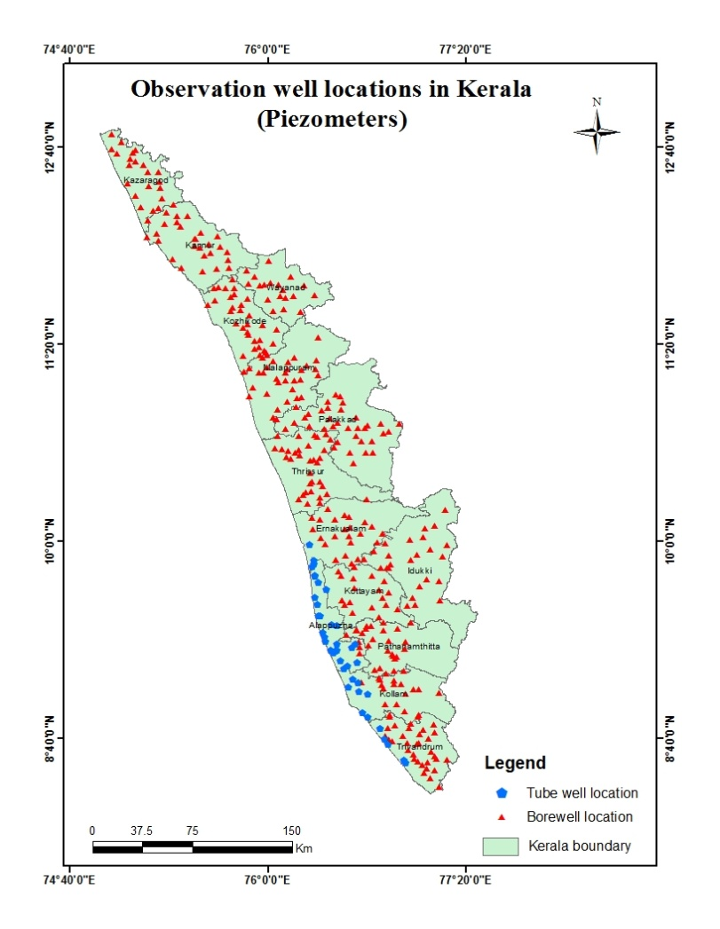
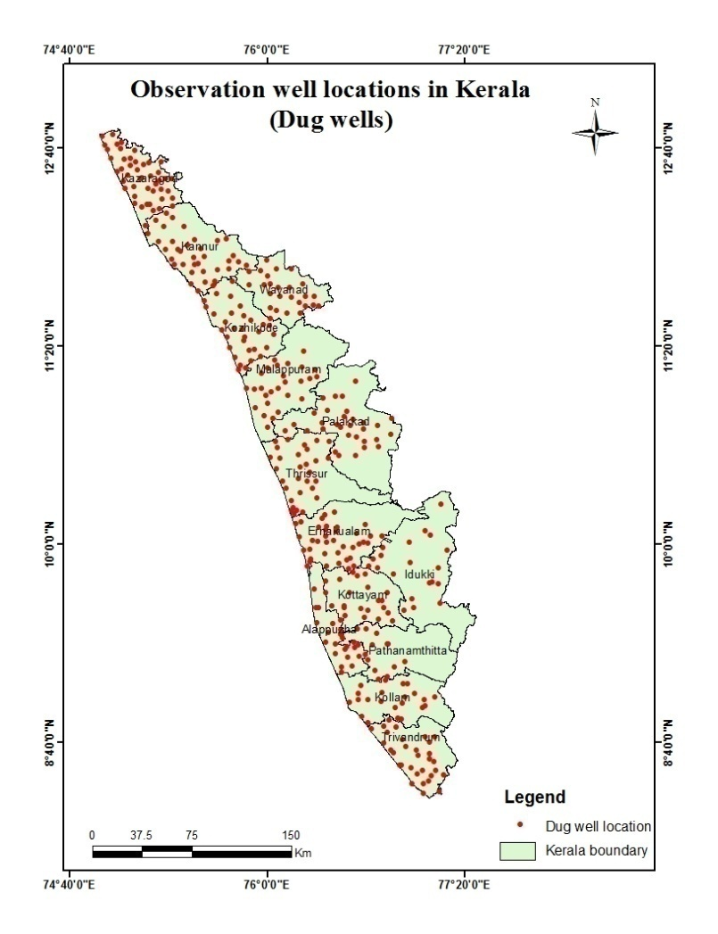
Groundwater Department is maintaining a network of observation wells throughout the state representing various hydro geological units. Observation wells includes dug wells (owned by public and private) and purpose built piezometer (bore wells and tube wells). Water level data has been collected monthly and water samples collected and analysis done periodically.
Fig: 3. Location map of observation dug wells and piezometers (bore wells & tube wells)

ANALYSIS OF GROUNDWATER LEVEL DATA – SEPTEMBER2021

During the month of September2021, groundwater level in 392 dug wells and 384 purpose built piezometers (bore wells- 343 and tube wells – 41) has been monitored. The data collected from the observation wells during the month of September 2021has been compared with previous year’s corresponding month data and also with respect to decadal mean data of the corresponding month to assess the groundwater scenario in the state.
- Depth to Groundwater level during SEPTEMBER 2021

Dug wells:-The depth to groundwater level in the observation dug wells during the month of September 2021ranges from a minimum of -0.72 m (TVM OW18Kilimanoor,TVM) to a maximum of 15.1mbgl(KNR-POW-C8, Thalipparamba, Kannur). Out of 392dug wells monitored water level in 32% of dug wells shows a depth to water level ranges from <=2 m, 34% ranges between 2-5 m, 30% ranges between 5-10 m and 4% dug wells recorded depth to water level ranges between 10-20 mbgl.Dugwells in Kollam, Pathanamthitta, Kottayam,Allapey,Ernakulam, Thrissur, Palakkad show water level below 10m . None of the wells in the state show water level above 20m. Table showing well frequency during September 2021 is appended. (Annexure-I)
Fig:4. Depth to water level in Dug wells during September2021

Bore wells (hard rock terrain):-The depth to groundwater level in the observation bore wells during the month of September2021 ranges from a minimum of -0.62m(MPM178, Wandoor, Malappuram)to a maximum of 40.53mbgl ( MPM174, Areekode, Malappuram).Out of 343bore wells monitored, water level in 14% of bore wells shows a depth to water level range from 0-2 m, 32 % ranges between 2-5 m, 34% ranges between 5-10 m, 17% of bore wells ranges between 10-20 m, and 3% ranges more than 20 m .Bore wells in Thiruvananthapuram, Kollam, Pathanamthitta,Alappuzha , Kottayam, Ernakulam, Thrissur, and Palakkaddistricts show water level below20 mbgl.Borewells in Kollam, and Allapey shows waterlevel below 10m. Table showing well frequency during September2021 is appended. (Annexure-I)

Fig:5. Depth to water level in Bore wells during September 2021
Tubewells (coastal sedimentary terrain):-The depth to groundwater level in the observation tubewells during the month of September 2021ranges from a minimum of 0.12 m in tube well no 33 Aroor, Alappuzha District to a maximum of 33.42mbgl in well no KLM/29 at Sasthamkotta, Kollam District. Out of 41tube wells monitored in the state, water level in 32 % of tube wells ranges between 0-2m, 29 % of tube wells ranges between 2-5 m, 25% ranges between 5-10 m and7%ranges between10-20 and 7% ranges more than 20m.Table showingtube well frequency is appended.(Annexure-I )

II.Comparison of Groundwater level in September2021 with respect toSeptember 2020
Comparison of the groundwater level in September2021with respect to the corresponding month in the previous year indicates that 52 % of observation dug wells (198 out of 381) show a fall in water level and 48 % of the wells (183 out of 381) show no remarkable change /marginal rise in water level.Out of 52% of the dugwells shows a falling trend, 50% ,(99 out of 198) recorded fall in water level less than 0.5m, 19% of dug wells ,(38 out of 198) show fall in the range between 0.5-1m, 13% of dug wells ,(27 out of 198) show fall in the range between 1-1.5 m, 9% of dug wells ,(17 out of 198) show a fall in the range between 1.5 -2m and 9% dug wells ,(17 out of 198) show a fall in water level more than 2m.2 wells in Kollam, 1 wellin Kottayam, 2 wells in Thrissur, 2 wells in Palakkad, 1 well in Kozhikode, 2 wells in Kannur and 7 wells in Kasaragod district show more than 2m fluctuation. Table showing water level comparison of dug wells during September2021with respect to September2020is appended. (Annexure-II).
Fig:6. Comparison of water level in Dug wells during September 2021wrtSeptember2020

Comparison of the water level in observation bore wells (hard rock terrain in midland and high land areas) in September 2021with that of the previous year, it has been noticed that46% of bore wells (156 out of 342) show fall in water level and 54% of the wells(186 out of 342)shows no remarkable change/marginal rise in water level. Out of 46 % of the bore wells showing falling trend, 46% of the bore wells (71 out of 156)recorded fall in water level less than 0.5m, 24 % (37 out of 156)show fall in the range between 0.5 - 1m, 13% of bore wells (20 out of 156)show fall in the range between 1 - 1.5m, 7% of bore wells (11 out of 156)show a fall in range between1.5-2m, 10% of bore wells(17 out of 342) show a fall inwater level more than 2m. Table showing water level comparison of bore wells during September 2021with respect toSeptember 2020 is appended. (Annexure-II)

Fig:7. Comparison of water level in Bore wells during September 2021 wrtSeptember2020

Comparison of the water level in observation tube wells (in the coastal sedimentary areas)during September2021 with that of the previous year reveals that 16 % of tube wells (7 out of 43) recorded a falling trend and 84 % of the wells (37 out of 43) show no remarkable change /marginal rise of water level.Out of 16% of the tube wells showing a falling trend, 57% of wells( 4 out of 7)recorded fall in range between 0 to 0.5m 29% , ( 2 out of 7) show fall in the range between 0.5 - 1m, 14% of bore wells( 1 out of 7) show fall in the range between 1 - 1.5m, None of the bore wells show a fall inwater level more than 1.5m..Table showing comparison of water level during September2021 with respect to September 2020is appended. (Annexure-II)

III.Comparison of Groundwater level in September2021 with respect to Decadal mean(2011- 20)

Comparison of the water level in September 2021 with respect to the decadal mean, it has been noticed that 21% of observation dug wells (80 out of 380) recorded a fall in water level and 79% of the wells(309 out of 389) shows marginal rise /no remarkable change in water level.Out of 21% of the dugwells show a falling trend, 81% of the dug wells (65 out of 80) recorded fall in water level less than 0.5m,9% (7 out of 80) show fall in the range between 0.5-1m, 8% of dug wells (6 out of 80) show fall in the range between1-1.5m, 1% of dug wells (1 out of 80) show a fall in range between 1.5-2m and 1% of dug wells (1 out of 80 ,well no KNR-MOW179, Koothuparamba, Kannur district) show a fall in range more than 2m.Table showing water level comparison of dug wells during September2021 with respect to decadal mean is appended. (Annexure-III)

Fig:7. Comparison of water level in Dug wells during September 2021wrt Decadal mean

Compared water level in the observation bore wells during September2021 with that of the decadal mean. It has been noticed that 32% of bore wells ( 108 out of 342) show fall in water level, and 68% of the wells ( 234 out of 342) shows marginal rise,no remarkable change in water level.Out of 32% of the bore wells shows a falling trend,61% (66 out of 108) shows a fall in water level less than 0.5m, 18 % (19 out of 108) show fall in the range between 0.5 - 1m, 6% (7 out of 108) show fall in the range between 1-1.5 m, 3% of wells (2 out of 108) show a fall in range between 1.5 - 2m,11% (14 out of 108) show a fall in water level more than 2 m.Table showing water level comparison of bore wells duringSeptember 2021with respect to decadal mean is appended. (Annexure-III)

Fig:8. Comparison of water level in Bore wells during September2021wrt Decadal mean

Comparison of the water level in the observation tube wells during September2021 with that of the decadal mean reveals that 17 % of tube wells (7 out of 41) recorded a falling trend and 83 % of the tube wells (34 out of41) show marginal rise/no remarkable change in water level.Out of 17 % of the tube wells shows a falling trend, 86% of the tube wells (6 out of7) show fall in water level less than 0.5m and14% of wells (1 out of7) show fall in the range0.5-1 m and none of thewell show a fall in water level more than 1 m.Table showing water level comparison of tube wells during September 2021with respect to decadal mean is appended. (Annexure-III)
Summary
Rainfall

- Actual Southwest monsoon Rain fall received in the state during 2020 (1June to 30September) is 2227.9mm which is 9% more than theNormal rainfall during the period .

- Actual Southwest monsoon Rain fall received in the state during 2021 (1June to 30September) is 1718.8 mm .Eventhough it is -16% deficient from the Normal rainfall during the period which is 2049.2mm the percentage departure comes under Normal category.

Groundwater level
- The depth to groundwater level in the observation dug wells during the month of September 2021 range from a minimum of -0.72 m (TVM OW18Kilimanoor, TVM) to a maximum of 15.1mbgl(KNR-POW-C8, Thalipparamba, Kannur), in bore wells from a minimum of -0.62m (MPM178, Wandoor, Malappuram) to a maximum of 40.53mbgl ( MPM174, Areekode, Malappuram)and in the tubewells ranges from a minimum of 0.12 m in tube well no 33 Aroor, Alappuzha District to a maximum of 33.42mbgl in well no KLM/29 at Sasthamkotta, Kollam District.
- Comparison of the water level in September2021 with respect to the previous year, reveals that 52 % of observation dug wells (198 out of 381), 46% of bore wells (156 out of342) and 16% of tube wells ( 7 out of 43) recorded a falling trend.Among all the 766 observation wells only 361 wells (47.13%) show declining trend.48.20%of the observation wells with falling trend show decline in water level less than 0.5 m.
- Comparison of groundwater level in September 2021with respect to the decadal mean reveals that 21% of observation dug wells (80 out of380), 32 % of bore wells (108 out of342) and 17% of tube wells (7 out of41) recorded a falling trend.Among all the 763 observation wells only 25.6% of wells (195 nos) show declining trend.70.26%of the observationwells (137 out of195)with falling trend show decline in water level less than 0.5 m.
- Wells showing decline of water level more than 2 m during long term analysis will be monitored closely.
- Open wells showing decline of water level more than 2m are shown in Annexure IV. Maximum Fluctuation from September 2020 water level (-5.12m) is noted inopen well at Mannarkad, Palakkad (132).Total 17 wells show more than 2m fall.More than 2m Fluctuation from Decadal mean water level (-2.515m) isnoted only in open well at Kannur, Koothuparampu (KNR-MOW179).District officers should take necessary recharge measures like artificial recharge through rainwater harvesting to recharge the wells with fall in water level more than 2m to raise the water level.

Districtwise Observation well Frequency on September 2021 Annexure I
District | Well Type | No. of WL measured | DTWL(mbgl) |  | Location |  | Depth range of wells (mts)
 |  |  | Min | Max | Min | Max | 0 to 2 | 2 to 5 | 5 to 10 | 10 to 20 | >20
Thiruvananthapuram | Dug well | 30 | -1 | 11.77 | TVM OW18,Kilimanoor,Thiruvananthapuram | TVM OW28,Kazhakkoottam,Thiruvananthapuram | 6 | 11 | 10 | 3 | 0
 | Bore well | 30 | -1 | 17.41 | 28,Vamanapuram,Thiruvananthapuram. | 25,Parassala,Thiruvananthapuram. | 4 | 5 | 14 | 7 | 0
 | Tube well | 4 | 2.87 | 7.59 | 36,Chirayinkeezhu,Thiruvananthapuram. | 37,Chirayinkeezhu,Thiruvananthapuram. | 0 | 1 | 3 | 0 | 0
Kollam | Dug well | 25 | 1 | 8.87 | OW-32,Karunagappally Municipality,KOLLAM | KLM OW 24,Munroethuruthu,KOLLAM. | 8 | 6 | 11 | 0 | 0
 | Bore well | 16 | 0 | 8.63 | KLM/6,Velinalloor,KOLLAM. | KLM/8,Kadakkal,KOLLAM. | 1 | 5 | 10 | 0 | 0
 | Tube well | 9 | 2.12 | 33.42 | KLM/17,Mayyanad,Kollam. | KLM/29,Sasthamkotta,Kollam. | 0 | 2 | 3 | 1 | 3
Pathanamthitta | Dug well | 12 | 1 | 6.74 | PTAOB34A,Patahanamthitta Municipality,PATHANAMTHITTA | PTA OW 43,Kunnanthanam,PATHANAMTHITTA | 4 | 7 | 1 | 0 | 0
 | Bore well | 23 | 0 | 16.56 | PTA/19,Erathu,PATHANAMTHITTA. | PTA/15,Chittar,PATHANAMTHITTA. | 5 | 7 | 9 | 2 | 0
Alappuzha | Dug well | 18 | 0 | 9.07 | OW-06 Pulinkunnu,Champakulam,Alappuzha | OW-02 Kattanam,Mavelikara,Alappuzha | 15 | 2 | 1 | 0 | 0
 | Bore well | 2 | 1 | 3.95 | 36 Punthala,Chengannoor,Alappuzha | 35 Pennukkara,Chengannoor,Alappuzha. | 1 | 1 | 0 | 0 | 0
 | Tube well | 27 | 0.12 | 16.76 | 33 Aroor,Pattanakkad,Alappuzha. | 04 Charumoodu,Bharanikavu,Alappuzha. | 13 | 9 | 3 | 2 | 0
Kottayam | Dug well | 20 | -1 | 8.60 | KTM-OW-11,Erattupetta,Kottayam | KTM-OW-4_,Pallom,Kottayam | 9 | 7 | 4 | 0 | 0
 | Bore well | 23 | 0.00 | 16.27 | 10,Uzhavoor,Kottayam. | 03,Kanjirappally,Kottayam | 6 | 10 | 5 | 2 | 0
Idukki | Dug well | 20 | 0.50 | 7.22 | 73,Santhanpara,IDUKKI. | IDK08,Kattappana Municipality,IDUKKI. | 8 | 8 | 4 | 0 | 0
 | Bore well | 23 | 1 | 36.03 | SO415,Udumbannoor,IDUKKI. | SO428,Peermade,IDUKKI | 2 | 9 | 6 | 4 | 2
Ernakulam | Dug well | 38 | 0 | 7.17 | E88,Chellanam,ERNAKULAM | GWE-23,Thrikkakkara Municipality,ERNAKULAM | 13 | 12 | 13 | 0 | 0
 | Bore well | 25 | 0 | 10.91 | BW 112,Muvattupuzha Municipality,Ernakulam | ,BW 100,Rayamangalam,ERNAKULAM. | 5 | 13 | 6 | 1 | 0
 | Tube well | 1 | 9.54 | 9.54 | TW 01,Kochi Corporation,ERNAKULAM |  | 0 | 0 | 1 | 0 | 0
Thrissur | Dug well | 31 | 0 | 9.11 | TSROW30,Kodungallur,Thrissur | TSROW12,Chowwannur,Thrissur | 12 | 8 | 11 | 0 | 0
 | Bore well | 37 | -1.00 | 18.67 | TSR124,Puzhakkal,Thrissur. | TSR136,Kandanassery,Thrissur | 5 | 12 | 13 | 7 | 0
Malappuram | Dug well | 26 | 1 | 11.64 | MPM OW 5A,Tirurangadi,Malappuram | MPM.OW24,Kuttippuram,Malappuram | 7 | 8 | 9 | 2 | 0
 | Bore well | 30 | -1.00 | 40.53 | MPM178,Wandoor,Malappuram. | MPM174,Areekode,Malappuram. | 6 | 11 | 7 | 2 | 4
Palakkad | Dug well | 31 | 0 | 8.14 | PKD S-7,Chittur,Palakkad | PKD S-10,Sreekrishnapuram,Palakkad | 9 | 12 | 10 | 0 | 0
 | Bore well | 33 | 1.00 | 18.81 | 149,Kollengode,Palakkad. | 157,Ottappalam,Palakkad. | 3 | 11 | 14 | 5 | 0
Kozhikkode | Dug well | 33 | 0 | 10.27 | QKKDO54,Chelannur,Kozhikode | QKKDO63,Kozhikode(corporation),Kozhikode | 9 | 16 | 7 | 1 | 0
 | Bore well | 34 | 0.00 | 29.24 | KKDPZ 197,Kozhikode,Kozhikode. | KKDPZ 202,Perambra,Kozhikkode | 5 | 12 | 7 | 7 | 3
Wayanad | Dug well | 26 | 0 | 11.05 | SOW-1,Mananthavady Municipality,WAYANAD | SOW-4,Nenmeni,WAYANAD | 8 | 8 | 9 | 1 | 0
 | Bore well | 19 | 1.00 | 20.82 | WYD216,Muttil,WAYANAD. | WYD223,Thirunelly,Wayanad | 1 | 4 | 6 | 7 | 1
Kannur | Dug well | 36 | 0 | 15.10 | KNR-POW-C23,Koothuparamba,Kannur | KNR-POW-C8,Taliparamba,Kannur. | 10 | 12 | 13 | 1 | 0
 | Bore well | 27 | 1.00 | 22.41 | KNRPz239,Taliparamba,Kannur | KNR-Pz228,Irikkur,Kannur. | 1 | 4 | 6 | 7 | 1
Kasaragod | Dug well | 46 | 0 | 15.01 | KSOW-10,Karadka,Kasaragod. | 200,Karadka,Kasaragod. | 7 | 16 | 16 | 7 | 0
 | Bore well | 21 | 0.00 | 21.61 | PZKGD241,Parappa,Kasaragod. | PZKGD242,Karadka,Kasaragod | 2 | 4 | 5 | 9 | 1

Comparison of Water level September 2021 with respect to September 2020 - Annexure II
District | Well Type | No. of WL Measured | Water level | Total | 0 - 0.5 m | 0.5 - 1 m | 1-1.5m | 1.5 - 2 m | >2 m
 |  |  |  |  | No. | No. | No. | No. | No.
Thiruvananthapuram | Dug well | 30 | Rise | 13 | 9 | 3 | 0 | 1 | 0
 |  |  | Fall | 17 | 7 | 5 | 2 | 3 | 0
 | Bore well | 29 | Rise | 12 | 7 | 2 | 0 | 2 | 1
 |  |  | Fall | 17 | 9 | 5 | 0 | 2 | 1
 | Tube well | 4 | Rise | 2 | 2 | 0 | 0 | 0 | 0
 |  |  | Fall | 2 | 1 | 0 | 1 | 0 | 0
Kollam | Dug well | 25 | Rise | 4 | 4 | 0 | 0 | 0 | 0
 |  |  | Fall | 21 | 7 | 3 | 5 | 4 | 2
 | Bore well | 16 | Rise | 4 | 3 | 0 | 1 | 0 | 0
 |  |  | Fall | 12 | 5 | 3 | 3 | 1 | 0
 | Tube well | 9 | Rise | 4 | 3 | 1 | 0 | 0 | 0
 |  |  | Fall | 5 | 3 | 2 | 0 | 0 | 0
Pathanamthitta | Dug well | 10 | Rise | 4 | 1 | 1 | 2 | 0 | 0
 |  |  | Fall | 6 | 2 | 1 | 2 | 1 | 0
 | Bore well | 23 | Rise | 11 | 3 | 2 | 1 | 2 | 3
 |  |  | Fall | 12 | 6 | 1 | 3 | 1 | 1
Alappuzha | Dug well | 18 | Rise | 18 | 18 | 0 | 0 | 0 | 0
 |  |  | Fall | 0 | 0 | 0 | 0 | 0 | 0
 | Bore well | 2 | Rise | 0 | 0 | 0 | 0 | 0 | 0
 |  |  | Fall | 2 | 0 | 2 | 0 | 0 | 0
 | Tube well | 29 | Rise | 29 | 29 | 0 | 0 | 0 | 0
 |  |  | Fall | 0 | 0 | 0 | 0 | 0 | 0
Kottayam | Dug well | 12 | Rise | 6 | 6 | 0 | 0 | 0 | 0
 |  |  | Fall | 6 | 4 | 1 | 0 | 0 | 1
 | Bore well | 24 | Rise | 12 | 7 | 3 | 0 | 0 | 2
 |  |  | Fall | 12 | 5 | 1 | 4 | 1 | 1
Idukki | Dug well | 20 | Rise | 19 | 1 | 11 | 4 | 1 | 2
 |  |  | Fall | 1 | 1 | 0 | 0 | 0 | 0
 | Bore well | 23 | Rise | 17 | 5 | 7 | 1 | 2 | 2
 |  |  | Fall | 6 | 2 | 2 | 0 | 0 | 2
Ernakulam | Dug well | 38 | Rise | 12 | 7 | 4 | 0 | 1 | 0
 |  |  | Fall | 26 | 17 | 5 | 4 | 0 | 0
 | Bore well | 23 | Rise | 14 | 10 | 4 | 0 | 0 | 0
 |  |  | Fall | 9 | 7 | 2 | 0 | 0 | 0
 | Tube well | 1 | Rise | 1 | 1 | 0 | 0 | 0 | 0
 |  |  | Fall | 0 | 0 | 0 | 0 | 0 | 0
Thrissur | Dug well | 31 | Rise | 20 | 12 | 3 | 3 | 1 | 1
 |  |  | Fall | 11 | 7 | 1 | 1 | 0 | 2
 | Bore well | 37 | Rise | 29 | 8 | 11 | 4 | 3 | 3
 |  |  | Fall | 8 | 3 | 3 | 1 | 0 | 1
Malappuram | Dug well | 26 | Rise | 22 | 10 | 8 | 3 | 1 | 0
 |  |  | Fall | 4 | 1 | 3 | 0 | 0 | 0
 | Bore well | 30 | Rise | 19 | 6 | 7 | 4 | 1 | 1
 |  |  | Fall | 11 | 7 | 1 | 1 | 0 | 2
Palakkad | Dug well | 31 | Rise | 17 | 10 | 5 | 1 | 1 | 0
 |  |  | Fall | 14 | 9 | 2 | 1 | 0 | 2
 | Bore well | 33 | Rise | 27 | 12 | 9 | 2 | 1 | 3
 |  |  | Fall | 6 | 5 | 0 | 0 | 1 | 0
Kozhikkode | Dug well | 33 | Rise | 3 | 3 | 0 | 0 | 0 | 0
 |  |  | Fall | 30 | 17 | 7 | 4 | 1 | 1
 | Bore well | 34 | Rise | 6 | 2 | 2 | 1 | 0 | 1
 |  |  | Fall | 28 | 11 | 7 | 4 | 1 | 5
Wayanad | Dug well | 26 | Rise | 19 | 13 | 3 | 1 | 2 | 0
 |  |  | Fall | 7 | 6 | 0 | 0 | 1 | 0
 | Bore well | 19 | Rise | 11 | 8 | 0 | 3 | 0 | 0
 |  |  | Fall | 8 | 4 | 4 | 0 | 0 | 0
Kannur | Dug well | 36 | Rise | 15 | 9 | 1 | 4 | 1 | 0
 |  |  | Fall | 21 | 9 | 4 | 2 | 4 | 2
 | Bore well | 28 | Rise | 15 | 4 | 1 | 3 | 1 | 6
 |  |  | Fall | 13 | 5 | 2 | 4 | 2 | 0
Kasaragod | Dug well | 45 | Rise | 11 | 8 | 1 | 0 | 0 | 2
 |  |  | Fall | 34 | 12 | 6 | 6 | 3 | 7
 | Bore well | 21 | Rise | 9 | 6 | 2 | 1 | 0 | 0
 |  |  | Fall | 12 | 2 | 4 | 0 | 2 | 4

Comparison of Water level September 2021 with respect to 10 yrs mean Annexure III
District | Well Type | No. of WL Measured | Water level | Total | 0 - 0.5 m | 0.5 - 1 m | 1 - 1.5 m | 1.5 - 2 m | <2 m
 |  |  |  |  | No. | No. | No. | No. | No.
Thiruvananthapuram | Dug well | 30 | Rise | 27 | 8 | 9 | 4 | 1 | 5
 |  |  | Fall | 3 | 1 | 0 | 2 | 0 | 0
 | Bore well | 29 | Rise | 24 | 11 | 7 | 1 | 2 | 3
 |  |  | Fall | 5 | 4 | 1 | 0 | 0 | 0
 | Tube well | 4 | Rise | 3 | 2 | 1 | 0 | 0 | 0
 |  |  | Fall | 1 | 1 | 0 | 0 | 0 | 0
Kollam | Dug well | 25 | Rise | 20 | 14 | 5 | 1 | 0 | 0
 |  |  | Fall | 5 | 3 | 0 | 2 | 0 | 0
 | Bore well | 16 | Rise | 6 | 5 | 1 | 0 | 0 | 0
 |  |  | Fall | 10 | 10 | 0 | 0 | 0 | 0
 | Tube well | 9 | Rise | 6 | 3 | 1 | 0 | 0 | 2
 |  |  | Fall | 3 | 3 | 0 | 0 | 0 | 0
Pathanamthitta | Dug well | 10 | Rise | 9 | 5 | 4 | 0 | 0 | 0
 |  |  | Fall | 1 | 1 | 0 | 0 | 0 | 0
 | Bore well | 23 | Rise | 21 | 12 | 2 | 4 | 1 | 2
 |  |  | Fall | 2 | 1 | 0 | 0 | 0 | 1
Alappuzha | Dug well | 17 | Rise | 14 | 6 | 4 | 1 | 2 | 1
 |  |  | Fall | 3 | 3 | 0 | 0 | 0 | 0
 | Bore well | 2 | Rise | 1 | 0 | 0 | 0 | 1 | 0
 |  |  | Fall | 1 | 0 | 0 | 0 | 0 | 1
 | Tube well | 27 | Rise | 24 | 15 | 5 | 3 | 0 | 1
 |  |  | Fall | 3 | 2 | 1 | 0 | 0 | 0
Kottayam | Dug well | 21 | Rise | 15 | 3 | 6 | 4 | 2 | 0
 |  |  | Fall | 6 | 4 | 1 | 0 | 1 | 0
 | Bore well | 24 | Rise | 19 | 8 | 4 | 4 | 2 | 1
 |  |  | Fall | 5 | 2 | 3 | 0 | 0 | 0
Idukki | Dug well | 20 | Rise | 18 | 12 | 5 | 1 | 0 | 0
 |  |  | Fall | 2 | 2 | 0 | 0 | 0 | 0
 | Bore well | 23 | Rise | 13 | 3 | 5 | 1 | 2 | 2
 |  |  | Fall | 10 | 6 | 2 | 0 | 0 | 2
Ernakulam | Dug well | 38 | Rise | 23 | 18 | 3 | 2 | 0 | 0
 |  |  | Fall | 15 | 14 | 1 | 0 | 0 | 0
 | Bore well | 23 | Rise | 18 | 14 | 2 | 2 | 0 | 0
 |  |  | Fall | 5 | 4 | 0 | 1 | 0 | 0
 | Tube well | 1 | Rise | 1 | 1 | 0 | 0 | 0 | 0
 |  |  | Fall | 0 | 0 | 0 | 0 | 0 | 0
Thrissur | Dug well | 31 | Rise | 18 | 12 | 4 | 1 | 1 | 0
 |  |  | Fall | 13 | 11 | 2 | 0 | 0 | 0
 | Bore well | 37 | Rise | 18 | 7 | 7 | 1 | 2 | 1
 |  |  | Fall | 19 | 13 | 4 | 1 | 0 | 1
Malappuram | Dug well | 26 | Rise | 21 | 12 | 9 | 0 | 0 | 0
 |  |  | Fall | 5 | 5 | 0 | 0 | 0 | 0
 | Bore well | 30 | Rise | 18 | 8 | 6 | 3 | 0 | 1
 |  |  | Fall | 12 | 5 | 3 | 0 | 1 | 3
Palakkad | Dug well | 31 | Rise | 19 | 10 | 6 | 1 | 1 | 1
 |  |  | Fall | 12 | 9 | 2 | 1 | 0 | 0
 | Bore well | 33 | Rise | 24 | 9 | 7 | 4 | 0 | 4
 |  |  | Fall | 9 | 2 | 3 | 1 | 1 | 2
Kozhikkode | Dug well | 33 | Rise | 30 | 17 | 9 | 3 | 1 | 0
 |  |  | Fall | 3 | 3 | 0 | 0 | 0 | 0
 | Bore well | 34 | Rise | 22 | 12 | 3 | 4 | 1 | 2
 |  |  | Fall | 12 | 5 | 3 | 0 | 1 | 3
Wayanad | Dug well | 26 | Rise | 24 | 17 | 6 | 1 | 0 | 0
 |  |  | Fall | 2 | 1 | 0 | 1 | 0 | 0
 | Bore well | 19 | Rise | 10 | 7 | 1 | 0 | 2 | 0
 |  |  | Fall | 9 | 6 | 1 | 2 | 0 | 0
Kannur | Dug well | 36 | Rise | 28 | 14 | 5 | 6 | 3 | 0
 |  |  | Fall | 8 | 6 | 1 | 0 | 0 | 1
 | Bore well | 28 | Rise | 21 | 8 | 2 | 5 | 3 | 3
 |  |  | Fall | 7 | 6 | 0 | 1 | 0 | 0
Kasaragod | Dug well | 45 | Rise | 43 | 9 | 12 | 7 | 7 | 8
 |  |  | Fall | 2 | 2 | 0 | 0 | 0 | 0
 | Bore well | 21 | Rise | 19 | 3 | 7 | 3 | 3 | 3
 |  |  | Fall | 2 | 1 | 0 | 0 | 0 | 1

Water Level Data & Fluctuation
SNo | District | Block | GP/Municipality/Corporation | WellNo | Well_Type | Latitude(°) | Longitude(°) | Sep-2021 | Sep-2020 | Sep-2019 | Decadal Avg(2011-2020) |  | Fluctuation in Sep-2021 wrt.
 |  |  |  |  |  |  |  |  |  |  | WL | Yrs | Sep-2020 | Sep-2019 | Decadal Avg
1 | KOLLAM | Anchal | Edamulakkal | OW-24 | Dug Well | 8.89902 | 76.86164 | 3.660 | 0.990 | 3.350 | 3.589 | 10 | -2.670 | -0.310 | -0.071
2 | KOLLAM | Pathanapuram | Pattazhi | KLM OW 20 | Dug Well | 9.07711 | 76.79648 | 6.800 | 3.840 | 3.910 | 5.341 | 10 | -2.960 | -2.890 | -1.459
3 | Kottayam | Meenachil | Uzhavoor | KTM-OW-22 | Dug Well | 9.79861 | 76.66194 | 6.240 | 4.020 | 4.650 | 4.544 | 10 | -2.220 | -1.590 | -1.696
4 | Thrissur | Kodakara | Varandarappilly | TSROW20 | Dug Well | 10.42347 | 76.33169 | 5.120 | 1.980 | 5.980 | 4.945 | 10 | -3.140 | 0.860 | -0.175
5 | THRISSUR | Mala | Poyya | TSROW21 | Dug Well | 10.21547 | 76.23869 | 8.040 | 5.100 | 6.730 | 7.746 | 10 | -2.940 | -1.310 | -0.293
6 | Palakkad | Mannarkad | Mannarkad | 132 | Dug Well | 10.89306 | 76.53917 | 5.310 | 0.190 | 2.450 | 4.698 | 9 | -5.120 | -2.860 | -0.612
7 | Palakkad | Ottappalam | Thrithala | 114 | Dug Well | 10.76056 | 76.12195 | 6.820 | 4.350 | 2.230 | 6.705 | 10 | -2.470 | -4.590 | -0.115
8 | Kozhikode | Badagaru | Thodannur | QKKDO60 | Dug Well | 11.54444 | 75.64250 | 9.050 | 6.250 | 6.840 | 9.738 | 10 | -2.800 | -2.210 | 0.687
9 | Kannur | Taliparamba | Payyannur | KNR-MOW187 | Dug Well | 12.13583 | 75.30139 | 8.750 | 5.440 | 6.620 | 8.749 | 10 | -3.310 | -2.130 | -0.001
10 | Kannur | Thalassery | Koothuparamba | KNR-MOW179 | Dug Well | 11.82889 | 75.56639 | 9.800 | 4.940 | 2.650 | 7.285 | 10 | -4.860 | -7.150 | -2.515
11 | Kasaragod | Kasaragod | Kasaragod | 212 | Dug Well | 12.54444 | 75.07500 | 2.380 | 0.190 | -0.070 | 4.718 | 10 | -2.190 | -2.450 | 2.338
12 | Kasaragod | Kasaragod | Kasaragod | KSOW-25 | Dug Well | 12.52250 | 75.01334 | 7.140 | 4.330 | 5.330 | 8.843 | 10 | -2.810 | -1.810 | 1.704
13 | Kasaragod | Manjeshwaram | Manjeshwar | 205 | Dug Well | 12.67917 | 74.90556 | 6.840 | 3.390 | 3.750 | 7.401 | 10 | -3.450 | -3.090 | 0.560
14 | Kasaragod | Manjeshwaram | Manjeshwar | 208 | Dug Well | 12.75139 | 74.93333 | 2.810 | 0.030 | 1.170 | 4.717 | 10 | -2.780 | -1.640 | 1.907
15 | Kasaragod | Manjeshwaram | Manjeshwar | 209 | Dug Well | 12.73333 | 74.88333 | 4.250 | 1.970 | 2.710 | 4.254 | 10 | -2.280 | -1.540 | 0.004
16 | Kasaragod | Manjeshwaram | Manjeshwar | 210 | Dug Well | 12.69861 | 75.01389 | 5.580 | 3.520 | 3.280 | 6.099 | 10 | -2.060 | -2.300 | 0.519
17 | Kasaragod | Vellarikkundu | Parappa | 218 | Dug Well | 12.28333 | 75.20277 | 6.490 | 3.960 | 7.320 | 8.010 | 10 | -2.530 | 0.830 | 1.520

Observation well frequency on August 2021 Abstract I
Well Type | No of WL measured | DTWL (mbgl) |  | Location |  | Depth range of wells (m)
 |  | min | max | min | max | 0 to 2 | 2 to 5 | 5 to 10 | 10 to 20 | >20
Dug well | 392 | -1 | 15.1 | TVM OW18,Kilimanoor,Thiruvananthapuram | KNR-POW-C8,Taliparamba,Kannur. | 125 | 133 | 119 | 15 | 0
 |  |  |  |  |  | 32% | 34% | 30% | 4% | 0%
Bore well | 343 | -1 | 40.53 | MPM178,Wandoor,Malappuram | MPM174,Areekode,Malappuram. | 48 | 111 | 113 | 59 | 12
 |  |  |  |  |  | 14% | 32% | 33% | 17% | 3%
Tube well | 41 | 0.12 | 33.42 | 33 Aroor,Pattanakkad,Alappuzha | KLM/29,Sasthamkotta,Kollam. | 13 | 12 | 10 | 3 | 3
 |  |  |  |  |  | 32% | 29% | 24% | 7% | 7%

Comparison of Water level August 2021 with respect to August 2020 Abstract II
Well type | No. of WL Measured |  | Water level |  | Total | 0 - 0.5 m |  |  | 0.5 - 1 m |  | 1 - 1.5 m |  | 1.5 - 2 m |  | >2 m
Dug well | 381 |  | Rise |  | 183 | 111 |  |  | 40 |  | 18 |  | 9 |  | 5
 |  |  | % |  | 48% | 61% |  |  | 22% |  | 10% |  | 5% |  | 3%
 |  |  | Fall |  | 198 | 99 |  |  | 38 |  | 27 |  | 17 |  | 17
 |  |  | % |  | 52% | 50% |  |  | 19% |  | 14% |  | 9% |  | 9%
Bore well | 342 |  | Rise |  | 186 | 81 |  |  | 50 |  | 21 |  | 12 |  | 22
 |  |  | % |  | 54% | 44% |  |  | 27% |  | 11% |  | 6% |  | 12%
 |  |  | Fall |  | 156 | 71 |  |  | 37 |  | 20 |  | 11 |  | 17
 |  |  | % |  | 46% | 46% |  |  | 24% |  | 13% |  | 7% |  | 11%
Tube well | 43 |  | Rise |  | 36 | 35 |  |  | 1 |  | 0 |  | 0 |  | 0
 |  |  | % |  | 84% | 97% |  |  | 3% |  | 0% |  | 0% |  | 0%
 |  |  | Fall |  | 7 | 4 |  |  | 2 |  | 1 |  | 0 |  | 0
 |  |  | % |  | 16% | 57% |  |  | 29% |  | 14% |  | 0% |  | 0%
Comparison of Water level August 2021 with respect to 10 yrs mean Abstract III
Well type |  | No. of WL Measured |  | Water level |  |  | Total | 0 - 0.5 m |  | 0.5 - 1 m |  | 1 - 1.5 m |  | 1.5 - 2 m |  |  | >2 m
Dug well |  | 389 |  | Rise |  |  | 309 | 157 |  | 87 |  | 32 |  | 18 |  |  | 15
 |  |  |  | % |  |  | 79% | 51% |  | 28% |  | 10% |  | 6% |  |  | 5%
 |  |  |  | Fall |  |  | 80 | 65 |  | 7 |  | 6 |  | 1 |  |  | 1
 |  |  |  | % |  |  | 21% | 81% |  | 9% |  | 8% |  | 1% |  |  | 1%
Bore well |  | 342 |  | Rise |  |  | 234 | 107 |  | 54 |  | 32 |  | 19 |  |  | 22
 |  |  |  | % |  |  | 68% | 46% |  | 23% |  | 14% |  | 8% |  |  | 9%
 |  |  |  | Fall |  |  | 108 | 66 |  | 19 |  | 7 |  | 2 |  |  | 14
 |  |  |  | % |  |  | 32% | 61% |  | 18% |  | 6% |  | 2% |  |  | 13%
Tube well |  | 41 |  | Rise |  |  | 34 | 21 |  | 7 |  | 3 |  | 0 |  |  | 3
 |  |  |  | % |  |  | 83% | 62% |  | 21% |  | 9% |  | 0% |  |  | 9%
 |  |  |  | Fall |  |  | 7 | 6 |  | 1 |  | 0 |  | 0 |  |  | 0
 |  |  |  | % |  |  | 17% | 86% |  | 14% |  | 0% |  | 0% |  |  | 0%

