GOVERNMENT OF KERALA
GROUNDWATER DEPARTMENT

GROUNDWATER LEVEL MONITORING REPORT – OCTOBER 2021

Wateris a replenishable natural resource which is essential for the existence of all living beings. In the past, the demand of water is mostly limited to domestic and in the agricultural sector. Due to the developments in agricultural and industrial sector the demand of water is increasing many folds since last few decades. Surface water resource alone couldn’t meet the increasing demand and hence persuaded to depend on groundwater resource during the past few decades made stress on groundwater regime. In order to sustain the groundwater resources, proper groundwater management practices are needed.
Rainfallis the primary source for groundwater recharge and has a vital role in the sustainability of groundwater resource in the state. Groundwater level fluctuation results from the seasonal availability of rainfall. Kerala state experiences four distinct seasons namely winter (January-February), Pre-monsoon (March-May), Monsoon (South-West) June to September and Post-monsoon (North-East) from October to December. Average annual precipitation in the state is nearly 3000 mm. The rainfall in the State is controlled primarily by the South-West and North-East monsoons. About 90% of the rainfall occurs during six monsoon months (South-West monsoon contributes major portion of rainfall (65-70%) and about 16% from the North-East) and remaining from summer showers.
Actual Southwest monsoon Rain fall received in the state during 2021(1June to 30September) is 1718.8 mm .Even though it is -16% deficient from the Normal rainfall during the period which is 2049.2mm the percentage departure comes under Normal category. All the districts received less Actual rain than the normal rain fall exceptPathanamthitta District which received 4% more rain than the Normal rain and Kottayam District which received 16% more rain than the normal rain fall during the period. Percentage departure of rain in Kannur, Malappuram, Palakkad, Thrissur, and Wayanad fall in Deficient category and all other districts comes in Normal category.
Actual Southwest monsoon Rain fall received in the state during 2020 (1June to 30September) is 2227.9 mm .It is 9% more than the normal Rain fall during the period which is2049.2mm. Kannur, Kasaragod, Kottayam, Kozhikode and Thiruvananthapuram districts received excess rain fall. Even though percentage departure of all other districts comes under Normal class ,Idukki, Malappuram, Thrissur and Wayanad districts received lesser rain than the normal rainfall during the season.
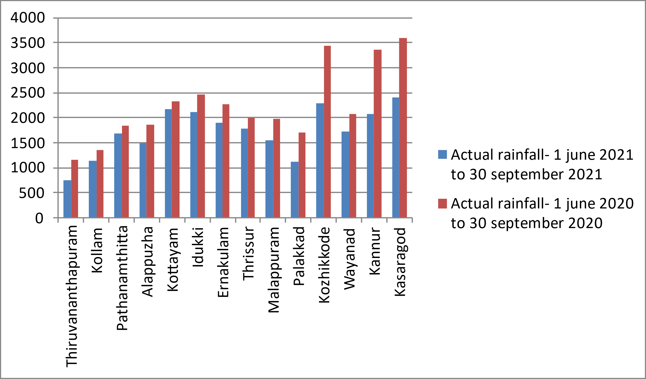
Fig:1. Comparison of actual rainfalloccurred during southwest monsoon 2021wrt 2020

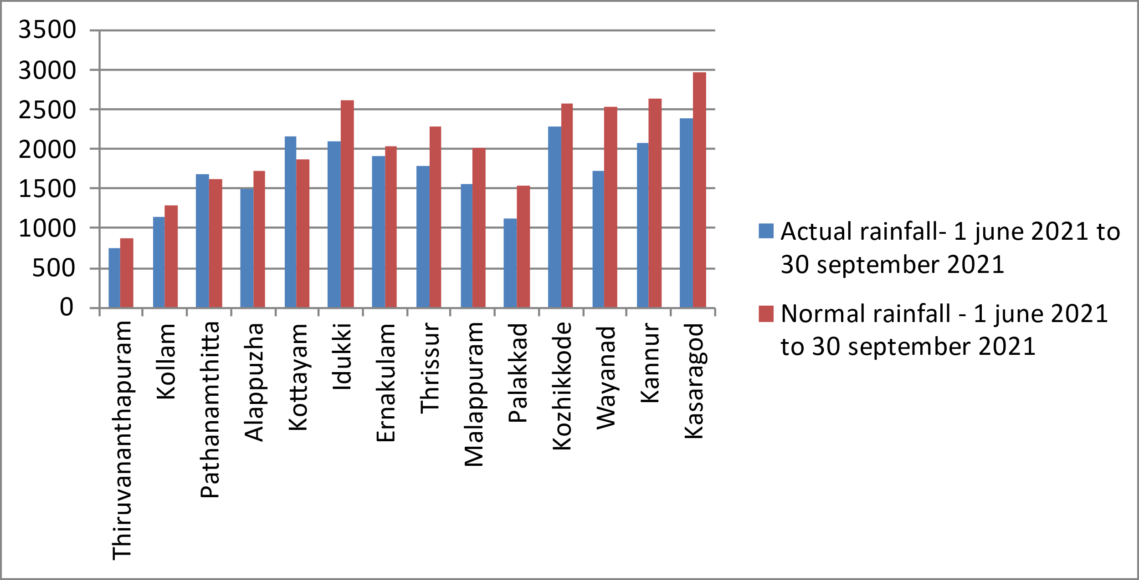

Fig:2. Comparison of actual rainfall occurred duringsouthwest monsoon2021wrtNormal Rainfall

Geology: Kerala, the southernmost state of Indian peninsula, is having a geographical area of 38863 km². The land area extends between latitude 8ᵒ17’30” and 12ᵒ27’40” and longitude 74ᵒ51’57” and 77ᵒ24’47”. Physiographically, Kerala state is sandwiched between Western Ghats on the east and Arabian Sea on the west. Being the part of the southern Indian peninsula, the peninsular geological formations exist in the state. The major geological formations in the state comprises crystalline rocks of Archaean Age, sedimentary rock formations of tertiary age and sub recent to recent rock formations of quaternary age.
Occurrence of Groundwater resource: Groundwater occurs under phreatic, semi-confined and confined conditions, Groundwater in unconfined aquifer is mainly utilized through tube wells in sedimentary terrain and through bore wells in hard rock areas.
Groundwater monitoring network:Short term and long term changes in the climatic conditions influence the groundwater scenario of an area. Groundwater level data are the principal information required for assessing the groundwater status and groundwater resource estimation.
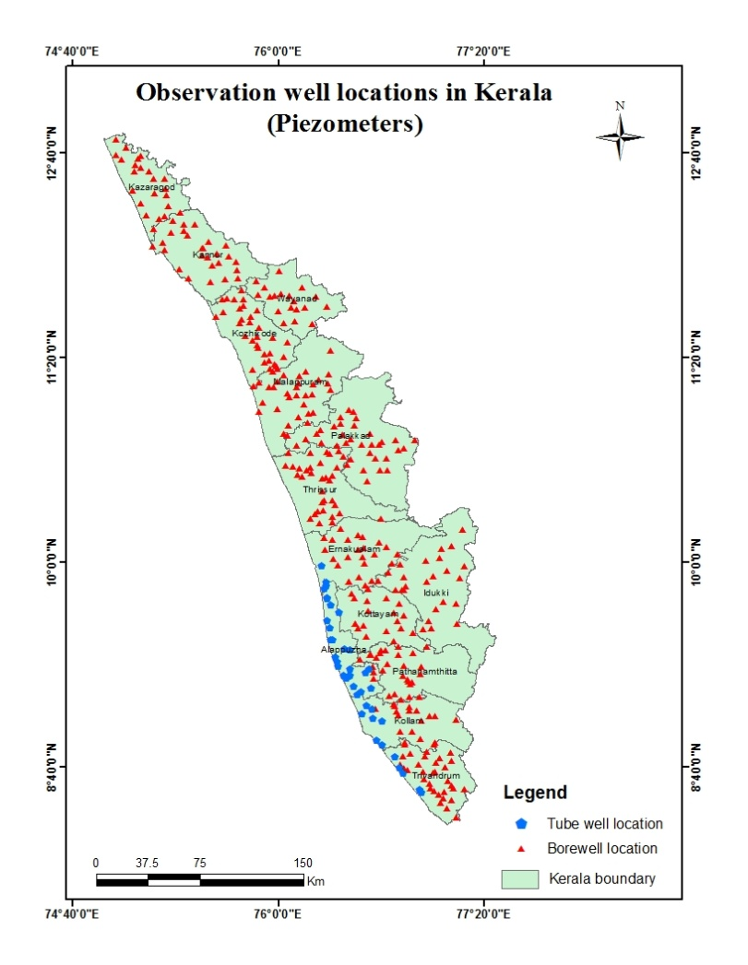
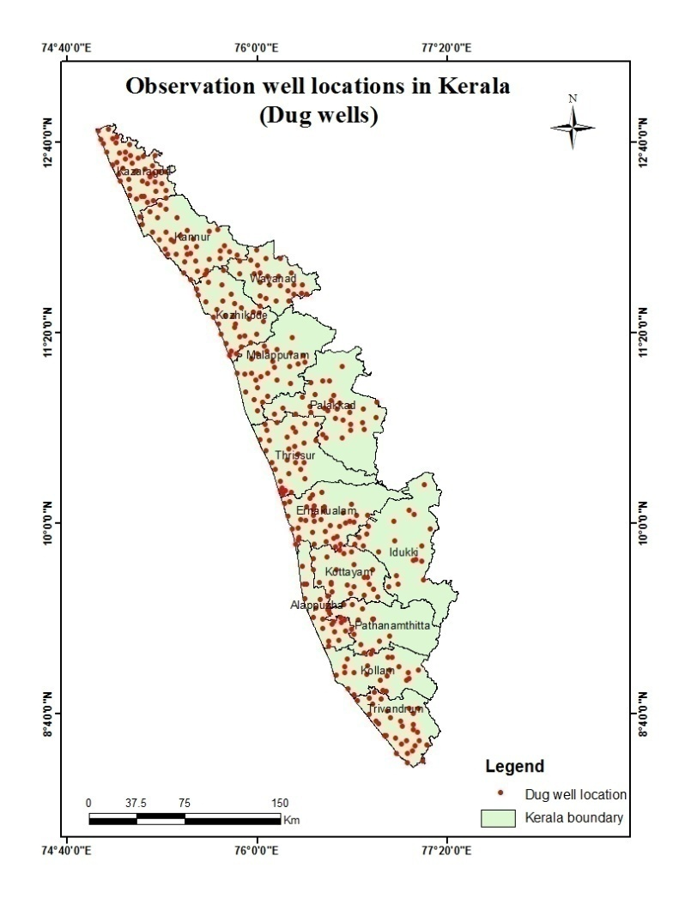
Groundwater Department is maintaining a network of observation wells throughout the state representing various hydrogeological units. Observation wells includes dug wells (owned by public and private) and purpose built piezometers (bore wells and tube wells). Water level data has been collected monthly and water samples collected and analysis done periodically.
Fig:3. Location map of observation dug wells and piezometers (bore wells & tube wells)
Analysis of Groundwater level data – October 2021
During the month of October 2021, groundwater level in 393 dug wells and 381purpose built piezometers (bore wells- 347 and tube wells – 34) has been monitored. The data collected from the observation wells during the month of October 2021has been compared with previous year’s corresponding month data and also with respect to decadal mean data of the corresponding month to assess the groundwater scenario in the state.
I.Depth to Groundwater level during October 2021
Dug wells:-The depth to groundwater level in the observation dug wells during the month of October 2021 ranges from a minimum of -0.92 m (KTM-OW-11, Erattupetta, Kottayam) to a maximum of 15.5 mbgl( KNR-POW-C8, Thalipparamba, Kannur). Out of 393dug wells monitored water level in 30% of dug wells shows a depth to water level ranges from 0-2 m, 36% ranges between 2-5 m, 30% ranges between 5-10 m and 4% dug wells recorded depth to water level ranges between 10-20 mbgl. Dug wells in Kollam,Pathanamthitta, Alappuzha, Kottayam, Idukki, Ernakulam,Thrissur and Palakkad show water level below 10 mtrs.None of the wells in the state show water level above 20m. Table showing well frequency during October 2021 is appended. (Annexure-I)

Fig:4. Depth to water level in Dug wells during October2021

Borewells (hardrock terrain):-The depth to groundwater level in the observation bore wells during the month of Octoer2021 ranges from a minimum of -1.0m (06, Nemaom, Thiruvananthapuram) to a maximum of 41.1mbgl (MPM174, Areekode, Malappuram).Out of 347borewells monitored, water level in 16% of bore wells shows a depth to water level range from 0-2 m, 30 % ranges between 2-5 m, 34% ranges between 5-10 m, 17% of borewells ranges between 10-20 m, and 3% ranges more than 20 m . Borewells in Thiruvananthapuram, Kollam, Pathanamthitta,Alappuzha , Kottayam Ernakulam, Thrissur and Palakkad districts show water level below20 mbgl. Table showing well frequency during October2021 is appended. (Annexure-I)

Fig:5. Depth to water level in Bore wells during October 2021
Tubewells (coastal sedimentary terrain):-The depth to groundwater level in the observation tubewells during the month of October 2021 ranges from a minimum of 0.24 min tubewell no 08 Thrikkunnappuzha, Alappuzha to a maximum of 33.22mbgl in tube well no KLM/29,Sasthamkotta, Kollam. Out of 34 tube wells monitored in the state, water level in 32 % of tube wells ranges between 0-2m, 24 % of tube wells ranges between 2-5 m,29% ranges between 5-10 m and6% ranges between10-20 and 9% ranges more than 20m.Tube wells in Thiruvananthapuram and Ernakulam districts show water level below 10mand tube wells in Alappuzha district show water level below 20m.Table showingtube well frequency is appended.(Annexure-I )
II.Comparison of Groundwater level in October2021 with respect toOctober 2020
Comparison of the groundwater level in October 2021with respect to the corresponding month in the previous year, indicates that 29% of observation dug wells(114 out of 388)show a fall in water level and 71 % of the wells (274 out of 388)shows no remarkable change /marginal rise in water level.Out of 29% of the dugwells shows a falling trend, 63% , (72 out of114) recorded fall in water level less than 0.5m, 16% of dug wells (18 out of114 )show fall in the range between 0.5-1m,9% of dug wells(10 out of114 ) show fall in the range between 1-1.5 m, 4% of dug wells (5 out of114 )show a fall in the range between 1.5 -2m and 8% dug wells (9 out of114 ) show a fall in water level more than 2m.Among the wells showing falling trend , 1well in Thiruvananthapuram district and 8 in Kasargod district show fall above 2m. Wells with falling trend in Kollam, Alappuzha, Thrissur, Palakkad, Malappuram, Kozhikkode and Kannur district show fall below 1m. All the wells in Pathanamthitta District show rise only. Table showing water level comparison of dug wells during October 2021with respect to October2020is appended. (Annexure-II).
Fig:6. Comparison of water level in Dug wells during October 2021wrtOctober2020

Comparison of the water level in observation bore wells (hard rock terrain in midland and high land areas) in October2021with that of the previous year, it has been noticed that36% of bore wells (123 out of 342) show fall in water level and 64% of the wells (219 out of 342) shows no remarkable change/marginal rise in water level.Out of 36 % of the borewells shows a falling trend, 55% of the bore wells (68 out of 123) recorded fall in water level less than 0.5m, 22% (27 out of123) show fall in the range between 0.5 - 1m, 5% of bore wells (6 out of 123) show fall in the range between 1 - 1.5m, 3% of bore wells (4 out of 123) show a fall in range between, 1.5-2m, 15% of bore wells (18 out of 123)show a fall inwater level more than 2m. All the 2 bore wells in Alappuzha district show rising trend only. Table showing water level comparison of bore wells during October 2021with respect to October 2020 is appended. (Annexure-II)
Fig:7. Comparison of water level in Bore wells duringOctober 2021 wrtOctober2020

Comparison of the water level in observation tube wells (in the coastal sedimentary areas)during October2021 with that of the previous year reveals that 39 % of tube wells (13 out of 33) recorded a falling trend and 61 % of the wells (20 out of 33) shows no remarkable change /marginal rise of water level.Out of 39% of the tube wells showing a falling trend,69% of wells (9 out of 13)recorded fall in range between 0 to 0.5m and 23% ofwells (3 out of 13) show a fall in range between 0.5 to1m and 8% of wells (1 out of13) recorded fall in range between 1 to 1.5m. No wells show fall above 1.5m.All the 4 tube wells in Thiruvananthapuram district show fall only. All the tube wells showing falling trend in Kollam , Alappuzha, and Ernakulam district show fall in the range 0- 1m. Table showing comparison of water level during October 2021 with respect to October2020is appended. (Annexure-II)

III.Comparison of Groundwater level in October2021 with respect to Decadal mean(2011- 20)
Comparison of the water level in October 2021 with respect to the decadal mean, it has been noticed that 13% of observation dug wells (52 out of 390) recorded a fall in water level and 87% of the wells (338 out of 390) shows marginal rise /no remarkable change in water level.Out of 13% of the dugwells show a falling trend, 81% of the dug wells (42 out of 52) recorded fall in water level less than 0.5m,15% , (8 out of 52) show fall in the range between 0.5-1m, 2% of dug wells(1 out of 52 , Ernakulam) show fall in the range between1-1.5m, and2% of dug wells (1 out of 52 , Wayanad) show a fall in range more than 2m.Except 1 no well in Ernakulam and 1 no. well in Wayanad, in all the wells with falling trend fluctuationis below 1m. All the 31 observation dug wells in Palakkad district show rise only. Table showing water level comparison of dug wells during October 2021 with respect to decadal mean is appended. (Annexure-III)

Fig:7. Comparison of water level in Dug wells during October 2021wrt Decadal mean

Compared water level in the observation bore wells during October2021 with that of the decadal mean. It has been noticed that 26% of bore wells (88 out of 345) show fall in water level, and 74% of the wells (257 out of 345) shows marginal rise,no remarkable change in water level.Out of 26 % of the bore wells that shows falling trend 56 % ,(49 out of 88) shows a fall in water level less than 0.5m, 19 % , (17 out of 88) show fall in the range between 0.5 - 1m6% of wells (5out of 88) show fall in the range1-1.5, 5% of wells (4 out of 88) show fall in the range1.5-2 and 15% wells (13 out of 88) show fall in water level more than 2m. Borewells with falling trend in Thiruvananthapuram , Alappuzha and Wayanad districts show fall less than 0.5m. Table showing water level comparison of bore wells duringOctober 2021with respect decadal mean is appended. (Annexure-III)

Fig:8. Comparison of water level in Bore wells during October2021wrt Decadal mean

Comparison of the water level in the observation tube wells during October2021 with that of the decadal mean reveals that 21 % of tube wells (7 out of 34) recorded a falling trend and79 % of the tube wells (27 out of 34 ) show marginal rise/no remarkable change in water level.Out of 21 % of the tube wells shows a falling trend, 100% of the tube wells(7 out of 7) show fall in water level less than 0.5m.Table showing water level comparison of tube wells during July 2021with respect to decadal mean is appended. (Annexure-III)

Summary
Rainfall

- Actual Southwest monsoon Rain fall received in the state during 2020 (1June to 30September) is 2227.9mm which is 9% more than theNormal rainfall during the period .

- Actual Southwest monsoon Rain fall received in the state during 2021 (1June to 0September) is 1718.8 mm .Eventhough it is -16% deficient from the Normal rainfall during the period which is 2049.2mm the percentage departure comes under Normal category.

Groundwater level
- The depth to groundwater level in the observation dug wells during the month of October 2021 range from a minimum of -0.92 m (KTM-OW-11, Erattupetta, Kottayam) to a maximum of 15.5 mbgl( KNR-POW-C8, Thalipparamba, Kannur), in bore wells -1.0 m (06, Nemaom, Thiruvananthapuram) to a maximum of 41.1mbgl (MPM174, Areekode, Malappuram) and in the tubewells 0.243min tubewell no 08 Thrikkunnappuzha, Alappuzha to a maximum of 33.22mbgl in tube well no KLM/29,Sasthamkotta, Kollam.
- Comparison of the water level inOctober2021 with respect to the previous year, reveals that 29% of observation dug wells (114 out of388), 36% of bore wells (123 out of 342) and 39% of tube wells (13 out of 33 )recorded a falling trend.Among all the 763 observation wells only 32.8% of wells (250nos) show declining trend. 59.6%of the observation wells with falling trend (149 out of250) show decline in water level less than 0.5 m.
- Comparison of groundwater level in October 2021with respect to the decadal mean reveals that 13% of observation dug wells(52 out of 390),26% of bore wells(88 out of 345) and 21% of tube wells (7 out of 34) recorded falling trend. Among all the 769 observation wells only 19.11% of wells (147 nos) show declining trend. 66.66%of the observationwells with falling trend (98 out of 147) show decline in water level less than 0.5 m.
- Wells showing decline of water level more than 2 m during long term analysis will be monitored closely.
- Open wells showing decline of water level more than 2m are shown in Annexure IV. Maximum Fluctuation from October 2020 water level (-5.15m) is noted inopen well 210 at Manjeshwaram, Kasargod.Total 9 wells show more than 2m fall.8 wells in Kasargod district and one in Thiruvananthapuram district.More than 2m Fluctuation from Decadal mean water level (-2.036m) is noted only inopen well no162 at vythiri, Wayanad. District officers should take necessary recharge measures like artificial recharge through rainwater harvesting to recharge the wells with fall in water level more than 2m to raise the water level.

Districtwise Observation well Frequency on Oct 2021 Annexure I
District | Well Type |  | No. of WL measured |  | DTWL(mbgl) |  |  |  | Location |  |  |  |  |  | Depth range of wells (mts)
 |  |  |  |  | Min |  | Max |  | Min |  |  | Max |  |  | 0 to 2 | 2 to 5 |  | 5 to 10 | 10 to 20 | >20
Thiruvananthapuram | Dug well |  | 31 |  | -0.75 |  | 11.83 |  | TVM OW28, Kazhakkoottam |  |  | TVM OW22, Perumkadavila |  |  | 7 | 11 |  | 12 | 1 | 0
 | Bore well |  | 34 |  | -1.00 |  | 16.91 |  | 13, Nedumangad |  |  | 43, Vamanapuram |  |  | 7 | 5 |  | 16 | 6 | 0
 | Tube well |  | 4 |  | 2.75 |  | 8.05 |  | 36, Chirayinkeezhu |  |  | 37, Chirayinkeezhu |  |  | 0 | 1 |  | 3 | 0 | 0
Kollam | Dug well |  | 25 |  | 0.37 |  | 8.58 |  | KLM OW 23, Ochira |  |  | KLM OW 24, Chittumala |  |  | 8 | 8 |  | 9 | 0 | 0
 | Bore well |  | 16 |  | 0.21 |  | 8.48 |  | KLM/6, Kottarakkara |  |  | KLM/07, Pathanapuram |  |  | 1 | 5 |  | 10 | 0 | 0
 | Tube well |  | 8 |  | 2.14 |  | 33.22 |  | KLM/17 ,Mughatahala |  |  | KLM/29, Sasthamkotta |  |  | 0 | 1 |  | 3 | 1 | 3
Pathanamthitta | Dug well |  | 14 |  | 0.60 |  | 7.35 |  | PTAOB34A,Kozhancherry |  |  | PTA OW, Mallappally |  |  | 4 | 9 |  | 1 | 0 | 0
 | Bore well |  | 24 |  | 0.29 |  | 16.68 |  | PTA/19,Parakkode |  |  | PTA/20, Adoor |  |  | 5 | 10 |  | 7 | 2 | 0
Alappuzha | Dug well |  | 14 |  | -0.18 |  | 7.60 |  | OW-27 Chambakkulam |  |  | OW-02 Kattanam |  |  | 12 | 0 |  | 2 | 0 | 0
 | Bore well |  | 2 |  | 0.13 |  | 4.12 |  | 36 Punthala |  |  | 35 Pennukkara |  |  | 1 | 1 |  | 0 | 0 | 0
 | Tube well |  | 21 |  | 0.24 |  | 16.60 |  | 08 Thrikkunnappuzha |  |  | 04 Charumoodu |  |  | 11 | 6 |  | 3 | 1 | 0
Kottayam | Dug well |  | 21 |  | -0.92 |  | 8.44 |  | KTM-OW-11, Erattupetta |  |  | KTM-OW-4_, Pallom |  |  | 8 | 11 |  | 2 | 0 | 0
 | Bore well |  | 24 |  | -0.52 |  | 16.34 |  | 10,Uzhavoor |  |  | 20, Pallom |  |  | 10 | 7 |  | 5 | 2 | 0
Idukki | Dug well |  | 20 |  | 0.13 |  | 6.50 |  | 73, Udumpanchola |  |  | 71, Kattappana |  |  | 7 | 10 |  | 3 | 0 | 0
 | Bore well |  | 22 |  | 0.94 |  | 36.10 |  | SO415,Elamdesom |  |  | SO428,Azhutha |  |  | 3 | 9 |  | 5 | 3 | 2
Ernakulam | Dug well |  | 38 |  | 0.08 |  | 6.80 |  | E85, Kochi corporation |  |  | GWE-09, Amballur |  |  | 14 | 12 |  | 12 | 0 | 0
 | Bore well |  | 25 |  | -0.29 |  | 10.94 |  | BW101,Asamannur |  |  | BW100, Rayamangalam |  |  | 4 | 14 |  | 6 | 1
 | Tube well |  | 1 |  | 9.81 |  | 9.81 |  | TW 01, Kochi corporation |  |  | TW 01, Kochi corporation |  |  | 0 | 0 |  | 1 | 0 | 0
Thrissur | Dug well |  | 32 |  | 0.25 |  | 9.41 |  | TSROW16, Thalikkulam |  |  | TSROW12,Chowwannur |  |  | 10 | 9 |  | 13 | 0 | 0
 | Bore well |  | 37 |  | 0.08 |  | 19.06 |  | TSR124, Puzhakkal |  |  | TSR122, Vadakkethara |  |  | 5 | 8 |  | 16 | 8 | 0
Malappuram | Dug well |  | 26 |  | 0.60 |  | 11.66 |  | MPM.OW.18, Kondotty |  |  | MPM.OW23, Vengara |  |  | 5 | 11 |  | 7 | 3 | 0
 | Bore well |  | 30 |  | -0.62 |  | 41.10 |  | MPM169, Wandoor |  |  | MPM174, Areekode |  |  | 6 | 12 |  | 6 | 2 | 4
Palakkad | Dug well |  | 31 |  | 0.10 |  | 7.37 |  | PKD S-2, Alathur |  |  | PKD S-10, Sreekrishnapuram |  |  | 12 | 14 |  | 5 | 0 | 0
 | Bore well |  | 33 |  | 0.31 |  | 18.94 |  | 154,Mannarkad |  |  | 136, Pattambi |  |  | 4 | 10 |  | 14 | 5 | 0
Kozhikkode | Dug well |  | 33 |  | -0.43 |  | 11.06 |  | QKKDO49, Kozhikkode |  |  | QKKDO60, Thodannur |  |  | 11 | 14 |  | 7 | 1 | 0
 | Bore well |  | 33 |  | -0.24 |  | 28.44 |  | Kozhikkode, KKDPZ 197 |  |  | KKDPZ 202, Perambra |  |  | 5 | 11 |  | 9 | 5 | 3
Wayanad | Dug well |  | 26 |  | 0.20 |  | 11.10 |  | SOW-10, Poothadi |  |  | SOW-4, Nenmeni |  |  | 8 | 8 |  | 9 | 1 | 0
 | Bore well |  | 19 |  | 1.28 |  | 20.39 |  | WYD2c16,Muttil |  |  | WYD223, Thirunelli |  |  | 1 | 3 |  | 7 | 7 | 1
Kannur | Dug well |  | 36 |  | 0.00 |  | 15.50 |  | KNR-POW-C23, Koothuparamba |  |  | KNR-POW-C8, Thaliparamba |  |  | 8 | 14 |  | 13 | 1 | 0
 | Bore well |  | 27 |  | 1.03 |  | 21.98 |  | KNRPz239,Thalipparamba |  |  | KNR-Pz228, Irikkur |  |  | 2 | 5 |  | 12 | 7 | 1
Kasaragod | Dug well |  | 46 |  | 0.96 |  | 14.95 |  | 199, Kanhangad |  |  | 200, Karadka |  |  | 5 | 11 |  | 21 | 9 | 0
 | Bore well |  | 21 |  | 0.46 |  | 22.52 |  | PZKGD241,Parappa |  |  | PZKGD242,Karadka |  |  | 1 | 4 |  | 5 | 10 | 1
Comparison of Water level Oct 2021 with respect to Oct 2020 Annexure II
District |  | Well Type |  | No. of WL Measured |  | Water level |  | Total |  | 0 - 0.5 m | 0.5 - 1 m |  | 1-1.5m | 1.5 - 2 m | >2 m
 |  |  |  |  |  |  |  |  |  | No. | No. |  | No. | No. | No.
Thiruvananthapuram |  | Dug well |  | 30 |  | Rise |  | 21 |  | 10 | 1 |  | 5 | 4 | 1
 |  |  |  |  |  | Fall |  | 9 |  | 6 | 0 |  | 2 | 0 | 1
 |  | Bore well |  | 33 |  | Rise |  | 18 |  | 11 | 2 |  | 3 | 1 | 1
 |  |  |  |  |  | Fall |  | 15 |  | 9 | 5 |  | 1 | 0 | 0
 |  | Tube well |  | 4 |  | Rise |  | 0 |  | 0 | 0 |  | 0 | 0 | 0
 |  |  |  |  |  | Fall |  | 4 |  | 3 | 0 |  | 1 | 0 | 0
Kollam |  | Dug well |  | 23 |  | Rise |  | 14 |  | 4 | 4 |  | 1 | 1 | 4
 |  |  |  |  |  | Fall |  | 9 |  | 5 | 4 |  | 0 | 0 | 0
 |  | Bore well |  | 16 |  | Rise |  | 13 |  | 6 | 3 |  | 3 | 1 | 0
 |  |  |  |  |  | Fall |  | 3 |  | 3 | 0 |  | 0 | 0 | 0
 |  | Tube well |  | 8 |  | Rise |  | 3 |  | 2 | 1 |  | 0 | 0 | 0
 |  |  |  |  |  | Fall |  | 5 |  | 3 | 2 |  | 0 | 0 | 0
Pathanamthitta |  | Dug well |  | 14 |  | Rise |  | 14 |  | 5 | 6 |  | 1 | 0 | 2
 |  |  |  |  |  | Fall |  | 0 |  | 0 | 0 |  | 0 | 0 | 0
 |  | Bore well |  | 24 |  | Rise |  | 22 |  | 8 | 5 |  | 3 | 0 | 6
 |  |  |  |  |  | Fall |  | 2 |  | 1 | 0 |  | 0 | 0 | 1
Alappuzha |  | Dug well |  | 14 |  | Rise |  | 12 |  | 7 | 1 |  | 0 | 3 | 1
 |  |  |  |  |  | Fall |  | 2 |  | 1 | 1 |  | 0 | 0 | 0
 |  | Bore well |  | 2 |  | Rise |  | 2 |  | 1 | 0 |  | 0 | 1 | 0
 |  |  |  |  |  | Fall |  | 0 |  | 0 | 0 |  | 0 | 0 | 0
 |  | Tube well |  | 20 |  | Rise |  | 17 |  | 11 | 4 |  | 1 | 1 | 0
 |  |  |  |  |  | Fall |  | 3 |  | 2 | 1 |  | 0 | 0 | 0
Kottayam |  | Dug well |  | 20 |  | Rise |  | 9 |  | 5 | 0 |  | 2 | 0 | 2
 |  |  |  |  |  | Fall |  | 11 |  | 7 | 1 |  | 2 | 1 | 0
 |  | Bore well |  | 24 |  | Rise |  | 13 |  | 7 | 4 |  | 1 | 0 | 1
 |  |  |  |  |  | Fall |  | 11 |  | 6 | 3 |  | 0 | 0 | 2
Idukki |  | Dug well |  | 20 |  | Rise |  | 16 |  | 11 | 3 |  | 1 | 0 | 1
 |  |  |  |  |  | Fall |  | 4 |  | 2 | 0 |  | 2 | 0 | 0
 |  | Bore well |  | 21 |  | Rise |  | 9 |  | 4 | 3 |  | 1 | 0 | 1
 |  |  |  |  |  | Fall |  | 12 |  | 5 | 3 |  | 2 | 1 | 1
Ernakulam |  | Dug well |  | 38 |  | Rise |  | 31 |  | 10 | 8 |  | 7 | 2 | 4
 |  |  |  |  |  | Fall |  | 7 |  | 6 | 0 |  | 1 | 0 | 0
 |  | Bore well |  | 23 |  | Rise |  | 20 |  | 10 | 5 |  | 2 | 1 | 2
 |  |  |  |  |  | Fall |  | 3 |  | 3 | 0 |  | 0 | 0 | 0
 |  | Tube well |  | 1 |  | Rise |  | 0 |  | 0 | 0 |  | 0 | 0 | 0
 |  |  |  |  |  | Fall |  | 1 |  | 1 | 0 |  | 0 | 0 | 0
Thrissur |  | Dug well |  | 31 |  | Rise |  | 19 |  | 16 | 1 |  | 2 | 0 | 0
 |  |  |  |  |  | Fall |  | 12 |  | 10 | 2 |  | 0 | 0 | 0
 |  | Bore well |  | 37 |  | Rise |  | 18 |  | 10 | 4 |  | 2 | 2 | 0
 |  |  |  |  |  | Fall |  | 19 |  | 10 | 4 |  | 2 | 0 | 3
Malappuram |  | Dug well |  | 26 |  | Rise |  | 23 |  | 16 | 4 |  | 1 | 1 | 1
 |  |  |  |  |  | Fall |  | 3 |  | 2 | 1 |  | 0 | 0 | 0
 |  | Bore well |  | 30 |  | Rise |  | 20 |  | 7 | 6 |  | 5 | 0 | 2
 |  |  |  |  |  | Fall |  | 10 |  | 4 | 2 |  | 0 | 1 | 3
Palakkad |  | Dug well |  | 31 |  | Rise |  | 30 |  | 10 | 7 |  | 6 | 2 | 5
 |  |  |  |  |  | Fall |  | 1 |  | 1 | 0 |  | 0 | 0 | 0
 |  | Bore well |  | 32 |  | Rise |  | 27 |  | 3 | 6 |  | 10 | 1 | 7
 |  |  |  |  |  | Fall |  | 5 |  | 3 | 1 |  | 0 | 0 | 1
Kozhikkode |  | Dug well |  | 33 |  | Rise |  | 23 |  | 22 | 0 |  | 0 | 0 | 1
 |  |  |  |  |  | Fall |  | 10 |  | 10 | 0 |  | 0 | 0 | 0
 |  | Bore well |  | 33 |  | Rise |  | 23 |  | 9 | 5 |  | 4 | 0 | 5
 |  |  |  |  |  | Fall |  | 10 |  | 7 | 1 |  | 0 | 0 | 2
Wayanad |  | Dug well |  | 26 |  | Rise |  | 20 |  | 14 | 2 |  | 2 | 1 | 1
 |  |  |  |  |  | Fall |  | 6 |  | 5 | 0 |  | 0 | 1 | 0
 |  | Bore well |  | 19 |  | Rise |  | 10 |  | 10 | 0 |  | 0 | 0 | 0
 |  |  |  |  |  | Fall |  | 9 |  | 9 | 0 |  | 0 | 0 | 0
Kannur |  | Dug well |  | 36 |  | Rise |  | 30 |  | 15 | 6 |  | 1 | 3 | 5
 |  |  |  |  |  | Fall |  | 6 |  | 3 | 3 |  | 0 | 0 | 0
 |  | Bore well |  | 27 |  | Rise |  | 20 |  | 10 | 1 |  | 3 | 1 | 5
 |  |  |  |  |  | Fall |  | 7 |  | 4 | 2 |  | 1 | 0 | 0
Kasaragod |  | Dug well |  | 46 |  | Rise |  | 12 |  | 8 | 2 |  | 0 | 2 | 0
 |  |  |  |  |  | Fall |  | 34 |  | 14 | 6 |  | 3 | 3 | 8
 |  | Bore well |  | 21 |  | Rise |  | 4 |  | 2 | 2 |  | 0 | 0 | 0
 |  |  |  |  |  | Fall |  | 17 |  | 4 | 6 |  | 0 | 2 | 5

Comparison of Water level Oct 2021 with respect to 10 yrs mean Annexure III
District | Well Type | No. of WL Measured | Water level | Total | 0 - 0.5 m | 0.5 - 1 m | 1 - 1.5 m | 1.5 - 2 m | <2 m
 |  |  |  |  | No. | No. | No. | No. | No.
Thiruvananthapuram | Dug well | 30 | Rise | 29 | 7 | 8 | 4 | 1 | 9
 |  |  | Fall | 1 | 0 | 1 | 0 | 0 | 0
 | Bore well | 33 | Rise | 29 | 13 | 8 | 2 | 3 | 3
 |  |  | Fall | 4 | 4 | 0 | 0 | 0 | 0
 | Tube well |  | Rise | 3 | 3 | 0 | 0 | 0 | 0
 |  |  | Fall | 1 | 1 | 0 | 0 | 0 | 0
Kollam | Dug well | 25 | Rise | 24 | 8 | 9 | 3 | 3 | 1
 |  |  | Fall | 1 | 1 | 0 | 0 | 0 | 0
 | Bore well | 16 | Rise | 11 | 3 | 6 | 2 | 0 | 0
 |  |  | Fall | 5 | 4 | 1 | 0 | 0 | 0
 | Tube well | 8 | Rise | 7 | 3 | 2 | 0 | 0 | 2
 |  |  | Fall | 1 | 1 | 0 | 0 | 0 | 0
Pathanamthitta | Dug well | 14 | Rise | 13 | 8 | 3 | 1 | 1 | 0
 |  |  | Fall | 1 | 1 | 0 | 0 | 0 | 0
 | Bore well | 24 | Rise | 18 | 5 | 3 | 3 | 1 | 6
 |  |  | Fall | 6 | 5 | 0 | 0 | 0 | 1
Alappuzha | Dug well | 14 | Rise | 13 | 4 | 5 | 0 | 0 | 4
 |  |  | Fall | 1 | 1 | 0 | 0 | 0 | 0
 | Bore well | 2 | Rise | 1 | 0 | 0 | 0 | 0 | 1
 |  |  | Fall | 1 | 1 | 0 | 0 | 0 | 0
 | Tube well | 21 | Rise | 17 | 7 | 5 | 4 | 0 | 1
 |  |  | Fall | 4 | 4 | 0 | 0 | 0 | 0
Kottayam | Dug well | 21 | Rise | 11 | 2 | 4 | 2 | 2 | 1
 |  |  | Fall | 10 | 9 | 1 | 0 | 0 | 0
 | Bore well | 24 | Rise | 17 | 7 | 5 | 2 | 2 | 1
 |  |  | Fall | 7 | 4 | 2 | 1 | 0 | 0
Idukki | Dug well | 20 | Rise | 15 | 10 | 2 | 2 | 0 | 1
 |  |  | Fall | 5 | 5 | 0 | 0 | 0 | 0
 | Bore well | 22 | Rise | 11 | 1 | 2 | 5 | 0 | 3
 |  |  | Fall | 11 | 5 | 3 | 1 | 0 | 2
Ernakulam | Dug well | 38 | Rise | 33 | 16 | 8 | 6 | 2 | 1
 |  |  | Fall | 5 | 4 | 0 | 1 | 0 | 0
 | Bore well | 23 | Rise | 20 | 9 | 8 | 1 | 1 | 1
 |  |  | Fall | 3 | 1 | 1 | 0 | 1 | 0
 | Tube well | 1 | Rise | 0 | 0 | 0 | 0 | 0 | 0
 |  |  | Fall | 1 | 1 | 0 | 0 | 0 | 0
Thrissur | Dug well | 31 | Rise | 20 | 13 | 4 | 2 | 1 | 0
 |  |  | Fall | 11 | 7 | 4 | 0 | 0 | 0
 | Bore well | 37 | Rise | 24 | 9 | 7 | 2 | 6 | 0
 |  |  | Fall | 13 | 7 | 3 | 1 | 0 | 2
Malappuram | Dug well | 26 | Rise | 24 | 13 | 9 | 0 | 1 | 1
 |  |  | Fall | 2 | 1 | 1 | 0 | 0 | 0
 | Bore well | 30 | Rise | 22 | 6 | 12 | 3 | 0 | 1
 |  |  | Fall | 8 | 4 | 0 | 0 | 0 | 4
Palakkad | Dug well | 31 | Rise | 31 | 4 | 10 | 4 | 7 | 6
 |  |  | Fall | 0 | 0 | 0 | 0 | 0 | 0
 | Bore well | 33 | Rise | 27 | 1 | 6 | 4 | 7 | 9
 |  |  | Fall | 6 | 2 | 1 | 1 | 0 | 2
Kozhikkode | Dug well | 33 | Rise | 32 | 31 | 0 | 0 | 0 | 1
 |  |  | Fall | 1 | 1 | 0 | 0 | 0 | 0
 | Bore well | 33 | Rise | 25 | 5 | 12 | 0 | 2 | 6
 |  |  | Fall | 8 | 3 | 2 | 0 | 2 | 1
Wayanad | Dug well | 26 | Rise | 23 | 14 | 3 | 2 | 3 | 1
 |  |  | Fall | 3 | 2 | 0 | 0 | 0 | 1
 | Bore well |  | Rise | 15 | 15 | 0 | 0 | 0 | 0
 |  |  | Fall | 4 | 4 | 0 | 0 | 0 | 0
Kannur | Dug well | 36 | Rise | 34 | 12 | 9 | 4 | 5 | 4
 |  |  | Fall | 2 | 1 | 1 | 0 | 0 | 0
 | Bore well | 28 | Rise | 25 | 9 | 7 | 4 | 1 | 4
 |  |  | Fall | 3 | 1 | 2 | 0 | 0 | 0
Kasaragod | Dug well | 45 | Rise | 36 | 18 | 10 | 2 | 2 | 4
 |  |  | Fall | 9 | 9 | 0 | 0 | 0 | 0
 | Bore well | 21 | Rise | 12 | 2 | 7 | 3 | 0 | 0
 |  |  | Fall | 9 | 4 | 2 | 1 | 1 | 1

Open wells showing more than 2m flutuation
Water Level Data & Fluctuation
SNo | District | Block | GP/Municipality/Corporation | WellNo | Well_Type | Latitude(°) | Longitude(°) | Oct-2021 | Oct-2020 | Oct-2019 | Decadal Avg(2011-2020) |  | Fluctuation in Oct-2021 wrt.
 |  |  |  |  |  |  |  |  |  |  | WL | Yrs | Oct-2020 | Oct-2019 | Decadal Avg
1 | Thiruvananthapuram | Chirayinkeezhu | Kazhakkoottam | TVM OW28 | Dug Well | 8.61333 | 76.83778 | 11.830 | 9.700 | 11.500 | 13.522 | 10 | -2.130 | -0.330 | 1.692
2 | WAYANAD | Kalpetta | Vythiri | 162 | Dug Well | 11.57316 | 76.05847 | 5.970 | 4.000 | 3.830 | 3.934 | 10 | -1.970 | -2.140 | -2.036
3 | Kasaragod | Manjeshwaram | Kasaragod | KSOW-2A | Dug Well | 12.59528 | 74.94278 | 6.800 | 4.450 | 7.880 | 6.977 | 7 | -2.350 | 1.080 | 0.177
4 | Kasaragod | Manjeshwaram | Manjeshwar | 204 | Dug Well | 12.65083 | 74.92361 | 3.740 | 1.350 | 4.480 | 4.136 | 9 | -2.390 | 0.740 | 0.396
5 | Kasaragod | Manjeshwaram | Manjeshwar | 205 | Dug Well | 12.67917 | 74.90556 | 7.400 | 3.100 |  | 7.829 | 9 | -4.300 |  | 0.429
6 | Kasaragod | Manjeshwaram | Manjeshwar | 208 | Dug Well | 12.75139 | 74.93333 | 4.680 | 0.820 | 5.950 | 4.974 | 9 | -3.860 | 1.270 | 0.294
7 | Kasaragod | Manjeshwaram | Manjeshwar | 209 | Dug Well | 12.73333 | 74.88333 | 4.950 | 2.700 | 4.520 | 4.587 | 10 | -2.250 | -0.430 | -0.363
8 | Kasaragod | Manjeshwaram | Manjeshwar | 210 | Dug Well | 12.69861 | 75.01389 | 5.930 | 0.780 | 6.460 | 6.727 | 10 | -5.150 | 0.530 | 0.797
9 | Kasaragod | Manjeshwaram | Manjeshwar | KSOW-04 | Dug Well | 12.68361 | 74.98389 | 7.490 | 4.950 | 7.690 | 7.518 | 10 | -2.540 | 0.200 | 0.028
10 | Kasaragod | Vellarikkundu | Parappa | 218 | Dug Well | 12.28333 | 75.20277 | 8.540 | 6.240 | 8.720 | 8.427 | 10 | -2.300 | 0.180 | -0.113
Observation well frequency on Oct 2021 Abstract I
Well Type | No of WL measured | DTWL (mbgl) |  | Location |  |  |  | Depth range of wells (m)
 |  | min | max | min |  |  | max | 0 to 2 | 2 to 5 | 5 to 10 | 10 to 20 | >20
Dug well | 393 | -0.92 | 15.5 | KTM-OW-11 | Erattupetta |  | KNR-POW-C8 | 119 | 142 | 116 | 16 | 0
 |  |  |  |  |  |  |  | 30% | 36% | 30% | 4% | 0%
Bore well | 347 | -1 | 41.1 | 06 Nemom |  |  | MPM174 | 55 | 104 | 118 | 58 | 12
 |  |  |  |  |  |  |  | 16% | 30% | 34% | 17% | 3%
Tube well | 34 | 0.243 | 33.22 | 08 Thrikkunnappuzha |  |  | KLM/29, Sasthamkotta, Kollam | 11 | 8 | 10 | 2 | 3
 |  |  |  |  |  |  |  | 32% | 24% | 29% | 6% | 9%

Comparison of Water level Oct 2021 with respect to Oct 2020 Abstract II
Well type | No. of WL Measured | Water level | Total | 0 - 0.5 m | 0.5 - 1 m | 1 - 1.5 m | 1.5 - 2 m | >2 m
Dug well | 388 | Rise | 274 | 153 | 45 | 29 | 19 | 28
 |  | % | 71% | 56% | 16% | 11% | 7% | 10%
 |  | Fall | 114 | 72 | 18 | 10 | 5 | 9
 |  | % | 29% | 63% | 16% | 9% | 4% | 8%
Bore well | 342 | Rise | 219 | 98 | 46 | 37 | 8 | 30
 |  | % | 64% | 45% | 21% | 17% | 4% | 13%
 |  | Fall | 123 | 68 | 27 | 6 | 4 | 18
 |  | % | 36% | 55% | 22% | 5% | 3% | 15%
Tube well | 33 | Rise | 20 | 13 | 5 | 1 | 1 | 0
 |  | % | 61% | 65% | 25% | 5% | 5% | 0%
 |  | Fall | 13 | 9 | 3 | 1 | 0 | 0
 |  | % | 39% | 69% | 23% | 8% | 0% | 0%

Comparison of Water level Oct 2021 with respect to 10 yrs mean \ Abstract III
Well type | No. of WL Measured | Water level | Total | 0 - 0.5 m | 0.5 - 1 m | 1 - 1.5 m | 1.5 - 2 m | >2 m
Dug well | 390 | Rise | 338 | 160 | 84 | 32 | 28 | 34
 |  | % | 87% | 47% | 25% | 9% | 8% | 10%
 |  | Fall | 52 | 42 | 8 | 1 | 0 | 1
 |  | % | 13% | 81% | 15% | 2% | 0% | 2%
Bore well | 345 | Rise | 257 | 85 | 83 | 31 | 23 | 35
 |  | % | 74% | 33% | 32% | 12% | 9% | 14%
 |  | Fall | 88 | 49 | 17 | 5 | 4 | 13
 |  | % | 26% | 56% | 19% | 6% | 5% | 15%
Tube well | 34 | Rise | 27 | 13 | 7 | 4 | 0 | 3
 |  | % | 79% | 48% | 26% | 15% | 0% | 11%
 |  | Fall | 7 | 7 | 0 | 0 | 0 | 0
 |  | % | 21% | 100% | 0% | 0% | 0% | 0%

