GOVERNMENT OF KERALA
GROUNDWATER DEPARTMENT

GROUNDWATER LEVEL MONITORING REPORT – DECEMBER 2021

Water is a replenishable natural resource which is essential for the existence of all living beings. In the past, t he demand of water is mostly limited to domestic and in the agricultural sector. Due to the developments in agricultural and industrial sector the demand of water is increasing many folds since last few decades. Surface water resource alone couldn’t meet the increasing demand and hence persuaded to depend on groundwater resource during the past few decades made stress on groundwater regime. In order to sustain the groundwater resources, proper groundwater management practices are needed.
Rainfallis the primary source for groundwater recharge and has a vital role in the sustainability of groundwater resource in the state. Groundwater level fluctuation results from the seasonal availability of rainfall. Kerala state experiences four distinct seasons namely winter (January-February), Pre-monsoon (March-May), Monsoon (South-West) June to September and Post-monsoon (North-East) from October to December. Average annual precipitation in the state is nearly 3000 mm. The rainfall in the State is controlled primarily by the South-West and North-East monsoons. About 90% of the rainfall occurs during six monsoon months (South-West monsoon contributes major portion of rainfall (65-70%) and about 16% from the North-East) and remaining from summer showers.
Actual Northeastmonsoon Rain fall received in the state during 2021 (1Oct to 31December2021) is 1026.3 mm.It is 109% Large excessfrom the Normal rainfall during the period which is 491.6 All the districts received “Large excess’’ Actual rainfall than the normal rain fall except Alappuzha District which received 58% more rain than the Normal rain and comes under category ‘’Excess’’. PathanamthittaDistrict received the highest rainfall; 1695.4mm which is 181%more from the normal rainfall of the district during the season which is 603.2mm.
The Northeast monsoon Rain fall received in the state during 2020 (1Oct to 31December2020) is 365.3 mm .It is -26% Deficient from the Normal rainfall during the period which is 491.6 .All the districts received less rainfall than the normal rainfall during the Northeast monsoon rainfall during 2020.

Fig:1. Comparison of actual rainfalloccurred during Northeast Rainfall 2021wrt 2020

Fig:2. Comparison of Actual Northeast rainfall occurred during2021wrtNormal Northeast Rainfall

Geology: Kerala, the southernmost state of Indian peninsula, is having a geographical area of 38863 km². The land area extends between latitude 8ᵒ17’30” and 12ᵒ27’40” and longitude 74ᵒ51’57” and 77ᵒ24’47”. Physiographically, Kerala state is sandwiched between Western Ghats on the east and Arabian Sea on the west. Being the part of the southern Indian peninsula, the peninsular geological formations exist in the state. The major geological formations in the state comprises crystalline rocks of Archaean Age, sedimentary rock formations of tertiary age and sub recent to recent rock formations of quaternary age.
Occurrence of Groundwater resource: Groundwater occurs under phreatic, semi-confined and confined conditions, Groundwater in unconfined aquifer is mainly utilized through tube wells in sedimentary terrain and through bore wells in hard rock areas.
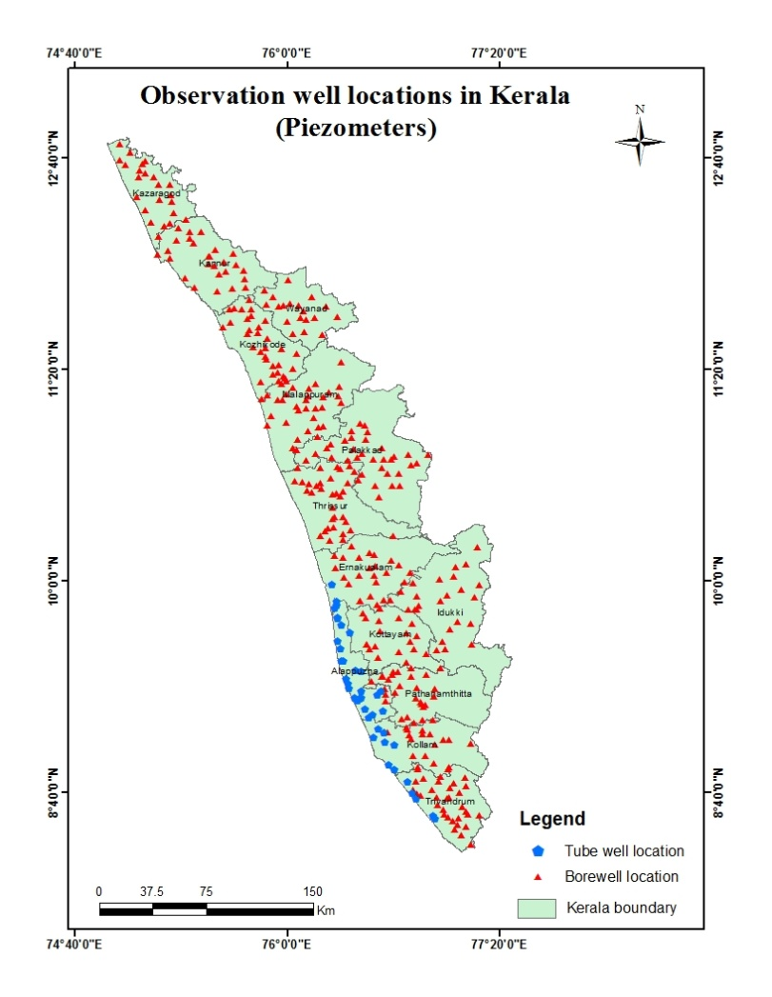
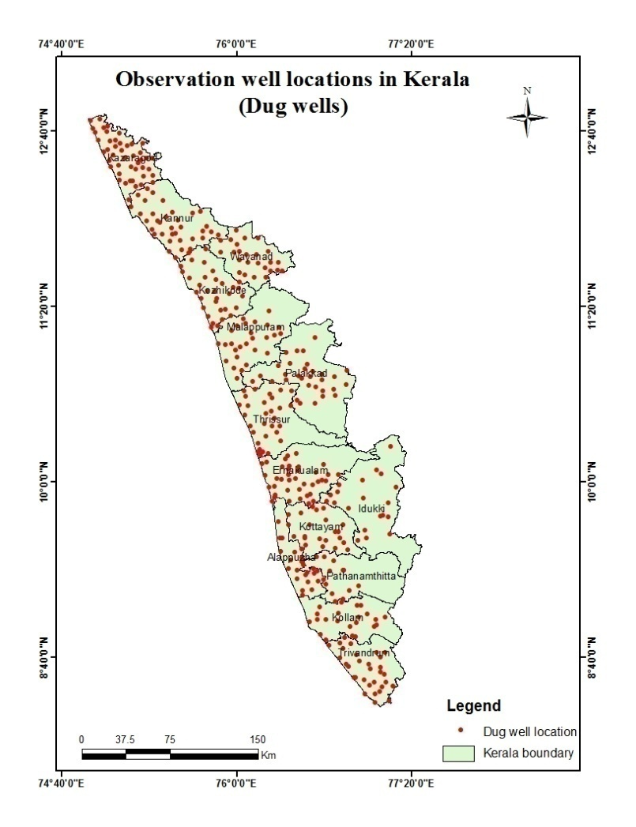
Groundwater monitoring network:Short term and long term changes in the climatic conditions influence the groundwater scenario of an area. Groundwater level data are the principal information required for assessing the groundwater status and groundwater resource estimation.
Fig:3. Location map of observation dug wells and piezometers (bore wells & tube wells)

Groundwater Department is maintaining a network of observation wells throughout the state representing various hydrogeological units. Observation wells includes dug wells (owned by public and private) and purpose built piezometers (bore wells and tube wells). Water level data has been collected monthly and water samples collected and analysis done periodically.

Analysis of Groundwater level data – December 2021
During the month of December 2021, groundwater level in 459 dug wells and 388purpose built piezometers (bore wells- 346 and tube wells – 42) has been monitored. The data collected from the observation wells during the month of December 2021has been compared with previous year’s corresponding month data and also with respect to decadal mean data of the corresponding month to assess the groundwater scenario in the state.

I.Depth to Groundwater level during December 2021
Dug wells:-The depth to groundwater level in the observation dug wells during the month of December 2021ranges from a minimum of -0.75m(E86, Kochi Corporation, Ernakula) m to a maximum of 16.16mbgl(KNR-POW-C8, Thalipparamba, Kannur). Out of 459 dug wells monitored water level in 22.22% of dug wells (102)shows a depth to water level ranges from 0-2 m, 37.9% , (174nos) ranges between 2-5 m, 34.4% (158) ranges between 5-10 m and 5.5% dug wells (25) recorded depth to water level ranges between 10-20 mbgl. Dug wells inThiruvananthapuram Kollam,Pathanamthitta, Kottayam, Idukki, Ernakulam,andPalakkad show water level below 10 mtrs.None of the wells in the state show water level above 20m. Large excess rain fall received in the state accounts for this shallow depth to water level. Table showing well frequency during December 2021 is appended. (Annexure-I)

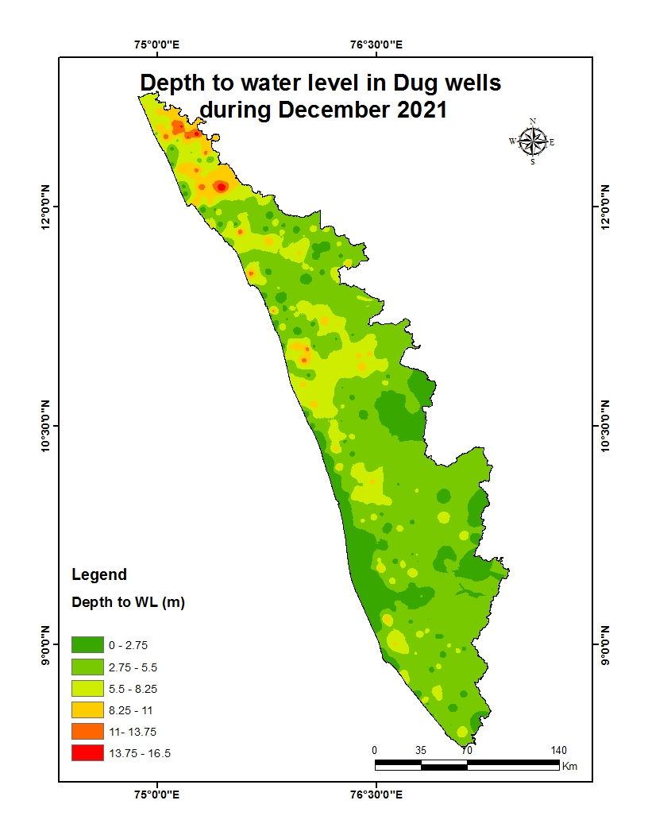
Fig:4. Depth to water level in Dug wells during December2021

Borewells (hardrock terrain):-The depth to groundwater level in the observation bore wells during the month of December 2021 ranges from a minimum of -0.21m in BW 101 Asamannur, ERNAKULAMto a maximum of 43.08mbgl in MPM174,Areekode,Malappuram.Out of 346borewells monitored, water level in 11.27% of bore wells (39 nos) shows a depth to water level range from 0-2 m, 28.32% (98 nos) ranges between 2-5 m, 37.57% (130 nos) ranges between 5-10 m, 19.94% of borewells (69 nos) ranges between 10-20 m, and 2.89% , (10 nos) ranges more than 20 m . Borewells in Thiruvananthapuram, Kollam, Pathanamthitta, Alappuzha,Kottayam Ernakulam, Thrissur and Palakkad districts show water level within 20 mbgl. Table showing well frequency during December2021 is appended. (Annexure-I)

Fig:5. Depth to water level in Bore wells during December 2021
Tubewells (coastal sedimentary terrain):-The depth to groundwater level in the observation tubewells during the month of December 2021 ranges from a minimum of -0.5 m(11 Cheriyanadu, Chengannoor, Alappuzhato a maximum of 32.35mbgl(KLM-31Kollam Corporation , Kollam.)Out of 42 tube wells monitored in the state, water level in 35.71 % of tube wells (15 nos) ranges between 0-2m, 30.95 % of tube wells (13 nos) ranges between 2-5 m,19.05% (8) ranges between 5-10 m and7.14%(3 nos) ranges between10-20 and 7.14%, (3 nos) ranges more than 20m.Except 3 tube in Kollam District all other tubewells in the state show water level below 20 mtrs.Table showingtube well frequency is appended.(Annexure-I )

II.Comparison of Groundwater level in December2021 with respect toDecember 2020

Comparison of the groundwater level in December2021with respect to the corresponding month in the previous year, indicates that 9% of observation dug wells (34 out of 384) show a fall in water level and 91% of the wells (350 out of384) shows no remarkable change /marginal rise in water level.Dug wells in Thiruvananthapuram andPathanamthitta, districts show only rise in water level. This may be due to the Large Excess rainfall received in the state. Out of 9% of the dugwells in the other districtsshowing falling trend, 65% recorded (22 out of 34) fall in water level less than 0.5m, and only one dug wells in the state (KTM-OW-22, Uzhavur, Kottayam district) show a fall in water level more than 2m(ie 2.6m). Table showing water level comparison of dug wells during December 2021with respect to December 2020is appended. (Annexure-II).
Fig:6. Comparison of water level in Dug wells during December 2021wrtDecember 2020

Comparison of the water level in observation bore wells (hard rock terrain in midland and high land areas) in December 2021with that of the previous year, it has been noticed that13.41% of bore wells (46 out of 343) show fall in water level and 86.59% of the wells (297out of 343) shows no remarkable change/marginal rise in water level.Out of 13.41 % of the borewells showing falling trend, 56% of the bore wells (26 out of 46) recorded fall in water level less than 0.5m, 11% show fall in the range between 0.5 - 1m, 11% of bore wells show fall in the range between 1 - 1.5m, 2% of bore wells show a fall in range between, 1.5-2m, 20% of bore wells show a fall inwater level more than 2m. Table showing water level comparison of bore wells during December2021with respect toDecember 2020 is appended. (Annexure-II)
Fig:7. Comparison of water level in Bore wells duringDecember2021 wrtDecember2020

Comparison of the water level in observation tube wells (in the coastal sedimentary areas)during December2021 with that of the previous year reveals that 23 % of tube wells (9 out of 39) recorded a falling trend and 77 % of the wells (30 out of 39) shows no remarkable change /marginal rise of water level.Out of 23% of the tube wells showing a falling trend,66.66% of wells (6 out of 9) recorded fall in range between 0 to 0.5m and no wells show fall above 2m.Tube wells in Thiruvananthapuram and Ernakulam shows only rise in water level. Table showing comparison of water level during December2021 with respect to December2020is appended. (Annexure-II)

III.Comparison of Groundwater level in December2021 with respect to Decadal mean(2011- 20)
Comparison of the water level in December 2021 with respect to the decadal mean, it has been noticed that 6% of observation dug wells (24 out of 394) recorded a fall in water level and 94% of the wells (370 out of 394) shows marginal rise /no remarkable change in water level.All the open wells in Pathanamthitta, Alappuzha, Malappuram districts show only rise in water level. Out of 6 % of the dugwells show a falling trend, 58% of the dug wells (14 out of24) recorded fall in water level less than 0.5m. Only 2dug wells(KTM-OW-11, Erattupetta, Kottayam and E80, Muvattupuzha Municipality, ERNAKULAM) in the state show a fall in range more than 2m.Table showing water level comparison of dug wells during December2021 with respect to decadal mean is appended. (Annexure-III)

Fig:8. Comparison of water level in Dug wells during December 2021wrt Decadal mean

Compared water level in the observation bore wells during December 2021 with that of the decadal mean. It has been noticed that 16% of bore wells (55 out of 343) show fall in water level, and 84% of the wells (291 out of 343) shows marginal rise,no remarkable change in water level.Out of 16 % of the bore wells shows a falling trend , 49% (27 out of 55) shows a fall in water level less than 0.5m.Table showing water level comparison of bore wells duringDecember 2021with respect to decadal mean is appended. (Annexure-III)

Fig:9. Comparison of water level in Bore wells during December2021wrt Decadal mean

Comparison of the water level in the observation tube wells during December 2021 with that of the decadal mean reveals that 18 % of tube wells (7 out of 38) recorded a falling trend and82 % of the tube wells (31 out of 38) show marginal rise/no remarkable change in water level.Out of 18 % of the tube wells shows a falling trend, 71% of the tube wells(5 out of 7) show fall in water level less than 0.5m.Only one tube well in the state show water level fluctuation above 2m, All the other tube wells with falling trend show fluctuation less than 1m. Table showing water level comparison of tube wells during Dec 2021with respect to decadal mean is appended. (Annexure-III)

Summary
Rainfall

- Actual North East Monsoon Rain fall received in the state during 2020 (1Oct to 31 December) is 365.3 mm which is -26% deficient than the normal rainfall.
- Actual North East Monsoon Rain fall received in the state during 2021 (1Oct to 31 December) is 1026.3 which is 109% large Excess than the normal. All the districts received “Large excess’’ Actual rainfall than the normal rain fall except Alappuzha District which received 58% more rain than the Normal rain and comes under category ‘’Excess’’. PathanamthittaDistrict received the highest rainfall; 1695.4mm which is 181%more from the normal rainfall of the district during the season which is 603.2mm.

Groundwater level
- The depth to groundwater level in the observation dug wells during the month of December 2021 range from a minimum of -0.75m( E86, Kochi Corporation, Ernakulam) to a maximum of 16.16mbgl(KNR-POW-C8, Thalipparamba, Kannur) , in bore wells -0.21 m (BW 101 Asamannur, ERNAKULAM)to a maximum of 43.08mbgl in MPM174,Areekode,Malappuram ) and in the tubewells a minimum of -0.5 m(11, Cheriyanadu, Chengannoor, Alappuzha to a maximum of 32.35mbgl (KLM-31 Kollam Corporation , Kollam.)

- Comparison of the water level inDecember 2021 with respect to the previous year, reveals that 9% of observation dug wells (34 out of 394) ,13% of bore wells (46 out of343) and 23% of tube wells ( 9 out of 39) recorded a falling trend.Among all the 766 observation wells only 11.6% of wells (89 out of 766) show declining trend. 60.67%of the observation wells with falling trend (54 out of 89) show decline in water level less than 0.5 m.

- Comparison of groundwater level in December 2021with respect to the decadal mean reveals that 6% of observation dug wells,16% of bore wells and 18% of tube wells recorded falling trend. Among all the 775 observation wells only 14.53% of wells (86 out of 775) show declining trend. 53.48%of the observationwells with falling trend (46 out of 86) show decline in water level less than 0.5 m.

- Wells showing decline of water level more than 2 m during long term analysis will be monitored closely. Open wells showing decline of water level more than 2m are shown in Annexure IV. Fluctuation above 2m from December 2020 water level (-2.6m) is noted in only one open well no.KTM-OW-22at Uzhavur, Kottayam. More than 2m Fluctuation from Decadal mean water level is noted in 2 open wells (KTM-OW-11, Erattupetta, Kottayam, and E80, Muvattupuzha Municipality, Ernakulam District. Necessary Artificial recharge structures may be implemented to rise the water level.

Districtwise Observation well Frequency on December 2021 Annexure I
District | Well Type | No. of WL measured | DTWL(mbgl) |  | Location |  | Depth range of wells (mts)
 |  |  | Min | Max | Min | Max | 0 to 2 | 2 to 5 | 5 to 10 | 10 to 20 | >20
Thiruvananthapuram | Dug well | 30 | 0.38 | 8.23 | TVM OW03,Perumkadavila,Thiruvananthapuram | TVM OW28,Kazhakkoottam,Thiruvananthapuram | 6 | 16 | 8 | 0 | 0
 | Bore well | 32 | 0.11 | 15.41 | 31,Vamanapuram,Thiruvananthapuram | 25,Parassala,Thiruvananthapuram | 3 | 14 | 10 | 5 | 0
 | Tube well | 4 | 1.64 | 6.46 | 36,Chirayinkeezhu,Thiruvananthapuram | 37,Chirayinkeezhu,Thiruvananthapuram | 1 | 2 | 1 | 0 | 0
Kollam | Dug well | 24 | 0.78 | 8.72 | OW-31,Neendakara,KOLLAM | KLM OW 24,Munroethuruthu,KOLLAM | 6 | 8 | 10 | 0 | 0
 | Bore well | 16 | 0.47 | 7.95 | KLM/6,Kottarakkara Municipality,KOLLAM | KLM/O7,Piravanthoor,Kollam | 2 | 5 | 9 | 0 | 0
 | Tube well | 8 | 1.45 | 32.35 | KLM/17,Mayyanad,KOLLAM | KLM-31,Kollam Corporation,KOLLAM | 1 | 0 | 4 | 0 | 3
Pathanamthitta | Dug well | 78 | 0.60 | 9.13 | 10 Seethathode,Seethathode,PATHANAMTHITTA | 20 Civil Station,Adoor Municipality,PATHANAMTHITTA | 13 | 46 | 19 | 0 | 0
 | Bore well | 24 | 0.42 | 12.68 | PTA/02,Kalanjoor,PATHANAMTHITTA | PTA/15,Chittar,PATHANAMTHITTA | 3 | 8 | 11 | 2 | 0
Alappuzha | Dug well | 20 | -0.09 | 10.47 | OW-06 Pulinkunnu,Champakulam,Alappuzha | OW-02 Kattanam,Mavelikara,Alappuzha | 14 | 4 | 1 | 1 | 0
 | Bore well | 2 | 1.99 | 4.10 | 36 Punthala,Chengannoor,Alappuzha | 35 Pennukkara,Chengannoor,Alappuzha | 1 | 1 | 0 | 0 | 0
 | Tube well | 29 | -0.50 | 16.61 | 11 Cheriyanadu,Chengannoor,Alappuzha | 04 Charumoodu,Bharanikavu,Alappuzha | 13 | 11 | 3 | 2 | 0
Kottayam | Dug well | 19 | 0.45 | 9.15 | KTM-OW-23,Uzhavoor,Kottayam | KTM-OW-4_,Pallom,Kottayam | 5 | 7 | 7 | 0 | 0
 | Bore well | 24 | -0.20 | 18.08 | 32,Kanjirappally,Kottayam. | 03,Kanjirappally,Kottayam | 7 | 9 | 6 | 2 | 0
Idukki | Dug well | 20 | -0.13 | 7.90 | 75,Marayoor,Idukki | IDK08,Kattappana Municipality,Idukki | 7 | 10 | 3 | 0 | 0
 | Bore well | 23 | 1.18 | 35.59 | SO415,Udumbannoor,Idukki | SO428,Peermade,IDUKKI | 3 | 9 | 5 | 4 | 2
Ernakulam | Dug well | 38 | -0.75 | 9.08 | E86,Kochi Corporation,ERNAKULAM | E95,Perumbavoor Municipality,Ernakulam | 10 | 13 | 15 | 0 | 0
 | Bore well | 25 | -0.21 | 11.56 | BW 101,Asamannur,ERNAKULAM | BW 100,Rayamangalam,ERNAKULAM | 4 | 8 | 12 | 1 | 0
 | Tube well | 1 | 10.24 | 10.24 | TW 01,Kochi Corporation,ERNAKULAM. | TW 01,Kochi Corporation,ERNAKULAM. | 0 | 0 | 0 | 1 | 0
Thrissur | Dug well | 32 | 0.30 | 10.15 | TSROW16,Talikkulam,Thrissur | TSROW12,Chowwannur,Thrissur | 9 | 10 | 12 | 1 | 0
 | Bore well | 37 | 0.25 | 19.95 | TSR124,Puzhakkal,Thrissur | TSR136,Kandanassery,Thrissur | 4 | 6 | 19 | 8 | 0
Malappuram | Dug well | 26 | 0.54 | 12.11 | MPM.OW.18,Kondotty,Malappuram |  | 3 | 11 | 9 | 3 | 0
 | Bore well | 30 | 0.83 | 43.08 | MPM178,Wandoor,Malappuram. | MPM174,Areekode,Malappuram | 5 | 10 | 9 | 3 | 3
Palakkad | Dug well | 31 | 0.33 | 9.50 | PKD S-7,Chittur,Palakkad | PKD S-10,Sreekrishnapuram,Palakkad | 5 | 18 | 8 | 0 | 0
 | Bore well | 33 | 1.30 | 19.38 | MPM169,Wandoor,Malappuram. | 157,Ottappalam,Palakkad | 3 | 5 | 19 | 6 | 0
Kozhikkode | Dug well | 34 | -0.60 | 11.71 | KKDOW 019,Melady,Kozhikkode | QKKDO60,Thodannur,Kozhikode | 8 | 15 | 8 | 3 | 0
 | Bore well | 33 | 0.12 | 28.13 | KKDPZ 197,Kozhikode,Kozhikode | KKDPZ 210,Kozhikode (corporation ),Kozhikkode | 3 | 12 | 8 | 8 | 2
Wayanad | Dug well | 26 | 0.08 | 10.80 | SOW-10,Poothadi,WAYANAD | SOW-4,Nenmeni,WAYANAD | 6 | 5 | 14 | 1 | 0
 | Bore well | 19 | 2.47 | 20.89 | WYD216,Muttil,WAYANAD | WYD223,Thirunelly,WAYANAD | 0 | 4 | 6 | 8 | 1
Kannur | Dug well | 36 | 0.63 | 16.16 | KNR-POW-C23,Koothuparamba,Kannur | KNR-POW-C8,Taliparamba,Kannur | 8 | 5 | 18 | 5 | 0
 | Bore well | 27 | 1.11 | 22.36 | KNRPz239,Taliparamba,Kannur | KNR-Pz228,Irikkur,Kannur | 1 | 4 | 10 | 11 | 1
Kasaragod | Dug well | 45 | 1.61 | 14.99 | 199,Kanhangad,Kasaragod | 200,Karadka,Kasaragod | 2 | 6 | 26 | 11 | 0
 | Bore well | 21 | 3.11 | 22.42 | PZKGD241,Parappa,Kasaragod | PZKGD242,Karadka,Kasaragod | 0 | 3 | 6 | 11 | 1

Comparison of Water level November 2021 with respect to December 2020 - Annexure II
District | Well Type | No. of WL Measured | Water level | Total | 0 - 0.5 m | 0.5 - 1 m | 1-1.5m | 1.5 - 2 m | >2 m
 |  |  |  |  | No. | No. | No. | No. | No.
Thiruvananthapuram | Dug well | 22 | Rise | 22 | 5 | 4 | 3 | 3 | 7
 |  |  | Fall | 0 | 0 | 0 | 0 | 0 | 0
 | Bore well | 32 | Rise | 31 | 7 | 3 | 6 | 4 | 11
 |  |  | Fall | 1 | 1 | 0 | 0 | 0 | 0
 | Tube well | 4 | Rise | 4 | 1 | 1 | 0 | 2 | 0
 |  |  | Fall | 0 | 0 | 0 | 0 | 0 | 0
Kollam | Dug well | 24 | Rise | 23 | 5 | 3 | 6 | 6 | 3
 |  |  | Fall | 1 | 1 | 0 | 0 | 0 | 0
 | Bore well | 16 | Rise | 16 | 3 | 1 | 5 | 4 | 3
 |  |  | Fall | 0 | 0 | 0 | 0 | 0 | 0
 | Tube well | 8 | Rise | 7 | 1 | 2 | 1 | 2 | 1
 |  |  | Fall | 1 | 1 | 0 | 0 | 0 | 0
Pathanamthitta | Dug well | 14 | Rise | 14 | 5 | 5 | 3 | 1 | 0
 |  |  | Fall | 0 | 0 | 0 | 0 | 0 | 0
 | Bore well | 24 | Rise | 22 | 4 | 8 | 4 | 0 | 6
 |  |  | Fall | 2 | 1 | 0 | 0 | 0 | 1
Alappuzha | Dug well | 19 | Rise | 16 | 9 | 4 | 3 | 0 | 0
 |  |  | Fall | 3 | 3 | 0 | 0 | 0 | 0
 | Bore well | 2 | Rise | 2 | 1 | 0 | 1 | 0 | 0
 |  |  | Fall | 0 | 0 | 0 | 0 | 0 | 0
 | Tube well | 26 | Rise | 18 | 15 | 2 | 1 | 0 | 0
 |  |  | Fall | 8 | 5 | 0 | 2 | 1 | 0
Kottayam | Dug well | 20 | Rise | 17 | 6 | 3 | 2 | 1 | 5
 |  |  | Fall | 3 | 1 | 1 | 0 | 0 | 1
 | Bore well | 24 | Rise | 20 | 4 | 6 | 4 | 2 | 4
 |  |  | Fall | 4 | 4 | 0 | 0 | 0 | 0
Idukki | Dug well | 20 | Rise | 17 | 7 | 6 | 2 | 1 | 1
 |  |  | Fall | 3 | 2 | 1 | 0 | 0 | 0
 | Bore well | 23 | Rise | 20 | 9 | 5 | 3 | 0 | 3
 |  |  | Fall | 3 | 1 | 0 | 1 | 0 | 1
Ernakulam | Dug well | 38 | Rise | 31 | 20 | 3 | 7 | 0 | 1
 |  |  | Fall | 7 | 4 | 2 | 1 | 0 | 0
 | Bore well | 22 | Rise | 17 | 7 | 5 | 2 | 1 | 2
 |  |  | Fall | 5 | 3 | 1 | 1 | 0 | 0
 | Tube well |  | Rise | 1 | 0 | 1 | 0 | 0 | 0
 |  |  | Fall | 0 | 0 | 0 | 0 | 0 | 0
Thrissur | Dug well | 31 | Rise | 28 | 12 | 9 | 4 | 2 | 1
 |  |  | Fall | 3 | 2 | 0 | 1 | 0 | 0
 | Bore well | 37 | Rise | 34 | 4 | 9 | 5 | 8 | 8
 |  |  | Fall | 3 | 2 | 0 | 0 | 0 | 1
Malappuram | Dug well | 26 | Rise | 24 | 13 | 9 | 0 | 1 | 1
 |  |  | Fall | 2 | 2 | 0 | 0 | 0 | 0
 | Bore well | 30 | Rise | 26 | 9 | 7 | 4 | 1 | 5
 |  |  | Fall | 4 | 1 | 0 | 1 | 0 | 2
Palakkad | Dug well | 31 | Rise | 27 | 12 | 12 | 1 | 1 | 1
 |  |  | Fall | 4 | 2 | 2 | 0 | 0 | 0
 | Bore well | 33 | Rise | 26 | 5 | 9 | 4 | 2 | 6
 |  |  | Fall | 7 | 2 | 1 | 1 | 1 | 2
Kozhikkode | Dug well | 32 | Rise | 30 | 7 | 16 | 5 | 0 | 2
 |  |  | Fall | 2 | 2 | 0 | 0 | 0 | 0
 | Bore well | 32 | Rise | 27 | 13 | 6 | 3 | 4 | 1
 |  |  | Fall | 5 | 3 | 1 | 0 | 0 | 1
Wayanad | Dug well | 26 | Rise | 25 | 14 | 5 | 2 | 2 | 2
 |  |  | Fall | 1 | 0 | 0 | 1 | 0 | 0
 | Bore well | 19 | Rise | 17 | 8 | 6 | 2 | 0 | 1
 |  |  | Fall | 2 | 1 | 1 | 0 | 0 | 0
Kannur | Dug well | 36 | Rise | 34 | 20 | 8 | 5 | 1 | 0
 |  |  | Fall | 2 | 1 | 1 | 0 | 0 | 0
 | Bore well | 28 | Rise | 23 | 12 | 5 | 1 | 1 | 4
 |  |  | Fall | 5 | 5 | 0 | 0 | 0 | 0
Kasaragod | Dug well | 45 | Rise | 42 | 21 | 10 | 4 | 3 | 4
 |  |  | Fall | 3 | 2 | 1 | 0 | 0 | 0
 | Bore well | 21 | Rise | 16 | 6 | 2 | 1 | 4 | 3
 |  |  | Fall | 5 | 2 | 1 | 1 | 0 | 1

Comparison of Water level December 2021 with respect to 10 yrs mean Annexure III
District | Well Type | No. of WL Measured | Water level | Total | 0 - 0.5 m | 0.5 - 1 m | 1 - 1.5 m | 1.5 - 2 m | <2 m
 |  |  |  |  | No. | No. | No. | No. | No.
Thiruvananthapuram | Dug well | 31 | Rise | 30 | 3 | 7 | 5 | 5 | 10
 |  |  | Fall | 1 | 1 | 0 | 0 | 0 | 0
 | Bore well | 33 | Rise | 32 | 5 | 6 | 1 | 1 | 19
 |  |  | Fall | 1 | 1 | 0 | 0 | 0 | 0
 | Tube well | 4 | Rise | 4 | 0 | 2 | 0 | 1 | 1
 |  |  | Fall | 0 | 0 | 0 | 0 | 0 | 0
Kollam | Dug well | 24 | Rise | 23 | 2 | 4 | 4 | 8 | 5
 |  |  | Fall | 1 | 1 | 0 | 0 | 0 | 0
 | Bore well | 16 | Rise | 16 | 4 | 2 | 3 | 5 | 2
 |  |  | Fall | 0 | 0 | 0 | 0 | 0 | 0
 | Tube well | 8 | Rise | 7 | 1 | 0 | 3 | 0 | 3
 |  |  | Fall | 1 | 0 | 1 | 0 | 0 | 0
Pathanamthitta | Dug well | 14 | Rise | 14 | 3 | 4 | 6 | 0 | 1
 |  |  | Fall | 0 | 0 | 0 | 0 | 0 | 0
 | Bore well | 24 | Rise | 23 | 3 | 3 | 8 | 0 | 9
 |  |  | Fall | 1 | 0 | 0 | 0 | 0 | 1
Alappuzha | Dug well | 19 | Rise | 19 | 10 | 5 | 3 | 1 | 0
 |  |  | Fall | 0 | 0 | 0 | 0 | 0 | 0
 | Bore well | 2 | Rise | 1 | 0 | 0 | 1 | 0 | 0
 |  |  | Fall | 1 | 1 | 0 | 0 | 0 | 0
 | Tube well | 25 | Rise | 20 | 7 | 7 | 4 | 2 | 0
 |  |  | Fall | 5 | 4 | 0 | 0 | 0 | 1
Kottayam | Dug well | 20 | Rise | 16 | 5 | 3 | 2 | 2 | 4
 |  |  | Fall | 4 | 1 | 0 | 0 | 2 | 1
 | Bore well | 24 | Rise | 21 | 3 | 7 | 5 | 4 | 2
 |  |  | Fall | 3 | 3 | 0 | 0 | 0 | 0
Idukki | Dug well | 20 | Rise | 19 | 10 | 4 | 2 | 1 | 2
 |  |  | Fall | 1 | 1 | 0 | 0 | 0 | 0
 | Bore well | 23 | Rise | 19 | 7 | 3 | 3 | 3 | 3
 |  |  | Fall | 4 | 1 | 0 | 1 | 0 | 2
Ernakulam | Dug well | 38 | Rise | 33 | 21 | 7 | 2 | 2 | 1
 |  |  | Fall | 5 | 3 | 0 | 1 | 0 | 1
 | Bore well | 23 | Rise | 17 | 9 | 5 | 1 | 1 | 1
 |  |  | Fall | 6 | 3 | 1 | 1 | 0 | 1
 | Tube well | 1 | Rise | 0 | 0 | 0 | 0 | 0 | 0
 |  |  | Fall | 1 | 1 | 0 | 0 | 0 | 0
Thrissur | Dug well | 31 | Rise | 29 | 11 | 10 | 5 | 2 | 1
 |  |  | Fall | 2 | 0 | 0 | 1 | 1 | 0
 | Bore well | 37 | Rise | 30 | 4 | 13 | 5 | 2 | 6
 |  |  | Fall | 7 | 4 | 2 | 0 | 1 | 0
Malappuram | Dug well | 26 | Rise | 26 | 10 | 12 | 3 | 1 | 0
 |  |  | Fall | 0 | 0 | 0 | 0 | 0 | 0
 | Bore well | 30 | Rise | 24 | 7 | 7 | 4 | 2 | 4
 |  |  | Fall | 6 | 1 | 1 | 1 | 1 | 2
Palakkad | Dug well | 31 | Rise | 28 | 11 | 8 | 6 | 0 | 3
 |  |  | Fall | 3 | 3 | 0 | 0 | 0 | 0
 | Bore well | 33 | Rise | 23 | 3 | 4 | 6 | 4 | 6
 |  |  | Fall | 10 | 4 | 2 | 0 | 2 | 2
Kozhikkode | Dug well | 31 | Rise | 32 | 6 | 14 | 8 | 2 | 2
 |  |  | Fall | 3 | 3 | 0 | 0 | 0 | 0
 | Bore well | 33 | Rise | 28 | 12 | 9 | 2 | 3 | 2
 |  |  | Fall | 5 | 0 | 0 | 1 | 0 | 0
Wayanad | Dug well | 26 | Rise | 24 | 11 | 2 | 8 | 1 | 2
 |  |  | Fall | 2 | 1 | 1 | 0 | 0 | 0
 | Bore well | 19 | Rise | 17 | 7 | 5 | 3 | 1 | 1
 |  |  | Fall | 2 | 1 | 1 | 0 | 0 | 0
Kannur | Dug well | 36 | Rise | 34 | 15 | 11 | 6 | 2 | 0
 |  |  | Fall | 2 | 1 | 1 | 0 | 0 | 0
 | Bore well | 28 | Rise | 23 | 8 | 10 | 1 | 2 | 2
 |  |  | Fall | 5 | 2 | 2 | 1 | 0 | 0
Kasaragod | Dug well | 45 | Rise | 43 | 17 | 14 | 3 | 5 | 4
 |  |  | Fall | 2 | 2 | 0 | 0 | 0 | 0
 | Bore well | 21 | Rise | 17 | 6 | 3 | 4 | 4 | 0
 |  |  | Fall | 4 | 2 | 1 | 0 | 0 | 1

List of open wells showing more than 2m fluctuation in Dec- 2021 wrt Dec-2020 and Decadal Average
Water Level Data & Fluctuation
SNo | District | Block | GP/Municipality/Corporation | WellNo | Well_Type | Latitude(°) | Longitude(°) | Dec-2021 | Dec-2020 | Dec-2019 | Decadal Avg(2011-2020) |  | Fluctuation in Dec-2021 wrt.
16 | Kottayam | Meenachil | Erattupetta | KTM-OW-11 | Dug Well | 9.67222 | 76.81445 | 3.520 | 3.550 | 1.300 | 1.454 | 10 | 0.030 | -2.220 | -2.066
21 | Kottayam | Meenachil | Uzhavoor | KTM-OW-22 | Dug Well | 9.79861 | 76.66194 | 6.850 | 4.250 | 4.450 | 5.335 | 10 | -2.600 | -2.400 | -1.515
20 | ERNAKULAM | Muvattupuzha | Muvattupuzha Municipality | E80 | Dug Well | 9.97967 | 76.57984 | 7.020 | 8.220 | 4.280 | 4.927 | 10 | 1.200 | -2.740 | -2.093

Observation well frequency on December 2021 Abstract I
Well Type | No of WL measured | DTWL (mbgl) |  | Location |  | Depth range of wells (m)
 |  | min | max | min | max | 0 to 2 | 2 to 5 | 5 to 10 | 10 to 20 | >20
Dug well | 459 | -0.75 | 16.16 | E86,Kochi Corporation,ERNAKULAM | KNR-POW-C8,Taliparamba,Kannur | 102 | 174 | 158 | 25 | 0
 |  |  |  |  |  | 22.22% | 37.91% | 34.42% | 5.45% | 0.00%
Bore well | 346 | -0.21 | 43.08 | BW 101,Asamannur,ERNAKULAM | MPM174,Areekode,Malappuram | 39 | 98 | 130 | 69 | 10
 |  |  |  |  |  | 11.27% | 28.32% | 37.57% | 19.94% | 2.89%
Tube well | 42 | -0.5 | 32.35 | 11 Cheriyanadu,Chengannoor,Alappuzha | KLM/29,Sasthamkotta,KOLLAM | 15 | 13 | 8 | 3 | 3
 |  |  |  |  |  | 35.71% | 30.95% | 19.05% | 7.14% | 7.14%

Comparison of Water level December 2021 with respect to December 2020 Abstract II
Well type | No. of WL Measured | Water level | Total | 0 - 0.5 m | 0.5 - 1 m | 1 - 1.5 m | 1.5 - 2 m | >2 m
Dug well | 384 | Rise | 350 | 156 | 97 | 47 | 22 | 28
 |  | % | 91% | 45% | 28% | 13% | 6% | 8%
 |  | Fall | 34 | 22 | 8 | 3 | 0 | 1
 |  | % | 9% | 65% | 24% | 9% | 0% | 3%
Bore well | 343 | Rise | 297 | 92 | 72 | 45 | 31 | 57
 |  | % | 87% | 31% | 24% | 15% | 10% | 19%
 |  | Fall | 46 | 26 | 5 | 5 | 1 | 9
 |  | % | 13% | 57% | 11% | 11% | 2% | 20%
Tube well | 39 | Rise | 30 | 17 | 6 | 2 | 4 | 1
 |  | % | 77% | 57% | 20% | 7% | 13% | 3%
 |  | Fall | 9 | 6 | 0 | 2 | 1 | 0
 |  | % | 23% | 67% | 0% | 22% | 11% | 0%

Comparison of Water level December 2021 with respect to 10 yrs mean Abstract III
Well type | No. of WL Measured | Water level | Total | 0 - 0.5 m | 0.5 - 1 m | 1 - 1.5 m | 1.5 - 2 m | >2 m
Dug well | 394 | Rise | 370 | 135 | 105 | 63 | 32 | 35
 |  | % | 94% | 36% | 28% | 17% | 9% | 9%
 |  | Fall | 24 | 14 | 2 | 3 | 3 | 2
 |  | % | 6% | 58% | 8% | 13% | 13% | 8%
Bore well | 346 | Rise | 291 | 78 | 77 | 47 | 32 | 57
 |  | % | 84% | 27% | 26% | 16% | 11% | 20%
 |  | Fall | 55 | 27 | 10 | 4 | 5 | 9
 |  | % | 16% | 49% | 18% | 7% | 9% | 16%
Tube well | 38 | Rise | 31 | 8 | 9 | 7 | 3 | 4
 |  | % | 82% | 26% | 29% | 23% | 10% | 13%
 |  | Fall | 7 | 5 | 1 | 0 | 0 | 1
 |  | % | 18% | 71% | 14% | 0% | 0% | 14%

