GOVERNMENT OF KERALA
GROUNDWATER DEPARTMENT

GROUNDWATER LEVEL MONITORING REPORT – AUGUST 2021

Wateris a replenishable natural resource which is essential for the existence of all living beings. In the past, the demand of water is mostly limited to domestic and in the agricultural sector. Due to the developments in agricultural and industrial sector the demand of water is increasing many folds since last few decades. Surface water resource alone couldn’t meet the increasing demand and hence persuaded to depend on groundwater resource during the past few decades made stress on groundwater regime. In order to sustain the groundwater resources, proper groundwater management practices are needed.
Rainfallis the primary source for groundwater recharge and has a vital role in the sustainability of groundwater resource in the state. Groundwater level fluctuation results from the seasonal availability of rainfall. Kerala state experiences four distinct seasons namely winter (January-February), Pre-monsoon (March-May), Monsoon (South-West) June to September and Post-monsoon (North-East) from October to December. Average annual precipitation in the state is nearly 3000 mm. The rainfall in the State is controlled primarily by the South-West and North-East monsoons. About 90% of the rainfall occurs during six monsoon months (South-West monsoon contributes major portion of rainfall (65-70%) and about 16% from the North-East) and remaining from summer showers.
Actual Southwest monsoon Rain fall received in the state during 2021(1June to 30September) is 1718.8 mm . It is -16% less than the Normal rainfall during the period which is 2049.2mm .The percentage departure comes under Normal category. All the districts received less Actual rain fall than the normal rain fall exceptPathanamthitta District which received 4% more rain than the Normal rain . Percentage departure of rain in Kannur, Malappuram, Palakkad, Thrissur, and Wayanadand fallin Deficient category and all other districts comes in Normal category.Kasargod district received the highest rainfall (2398.7mm and Thiruvananthapuram district received the lowest rainfall (745.6mm).
Actual Southwest monsoon Rain fall received in the state during 2020(1June to 30September) is 2227.9 mm . It is 9% more than the Normal rainfall during the period

Fig:1. Comparison of actual rainfalloccurred during June-August 2021wrt 2020

Fig:2. Comparison of actual rainfall occurred during June-August2021wrtNormal Rainfall

Geology: Kerala, the southernmost state of Indian peninsula, is having a geographical area of 38863 km². The land area extends between latitude 8ᵒ17’30” and 12ᵒ27’40” and longitude 74ᵒ51’57” and 77ᵒ24’47”. Physiographically, Kerala state is sandwiched between Western Ghats on the east and Arabian Sea on the west. Being the part of the southern Indian peninsula, the peninsular geological formations exist in the state. The major geological formations in the state comprises crystalline rocks of Archaean Age, sedimentary rock formations of tertiary age and sub recent to recent rock formations of quaternary age.
Occurrence of Groundwater resource: Groundwater occurs under phreatic, semi-confined and confined conditions, Groundwater in unconfined aquifer is mainly utilized through tube wells in sedimentary terrain and through bore wells in hard rock areas.
Groundwater monitoring network:Short term and long term changes in the climatic conditions influence the groundwater scenario of an area. Groundwater level data are the principal information required for assessing the groundwater status and groundwater resource estimation.
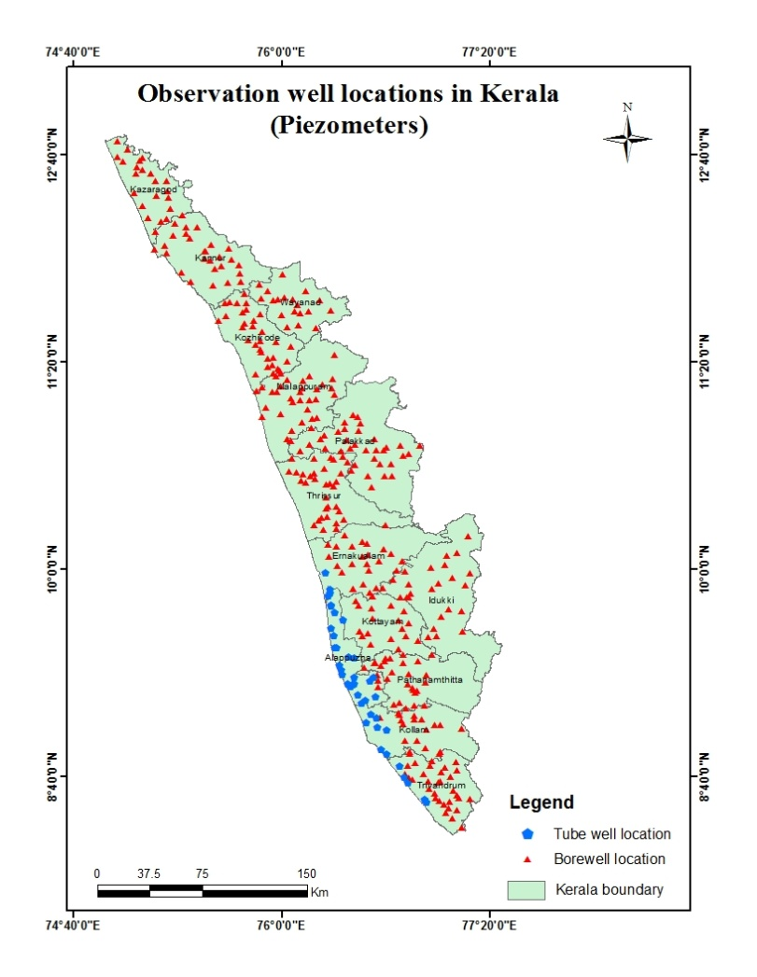
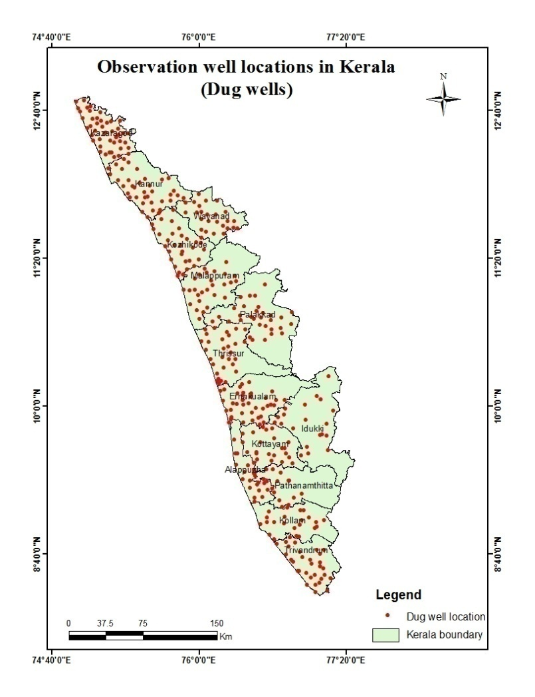
Groundwater Department is maintaining a network of observation wells throughout the state representing various hydro geological units. Observation wells includes dug wells (owned by public and private) and purpose built piezometer (bore wells and tube wells). Water level data has been collected monthly and water samples collected and analysis done periodically.

Fig: 3. Location map of observation dug wells and piezometers (bore wells & tube wells)
Analysis of Groundwater level data – August 2021
During the month of August 2021, groundwater level in 381 dug wells and 391purpose built piezometers (bore wells- 348 and tube wells – 43) has been monitored. The data collected from the observation wells during the month of August 2021has been compared with previous year’s corresponding month data and also with respect to decadal mean data of the corresponding month to assess the groundwater scenario in the state.
I. Depth to Groundwater level during August 2021
Dug wells:-The depth to groundwater level in the observation dug wells during the month of August 2021ranges from a minimum of -1m in open well TVM OW18,Kilimanoor,Thiruvananthapuram& OW-08 Thaneermukkom,Cherthala,Alappuzha m to a maximum of 15.04mbgl in open well KNR-POW-C23,Koothuparamba,Kannur. Out of 383dug wells monitored water level in 30% of dug wells shows a depth to water level ranges from <=2 m, 34% ranges between 2-5 m, 32% ranges between 5-10 m and 4% dug wells recorded depth to water level ranges between 10-20 mbgl. None of the wells in the state show water level above 20m.. Dug wells inPathanamthitta, Alappuzha, Kottayam, Idukki, Ernakulam, Thrissur, Palakkad and Kozhikkode show water level below 10m.Table showing well frequency during August 2021 is appended. (Annexure-I)

Fig:4. Depth to water level in Dug wells during August2021

Bore wells (hard rock terrain):-The depth to groundwater level in the observation bore wells during the month of August2021 ranges from a minimum of -1m in open well 44 &10,Vellanad,Thiruvananthapuram to a maximum of 42.42mbgl in open well. MPM174,Areekode,Malappuram.Out of 348 bore wells monitored, water level in 12% of bore wells shows a depth to water level range from 0-2 m, 31 % ranges between 2-5 m, 36% ranges between 5-10 m, 17% of bore wells ranges between 10-20 m, and 3% ranges more than 20 m .Bore wells inErnakulam, Kollam, Pathanamthitta, Alappuzha, Thiruvananthapuram, Kottayam, Thrissur, and Palakkaddistricts show water level below20 mbgl. Table showing well frequency during August 2021 is appended. (Annexure-I)

Fig:5. Depth to water level in Bore wells during August 2021
Tubewells (coastal sedimentary terrain):-The depth to groundwater level in the observation tubewells during the month of August 2021ranges from a minimum of -0.80 min tube well 05 Chingoly,Alappuzha to a maximum of 33.70mbglin tube well noKLM/29, Sasthamkotta, Kollam. Out of 43 tube wells monitored in the state, water level in 37 % of tube wells ranges between 0-2m, 24 % of tube wells ranges between 2-5 m, 23% ranges between 5-10 m and9%ranges between10-20 and 8% ranges more than 20m.Table showingtube well frequency is appended.(Annexure-I )
II.Comparison of Groundwater level in August2021 with respect toAugust 2020
Comparison of the groundwater level in August2021with respect to the corresponding month in the previous year indicates that 75 % of observation dug wells(280 out of 376) show a fall in water level and 25 % of the wells(96 out of 376)show no remarkable change /marginal rise in water level.Out of 75% of the dugwells shows a falling trend, 30% recorded fall in water level less than 0.5m, 21 % of dug wells show fall in the range between 0.5-1m, 16% of dug wells show fall in the range between 1-1.5 m, 12% of dug wells show a fall in the range between 1.5 -2m and 21% dug wells show a fall in water level more than 2m. Table showing water level comparison of dug wells during August 2021with respect to August2020is appended. (Annexure-II).
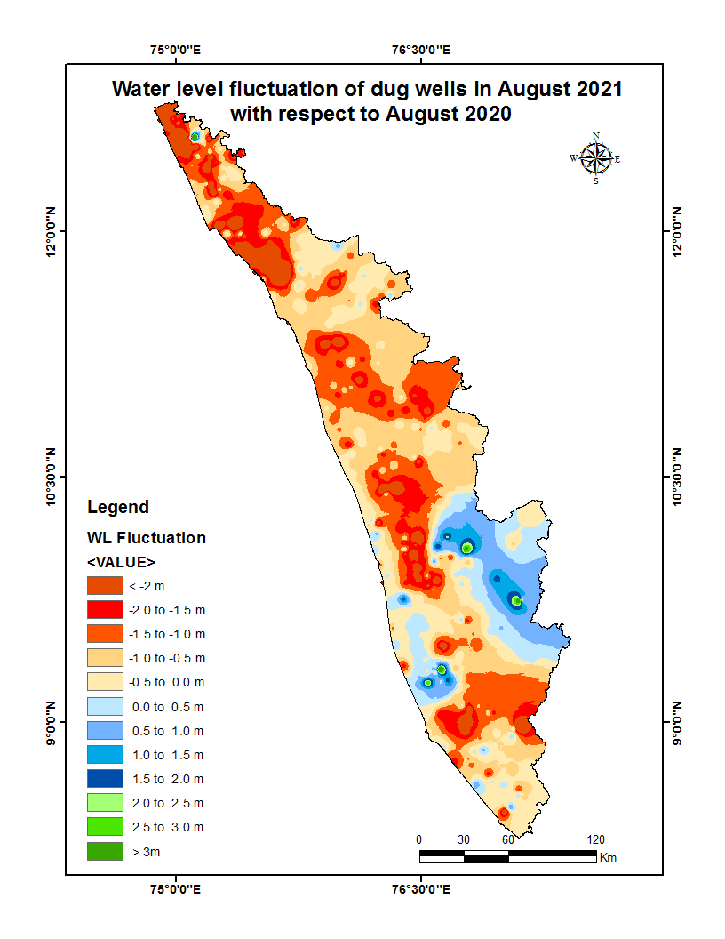

Fig:6. Comparison of water level in Dug wells during August 2021wrt August2020

Comparison of the water level in observation bore wells (hard rock terrain in midland and high land areas) in August 2021with that of the previous year, it has been noticed that66% of bore wells(222 out of 337) show fall in water level and 34% of the wells(115 out of 337) shows no remarkable change/marginal rise in water level. Out of 66 % of the bore wells shows a falling trend, 24% of the bore wells recorded fall in water level less than 0.5m, 23 % show fall in the range between 0.5 - 1m, 18% of bore wells show fall in the range between 1 - 1.5m, 16% of bore wells show a fall in range between1.5-2m, 20% of bore wells show a fall inwater level more than 2m. Table showing water level comparison of bore wells during August 2021with respect toAugust2020 is appended. (Annexure-II)
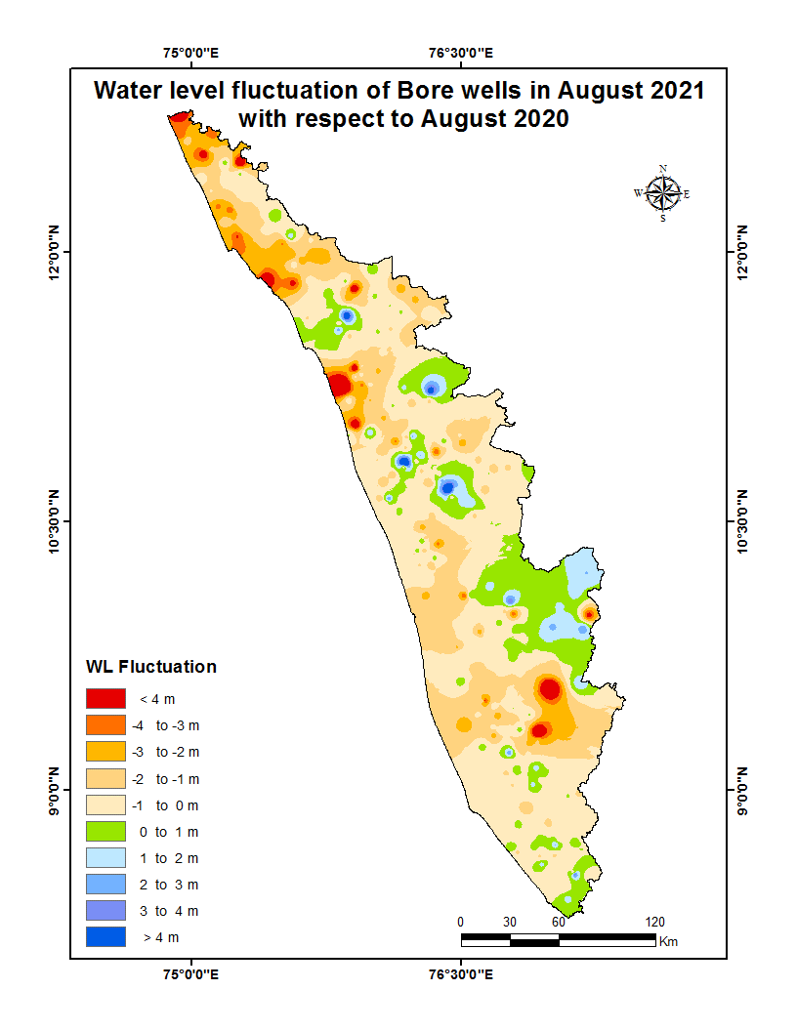

Fig:7. Comparison of water level in Bore wells during August 2021 wrt August2020

Comparison of the water level in observation tube wells (in the coastal sedimentary areas)during August 2021 with that of the previous year reveals that 33 % of tube wells(13 out of 39) recorded a falling trend and 67 % of the wells (26 out of 39) shows no remarkable change /marginal rise of water level.Out of 33% of the tube wells showing a falling trend, 77% of wells recorded fall in range between 0 to 0.5m 8% show fall in the range between 0.5 - 1m, 8% of bore wells show fall in the range between 1 - 1.5m, 7% of bore wells show a fall in range between1.5-2m, None of the bore wells show a fall inwater level more than 2m..Table showing comparison of water level during August2021 with respect to August 2020is appended. (Annexure-II)

III.Comparison of Groundwater level in August2021 with respect to Decadal mean(2011- 20)
Comparison of the water level in August 2021 with respect to the decadal mean, it has been noticed that 52% of observation dug wells (195 out of 375) recorded a fall in water level and 48% of the wells (180 out of 375)shows marginal rise /no remarkable change in water level.Out of 52% of the dugwells show a falling trend, 66% of the dug wells recorded fall in water level less than 0.5m,19% show fall in the range between 0.5-1m, 6% of dug wells show fall in the range between1-1.5m, 5% of dug wells show a fall in range between 1.5-2m and 4% of dug wells show a fall in range more than 2m.Table showing water level comparison of dug wells during August2021 with respect to decadal mean is appended. (Annexure-III)

Fig:7. Comparison of water level in Dug wells during August2021wrt Decadal mean
Compared water level in the observation bore wells during August2021 with that of the decadal mean. It has been noticed that 52% of bore wells (178 out of 340)show fall in water level, and 48% of the wells (162 out of 340)shows marginal rise,no remarkable change in water level.Out of 52% of the bore wells shows a falling trend,48% shows a fall in water level less than 0.5m, 20 % show fall in the range between 0.5 - 1m, 11% show fall in the range between 1-1.5 m, 9% of wells show a fall in range between 1.5 - 2m,12% show a fall in water level more than 2 m.Table showing water level comparison of bore wells duringAugust 2021with respect to decadal mean is appended. (Annexure-III)
Fig:8. Comparison of water level in Bore wells during August2021wrt Decadal mean

Comparison of the water level in the observation tube wells during August2021 with that of the decadal mean reveals that 21 % of tube wells (8 out of 38)recorded a falling trend and79 % of the tube wells(30 out of 38) show marginal rise/no remarkable change in water level.Out of 21 % of the tube wells shows a falling trend, 88% of the tube wells show fall in water level less than 0.5m and12% of wells show fall in the range0.5-1 m and none of thewell show a fall in water level more than 1 m.Table showing water level comparison of tube wells during August 2021with respect to decadal mean is appended. (Annexure-III)

Summary
Rainfall
- Actual Southwest monsoon Rain fall received in the state during 2020 (1June to 30September) is 2227.9mm which is 9% more than theNormal rainfall during the period .

- Actual Southwest monsoon Rain fall received in the state during 2021 (1June to 0September) is 1718.8 mm .Eventhough it is -16% deficient from the Normal rainfall during the period which is 2049.2mm the percentage departure comes under Normal category.

Groundwater level
- The depth to groundwater level in the observation dug wells during the month of August 2021 range from a minimum of -1 m to a maximum of 15.04mbgl, in bore wells -1 m to a maximum of 42.42mbgl and in the tubewells-0.80m to a maximum of 33.70mbgl.
- Comparison of the water level inAugust2021 with respect to the previous year, reveals that 75 % of observation dug wells(280 out of 376) , 66% of bore wells (222 out of 337) and 33% of tube wells(13 out of 39) recorded a falling trend.30%of the total observation wells with falling trend (146 out of 515)show decline in water level less than 0.5 m.
- Comparison of groundwater level in August 2021with respect to the decadal mean reveals that 52% of observation dug wells (195 out of 375),52 % of bore wells (178 out of 340)and 21% of tube wells(8 out of 38) recorded a falling trend. 66%of the totalobservationwells with falling trend (221 out of 381)show decline in water level less than 0.5 m.
- .Open wells showing decline of water level more than 2m are shown in Annexure IV. Maximum Fluctuation from August 2020 water level (-5.570m) is noted inopen well at Koothuparamba, Kannur(KNR-MOW179).Total 58 wells show more than 2m fall.Maximum Fluctuation from Decadal mean water level(-3.327m) isnoted in open well at Kasaragod, Kasaragod(KSOW-09).Total 7 wells show more than 2m fall . 4wells inKasaragod and 1 well each in Thiruvananthapuram and Kollam districtsshowmore than 2m fall from both 2020 july water level and decadal meanwater level.District officers should take necessary recharge measures like artificial recharge through rainwater harvesting to recharge the wells with fall in water level more than 2m to raise the water level.

Districtwise Observation well Frequency on August 2021
District | Well Type | No. of WL measured | DTWL(mbgl) |  | Location |  | Depth range of wells (mts)
 |  |  | Min | Max | Min | Max | 0 to 2 | 2 to 5 | 5 to 10 | 10 to 20 | >20
Thiruvananthapuram | Dug well | 31 | -1 | 11.83 | TVM OW18,Kilimanoor,Thiruvananthapuram | TVM OW28,Kazhakkoottam,Thiruvananthapuram | 6 | 10 | 12 | 3 | 0
 | Bore well | 33 | -1 | 16.98 | 44 & 10,Vellanad,Thiruvananthapuram | 25,Parassala,Thiruvananthapuram | 4 | 6 | 18 | 5 | 0
 | Tube well | 4 | 2.91 | 8.04 | 36, Chirayinkeezhu,Thiruvananthapuram | 37, Chirayinkeezhu,Thiruvananthapuram | 0 | 1 | 3 | 0 | 0
Kollam | Dug well | 25 | 1 | 10.10 | KLM OW 18,Piravanthoor,KOLLAM | KLM OW 24,Veliyam,KOLLAM | 5 | 10 | 8 | 0 | 0
 | Bore well | 16 | 1 | 9.00 | KLM/6,Kottarakkara Municipality,KOLLAM | KLM/8,Kadakkal,KOLLAM | 1 | 4 | 11 | 0 | 0
 | Tube well | 9 | 2.44 | 33.70 | KLM/17,Mayyanad,KOLLAM | KLM/29, Sasthamkotta, KOLLAM | 0 | 2 | 2 | 2 | 3
Pathanamthitta | Dug well | 14 | 1.52 | 7.41 | PTA OW 44, Peringara, PATHANAMTHITTA | PTA OW 43, Kunnanthanam, PATHANAMTHITTA | 2 | 9 | 1 | 0 | 0
 | Bore well | 25 | 0 | 15.73 | PTA/02, Kalanjoor, PATHANAMTHITTA | PTA/15, Chittar, PATHANAMTHITTA | 3 | 7 | 13 | 2 | 0
Alappuzha | Dug well | 22 | -1 | 9.70 | OW-08 Thaneermukkom,Cherthala,Alappuzha | OW-02 Kattanam,Mavelikara,Alappuzha | 16 | 4 | 2 | 0 | 0
 | Bore well | 3 | 0 | 4.17 | 34 Chengannur,Chengannur,Alappuzha | 35 Pennukkara,Chengannoor,Alappuzha | 1 | 2 | 0 | 0 | 0
 | Tube well | 29 | -0.80 | 16.80 | 05 Chingoly,Ambalapuzha,Alappuzha | 04 Charumoodu,Mavelikara,Alappuzha | 16 | 7 | 4 | 2 | 0
Kottayam | Dug well | 20 | 0 | 8.44 | KTM-OW-5,Pallom,Kottayam | KTM-OW-4_,Pallom,Kottayam | 6 | 11 | 3 | 0 | 0
 | Bore well | 23 | 0 | 16.08 | 10,Uzhavoor,Kottayam | 20,Pallom,Kottayam | 5 | 11 | 5 | 2 | 0
Idukki | Dug well | 20 | 1 | 6.90 | 73,Santhanpara,IDUKKI | IDK08,Kattappana Municipality,IDUKKI | 8 | 9 | 3 | 0 | 0
 | Bore well | 23 | 1 | 36.20 | SO415,Udumbannoor,IDUKKI | SO428,Peermade,IDUKKI | 2 | 9 | 6 | 4 | 2
Ernakulam | Dug well | 38 | 0 | 7.43 | GWE-08,Pallippuram,ERNAKULAM | E95,Perumbavoor Municipality,ERNAKULAM | 14 | 12 | 12 | 0 | 0
 | Bore well | 24 | 0 | 12.72 | , | BW 100,Rayamangalam,ERNAKULAM | 4 | 13 | 6 | 1 | 0
 | Tube well | 1 | 9.54 | 9.54 | TW 01,Kochi Corporation,ERNAKULAM | TW 01,Kochi Corporation,ERNAKULAM | 0 | 0 | 1 | 0 | 0
Thrissur | Dug well | 31 | 0 | 9.16 | TSROW16,Kadangode,Thrissur | TSROW12,Chowwannur,Thrissur | 11 | 7 | 13 | 0 | 0
 | Bore well | 38 | 0.33 | 19.00 | TSR124,Puzhakkal,Thrissur | TSR136,Kandanassery,Thrissur | 6 | 10 | 14 | 8 | 0
Malappuram | Dug well | 26 | 0 | 11.66 | MPM.OW26,Areekode,Malappuram | MPM.OW24,Kuttippuram,Malappuram | 7 | 8 | 9 | 2 | 0
 | Bore well | 30 | 0.02 | 42.42 | MPM178,Wandoor,Malappuram & MPM169,Wandoor,Malappuram | MPM174,Areekode,Malappuram | 6 | 9 | 9 | 3 | 3
Palakkad | Dug well | 31 | 0 | 8.38 | PKD S-7,Chittur,Palakkad | PKD S-10,Sreekrishnapuram,Palakkad | 8 | 13 | 10 | 0 | 0
 | Bore well | 33 | 1.06 | 18.85 | 149,Mannarkad,Palakkad | 157,Ottappalam,Palakkad | 3 | 8 | 15 | 7 | 0
Kozhikkode | Dug well | 17 | 0 | 9.18 | KKDOW 175,Perambra,Kozhikkode | KKDOW 020,Thuneri,Kozhikkode | 3 | 9 | 5 | 0 | 0
 | Bore well | 33 | -0.11 | 29.16 | KKDPZ 188,Perambra,Kozhikkode | ,KKDPZ 202,Perambra,Kozhikkode | 3 | 14 | 7 | 6 | 3
Wayanad | Dug well | 26 | 0 | 11.02 | SOW-1,Vythiri,Wayanad | SOW-4,Nenmeni,Wayanad | 10 | 6 | 9 | 1 | 0
 | Bore well | 19 | 1.36 | 22.91 | WYD216,Muttill,Wayanad | WYD223,Thirunelly,Wayanad | 1 | 4 | 7 | 6 | 1
Kannur | Dug well | 36 | 0 | 15.04 | KNR-POW-C23,Koothuparamba,Kannur | KNR-POW-C8,Taliparamba,Kannur | 10 | 12 | 13 | 1 | 0
 | Bore well | 27 | 0.68 | 22.57 | KNRPz239,Taliparamba,Kannur & KNR-Pz236,Iritty,Kannur | KNR-Pz228,Irikkur,Kannur | 2 | 9 | 9 | 6 | 1
Kasaragod | Dug well | 46 | 0 | 14.98 | KSOW-10,Karadka,Kasaragod | 200,Karadka,Kasaragod | 6 | 14 | 19 | 7 | 0
 | Bore well | 21 | -0.26 | 21.59 | PZKGD241,Parappa,Kasaragod | PZKGD242,Karadka,Kasaragod | 2 | 2 | 7 | 9 | 1

Comparison of Water level August 2021 with respect to August 2020 Annexure II
District | Well Type | No. of WL Measured | Water level | Total | 0 - 0.5 m | 0.5 - 1 m | 1-1.5m | 1.5 - 2 m | >2 m
 |  |  |  |  | No. | No. | No. | No. | No.
Thiruvananthapuram | Dug well | 31 | Rise | 17 | 15 | 2 | 0 | 0 | 0
 |  |  | Fall | 14 | 5 | 3 | 2 | 3 | 1
 | Bore well | 31 | Rise | 13 | 6 | 3 | 2 | 0 | 2
 |  |  | Fall | 18 | 7 | 8 | 3 | 0 | 0
 | Tube well | 4 | Rise | 0 | 0 | 0 | 0 | 0 | 0
 |  |  | Fall | 4 | 2 | 1 | 0 | 1 | 0
Kollam | Dug well | 25 | Rise | 7 | 6 | 1 | 0 | 0 | 0
 |  |  | Fall | 18 | 5 | 4 | 2 | 2 | 5
 | Bore well | 16 | Rise | 4 | 3 | 0 | 1 | 0 | 0
 |  |  | Fall | 12 | 3 | 4 | 3 | 2 | 0
 | Tube well | 9 | Rise | 7 | 4 | 1 | 0 | 1 | 1
 |  |  | Fall | 2 | 2 | 0 | 0 | 0 | 0
Pathanamthitta | Dug well | 12 | Rise | 0 | 0 | 0 | 0 | 0 | 0
 |  |  | Fall | 12 | 3 | 2 | 6 | 0 | 1
 | Bore well | 24 | Rise | 16 | 4 | 3 | 2 | 7 | 0
 |  |  | Fall | 9 | 6 | 2 | 0 | 1 | 0
Alappuzha | Dug well | 22 | Rise | 17 | 13 | 1 | 0 | 1 | 2
 |  |  | Fall | 5 | 3 | 0 | 1 | 1 | 0
 | Bore well | 2 | Rise | 2 | 2 | 0 | 0 | 0 | 0
 |  |  | Fall | 0 | 0 | 0 | 0 | 0 | 0
 | Tube well | 25 | Rise | 19 | 18 | 0 | 0 | 1 | 0
 |  |  | Fall | 6 | 5 | 0 | 1 | 0 | 0
Kottayam | Dug well | 23 | Rise | 5 | 4 | 0 | 0 | 1 | 0
 |  |  | Fall | 15 | 5 | 5 | 4 | 1 | 0
 | Bore well | 24 | Rise | 3 | 2 | 0 | 0 | 0 | 1
 |  |  | Fall | 20 | 8 | 2 | 2 | 6 | 2
Idukki | Dug well | 20 | Rise | 16 | 8 | 6 | 0 | 1 | 1
 |  |  | Fall | 4 | 1 | 3 | 0 | 0 | 0
 | Bore well | 23 | Rise | 17 | 8 | 1 | 2 | 3 | 3
 |  |  | Fall | 6 | 1 | 1 | 0 | 1 | 3
Ernakulam | Dug well | 38 | Rise | 13 | 6 | 4 | 0 | 1 | 2
 |  |  | Fall | 25 | 3 | 2 | 6 | 6 | 8
 | Bore well | 21 | Rise | 5 | 1 | 1 | 1 | 1 | 1
 |  |  | Fall | 16 | 4 | 3 | 3 | 3 | 3
 | Tube well | 1 | Rise | 0 | 0 | 0 | 0 | 0 | 0
 |  |  | Fall | 1 | 1 | 0 | 0 | 0 | 0
Thrissur | Dug well | 31 | Rise | 3 | 3 | 0 | 0 | 0 | 0
 |  |  | Fall | 28 | 10 | 7 | 5 | 2 | 4
 | Bore well | 37 | Rise | 10 | 4 | 2 | 0 | 0 | 4
 |  |  | Fall | 27 | 5 | 8 | 6 | 6 | 2
Malappuram | Dug well | 23 | Rise | 0 | 0 | 0 | 0 | 0 | 0
 |  |  | Fall | 23 | 4 | 7 | 6 | 4 | 2
 | Bore well | 27 | Rise | 6 | 2 | 0 | 1 | 1 | 2
 |  |  | Fall | 21 | 3 | 3 | 6 | 3 | 6
Palakkad | Dug well | 31 | Rise | 4 | 4 | 0 | 0 | 0 | 0
 |  |  | Fall | 27 | 12 | 6 | 3 | 3 | 3
 | Bore well | 33 | Rise | 12 | 6 | 2 | 1 | 1 | 2
 |  |  | Fall | 21 | 5 | 5 | 5 | 4 | 2
Kozhikkode | Dug well | 17 | Rise | 2 | 2 | 0 | 0 | 0 | 0
 |  |  | Fall | 15 | 5 | 6 | 1 | 1 | 2
 | Bore well | 33 | Rise | 7 | 2 | 3 | 0 | 0 | 2
 |  |  | Fall | 26 | 9 | 6 | 4 | 2 | 5
Wayanad | Dug well | 26 | Rise | 5 | 3 | 2 | 0 | 0 | 0
 |  |  | Fall | 21 | 8 | 6 | 2 | 3 | 2
 | Bore well | 19 | Rise | 6 | 5 | 1 | 0 | 0 | 0
 |  |  | Fall | 13 | 2 | 3 | 2 | 2 | 4
Kannur | Dug well | 36 | Rise | 5 | 5 | 0 | 0 | 0 | 0
 |  |  | Fall | 31 | 9 | 2 | 2 | 6 | 12
 | Bore well | 27 | Rise | 4 | 2 | 1 | 0 | 1 | 0
 |  |  | Fall | 23 | 2 | 3 | 4 | 2 | 12
Kasaragod | Dug well | 44 | Rise | 2 | 1 | 0 | 0 | 0 | 1
 |  |  | Fall | 42 | 10 | 6 | 6 | 2 | 18
 | Bore well | 21 | Rise | 21 | 21 | 0 | 0 | 0 | 0
 |  |  | Fall | 0 | 0 | 0 | 0 | 0 | 0

Comparison of Water level August 2021 with respect to 10 yrs mean Annexure III
District | Well Type | No. of WL Measured | Water level | Total | 0 - 0.5 m | 0.5 - 1 m | 1 - 1.5 m | 1.5 - 2 m | <2 m
 |  |  |  |  | No. | No. | No. | No. | No.
Thiruvananthapuram | Dug well | 31 | Rise | 25 | 7 | 3 | 6 | 1 | 8
 |  |  | Fall | 6 | 3 | 2 | 0 | 0 | 1
 | Bore well | 31 | Rise | 23 | 8 | 7 | 2 | 3 | 3
 |  |  | Fall | 8 | 5 | 3 | 0 | 0 | 0
 | Tube well | 4 | Rise | 3 | 3 | 0 | 0 | 0 | 0
 |  |  | Fall | 1 | 1 | 0 | 0 | 0 | 0
Kollam | Dug well | 25 | Rise | 11 | 10 | 1 | 0 | 0 | 0
 |  |  | Fall | 14 | 9 | 1 | 2 | 1 | 1
 | Bore well | 16 | Rise | 3 | 1 | 0 | 2 | 0 | 0
 |  |  | Fall | 13 | 7 | 5 | 1 | 0 | 0
 | Tube well | 9 | Rise | 5 | 2 | 1 | 0 | 0 | 2
 |  |  | Fall | 4 | 3 | 1 | 0 | 0 | 0
Pathanamthitta | Dug well | 12 | Rise | 0 | 0 | 0 | 0 | 0 | 0
 |  |  | Fall | 12 | 7 | 2 | 2 | 1 | 0
 | Bore well | 24 | Rise | 7 | 3 | 2 | 0 | 1 | 1
 |  |  | Fall | 17 | 9 | 2 | 4 | 0 | 2
Alappuzha | Dug well | 16 | Rise | 11 | 8 | 2 | 0 | 0 | 1
 |  |  | Fall | 5 | 4 | 0 | 1 | 0 | 0
 | Bore well | 1 | Rise | 0 | 0 | 0 | 0 | 0 | 0
 |  |  | Fall | 1 | 1 | 0 | 0 | 0 | 0
 | Tube well | 24 | Rise | 21 | 13 | 4 | 2 | 2 | 0
 |  |  | Fall | 3 | 3 | 0 | 0 | 0 | 0
Kottayam | Dug well | 21 | Rise | 13 | 4 | 4 | 0 | 2 | 3
 |  |  | Fall | 8 | 4 | 2 | 1 | 0 | 1
 | Bore well | 23 | Rise | 16 | 7 | 4 | 1 | 1 | 3
 |  |  | Fall | 7 | 3 | 1 | 2 | 1 | 0
Idukki | Dug well | 20 | Rise | 17 | 10 | 6 | 0 | 1 | 0
 |  |  | Fall | 3 | 3 | 0 | 0 | 0 | 0
 | Bore well | 23 | Rise | 17 | 4 | 7 | 3 | 1 | 2
 |  |  | Fall | 6 | 3 | 1 | 0 | 0 | 2
Ernakulam | Dug well | 38 | Rise | 19 | 12 | 3 | 1 | 2 | 1
 |  |  | Fall | 19 | 14 | 3 | 1 | 1 | 0
 | Bore well | 22 | Rise | 13 | 9 | 2 | 0 | 1 | 1
 |  |  | Fall | 9 | 6 | 1 | 0 | 0 | 2
 | Tube well | 1 | Rise | 1 | 1 | 0 | 0 | 0 | 0
 |  |  | Fall | 0 | 0 | 0 | 0 | 0 | 0
Thrissur | Dug well | 31 | Rise | 10 | 9 | 1 | 0 | 0 | 0
 |  |  | Fall | 21 | 14 | 7 | 0 | 0 | 0
 | Bore well | 37 | Rise | 8 | 6 | 1 | 1 | 0 | 0
 |  |  | Fall | 29 | 15 | 6 | 3 | 3 | 2
Malappuram | Dug well | 26 | Rise | 4 | 4 | 0 | 0 | 0 | 0
 |  |  | Fall | 22 | 14 | 6 | 2 | 0 | 0
 | Bore well | 29 | Rise | 10 | 6 | 2 | 0 | 0 | 2
 |  |  | Fall | 19 | 7 | 4 | 3 | 2 | 3
Palakkad | Dug well | 31 | Rise | 14 | 11 | 2 | 1 | 0 | 0
 |  |  | Fall | 17 | 11 | 4 | 1 | 1 | 0
 | Bore well | 33 | Rise | 15 | 7 | 4 | 2 | 1 | 1
 |  |  | Fall | 18 | 8 | 1 | 3 | 3 | 3
Kozhikkode | Dug well | 17 | Rise | 9 | 7 | 1 | 0 | 1 | 0
 |  |  | Fall | 8 | 7 | 0 | 0 | 1 | 0
 | Bore well | 33 | Rise | 21 | 18 | 0 | 1 | 1 | 1
 |  |  | Fall | 12 | 3 | 3 | 1 | 1 | 4
Wayanad | Dug well | 26 | Rise | 20 | 14 | 1 | 3 | 1 | 1
 |  |  | Fall | 6 | 5 | 0 | 0 | 1 | 0
 | Bore well | 19 | Rise | 12 | 8 | 3 | 0 | 1 | 0
 |  |  | Fall | 7 | 4 | 1 | 0 | 1 | 1
Kannur | Dug well | 36 | Rise | 13 | 10 | 1 | 2 | 0 | 0
 |  |  | Fall | 23 | 19 | 2 | 0 | 2 | 0
 | Bore well | 28 | Rise | 13 | 9 | 2 | 1 | 0 | 1
 |  |  | Fall | 15 | 7 | 4 | 2 | 2 | 0
Kasaragod | Dug well | 45 | Rise | 14 | 11 | 1 | 1 | 0 | 1
 |  |  | Fall | 31 | 15 | 8 | 2 | 2 | 4
 | Bore well | 21 | Rise | 4 | 3 | 0 | 0 | 0 | 1
 |  |  | Fall | 17 | 7 | 4 | 1 | 3 | 2

Water Level Data & Fluctuation
SNo | District | Block | GP/Municipality/Corporation | WellNo | Well_Type | Latitude(°) | Longitude(°) | Aug-2021 | Aug-2020 | Aug-2019 | Decadal Avg(2011-2020) | Fluctuation in Aug-2021 wrt.
 |  |  |  |  |  |  |  |  |  |  | WL | Yrs | Aug-2020 | Aug-2019 | Decadal Avg
1 | ERNAKULAM | Koovappady | Perumbavoor Municipality | E95 | Dug Well | 10.11590 | 76.47304 | 7.430 | 2.930 | 3.200 | 5.487 | 9 | -4.500 | -4.230 | -1.943
2 | ERNAKULAM | Koovappady | Rayamangalam | GWE-02 | Dug Well | 10.09583 | 76.39778 | 3.200 | 0.960 | 1.030 | 2.943 | 9 | -2.240 | -2.170 | -0.257
3 | ERNAKULAM | Pampakkuda | Elanji | GWE-21 | Dug Well | 9.83223 | 76.54427 | 3.225 | 1.090 | 4.130 | 2.981 | 10 | -2.135 | 0.905 | -0.244
4 | ERNAKULAM | Pampakkuda | Koothattukulam Municipality | E81 | Dug Well | 9.86248 | 76.59414 | 3.480 | 0.470 | 3.520 | 2.756 | 10 | -3.010 | 0.040 | -0.724
5 | ERNAKULAM | Pampakkuda | Piravom Municipality | E83 | Dug Well | 9.87470 | 76.48992 | 6.750 | 4.260 | 6.150 | 5.878 | 10 | -2.490 | -0.600 | -0.872
6 | ERNAKULAM | Pampakkuda | Ramamangalam | E82 | Dug Well | 9.94268 | 76.48225 | 4.210 | 1.610 | 4.280 | 3.521 | 10 | -2.600 | 0.070 | -0.689
7 | ERNAKULAM | Vadavukodu | Kunnathunadu | GWE-16 | Dug Well | 10.02617 | 76.44948 | 6.490 | 3.510 | 6.750 | 6.267 | 10 | -2.980 | 0.260 | -0.223
8 | ERNAKULAM | Vadavukodu | Kunnathunadu | GWE-17 | Dug Well | 10.02566 | 76.40378 | 5.860 | 3.690 | 5.820 | 5.494 | 10 | -2.170 | -0.040 | -0.366
9 | KOLLAM | Anchal | Aryankavu | KLM OW 17 | Dug Well | 8.97034 | 77.09732 | 6.330 | 1.390 | 4.020 | 4.094 | 10 | -4.940 | -2.310 | -2.236
10 | KOLLAM | Kottarakkara | Kottarakkara Municipality | OW-37 | Dug Well | 9.00113 | 76.77229 | 6.000 | 2.940 | 3.880 | 4.345 | 10 | -3.060 | -2.120 | -1.655
11 | KOLLAM | Kottarakkara | Veliyam | KLM OW 25 | Dug Well | 8.94046 | 76.77284 | 7.480 | 5.090 | 10.840 | 6.921 | 10 | -2.390 | 3.360 | -0.559
12 | KOLLAM | Pathanapuram | Pattazhi | KLM OW 20 | Dug Well | 9.07711 | 76.79648 | 6.960 | 4.100 | 6.730 | 5.646 | 10 | -2.860 | -0.230 | -1.314
13 | KOLLAM | Sasthamkotta | Sasthamkotta | OW-38 | Dug Well | 9.04386 | 76.62729 | 7.130 | 5.110 | 7.230 | 5.924 | 10 | -2.020 | 0.100 | -1.206
14 | PATHANAMTHITTA | Mallappally | Mallappally | PTA OW 49 | Dug Well | 9.46269 | 76.63721 | 4.900 | 1.430 | 4.520 | 3.232 | 10 | -3.470 | -0.380 | -1.668
15 | Thiruvananthapuram | Thiruvananthapuram | Nemom | TVM OW05 | Dug Well | 8.45028 | 77.01334 | 4.900 | 2.100 | 4.160 | 2.314 | 9 | -2.800 | -0.740 | -2.586
16 | Kottayam | Meenachil | Erattupetta | KTM-OW-11 | Dug Well | 9.67222 | 76.81445 | 2.770 |  | -0.750 | 0.560 | 9 |  | -3.520 | -2.210
17 | Thrissur | Chowannur | Kattakampal | TSROW14 | Dug Well | 10.69069 | 76.05661 | 5.130 | 3.030 | 4.450 | 4.268 | 10 | -2.100 | -0.680 | -0.863
18 | Thrissur | Kodakara | Pudukad | TSROW4 | Dug Well | 10.41900 | 76.27169 | 7.480 | 3.340 | 2.810 | 6.409 | 10 | -4.140 | -4.670 | -1.071
19 | Thrissur | Kodakara | Varandarappilly | TSROW20 | Dug Well | 10.42347 | 76.33169 | 5.780 | 2.100 | 4.980 | 4.963 | 10 | -3.680 | -0.800 | -0.817
20 | THRISSUR | Mala | Poyya | TSROW21 | Dug Well | 10.21547 | 76.23869 | 8.800 | 6.210 | 9.750 | 7.978 | 10 | -2.590 | 0.950 | -0.822
21 | Palakkad | Alathur | Alathur | 121 PKD | Dug Well | 10.59194 | 76.48361 | 4.470 | 2.020 | 2.690 | 2.639 | 10 | -2.450 | -1.780 | -1.830
22 | Palakkad | Mannarkad | Mannarkad | 132 | Dug Well | 10.89306 | 76.53917 | 5.910 | 3.250 | 6.900 | 4.652 | 9 | -2.660 | 0.990 | -1.258
23 | Palakkad | Mannarkad | Mannarkad | 135 | Dug Well | 10.99250 | 76.45861 | 8.340 | 6.210 | 9.570 | 8.095 | 10 | -2.130 | 1.230 | -0.245
24 | Malappuram | Ernad | Malappuram | MPM.OW.15 | Dug Well | 11.09028 | 76.12083 | 4.540 | 1.780 | 3.840 | 3.656 | 10 | -2.760 | -0.700 | -0.884
25 | Malappuram | Perinthalmanna | Perinthalmanna | MPM.OW.9 | Dug Well | 10.97500 | 76.23361 | 5.050 | 2.810 | 2.920 | 4.691 | 10 | -2.240 | -2.130 | -0.359
26 | Kozhikode | Kozhikode | Kunnamangalam | KKDOW 158 | Dug Well | 11.30583 | 75.91528 | 5.340 | 2.760 | 5.390 | 3.839 | 10 | -2.580 | 0.050 | -1.502
27 | Kozhikode | Kozhikode | Kunnamangalam | KKDOW 159 | Dug Well | 11.32194 | 75.99722 | 6.430 | 3.470 | 7.010 | 6.220 | 10 | -2.960 | 0.580 | -0.210
28 | Kannur | Kannur | Kannur | KNR-MOW181 | Dug Well | 11.87639 | 75.37417 | 7.190 | 2.700 | 6.740 | 6.781 | 10 | -4.490 | -0.450 | -0.409
29 | Kannur | Kannur | Payyannur | KNR-MOW184 | Dug Well | 12.03250 | 75.26611 | 9.480 | 6.600 | 8.200 | 7.922 | 10 | -2.880 | -1.280 | -1.558
30 | Kannur | Taliparamba | Irikkur | KNR-POW-C2 | Dug Well | 11.97056 | 75.41222 | 7.690 | 5.080 | 7.230 | 7.236 | 10 | -2.610 | -0.460 | -0.454
31 | Kannur | Taliparamba | Payyannur | KNR-MOW190 | Dug Well | 12.22167 | 75.31555 | 3.790 | 1.730 | 3.670 | 3.463 | 10 | -2.060 | -0.120 | -0.327
32 | Kannur | Taliparamba | Taliparamba | KNR-POW-C7 | Dug Well | 12.03389 | 75.36250 | 8.140 | 4.420 | 7.760 | 7.662 | 10 | -3.720 | -0.380 | -0.478
33 | Kannur | Thalassery | Iritty | KNR-MOW173 | Dug Well | 11.93056 | 75.57389 | 4.630 | 2.420 | 3.900 | 4.278 | 10 | -2.210 | -0.730 | -0.352
34 | Kannur | Thalassery | Iritty | KNR-POW-C11 | Dug Well | 12.05389 | 75.72111 | 4.960 | 2.820 | 4.700 | 4.886 | 10 | -2.140 | -0.260 | -0.074
35 | Kannur | Thalassery | Koothuparamba | KNR-MOW178 | Dug Well | 11.75861 | 75.58305 | 3.200 | 0.510 | 2.610 | 2.982 | 10 | -2.690 | -0.590 | -0.218
36 | Kannur | Thalassery | Koothuparamba | KNR-MOW179 | Dug Well | 11.82889 | 75.56639 | 8.350 | 2.780 | 6.450 | 6.758 | 10 | -5.570 | -1.900 | -1.592
37 | Kannur | Thalassery | Koothuparamba | KNR-POW-C21 | Dug Well | 11.82528 | 75.49277 | 5.720 | 3.330 | 5.050 | 5.373 | 10 | -2.390 | -0.670 | -0.347
38 | Kannur | Thalassery | Thalassery | KNR-POW-C18 | Dug Well | 11.76500 | 75.64806 | 6.300 | 1.220 | 6.330 | 5.330 | 10 | -5.080 | 0.030 | -0.970
39 | Kannur | Thalassery | Thalassery | KNR-POW-C19 | Dug Well | 11.73833 | 75.63667 | 5.650 | 1.440 | 6.630 | 5.224 | 10 | -4.210 | 0.980 | -0.426
40 | Kasaragod | Hosdurg | Nileshwar | 192 | Dug Well | 12.23750 | 75.23333 | 6.520 | 3.300 | 1.600 | 5.519 | 10 | -3.220 | -4.920 | -1.001
41 | Kasaragod | Kasaragod | Karadka | KSOW-06 | Dug Well | 12.55972 | 75.20084 | 3.730 | 1.320 | 3.670 | 4.015 | 10 | -2.410 | -0.060 | 0.285
42 | Kasaragod | Kasaragod | Karadka | KSOW-08 | Dug Well | 12.51389 | 75.12417 | 12.300 | 9.050 | 12.090 | 12.113 | 10 | -3.250 | -0.210 | -0.187
43 | Kasaragod | Kasaragod | Kasaragod | 203 | Dug Well | 12.58750 | 75.07361 | 4.560 | 2.320 | 4.120 | 4.143 | 10 | -2.240 | -0.440 | -0.417
44 | Kasaragod | Kasaragod | Kasaragod | 206 | Dug Well | 12.58472 | 75.03056 | 4.900 | 0.320 | 1.100 | 2.662 | 10 | -4.580 | -3.800 | -2.238
45 | Kasaragod | Kasaragod | Kasaragod | 212 | Dug Well | 12.54444 | 75.07500 | 3.830 | 0.370 | 1.560 | 3.461 | 9 | -3.460 | -2.270 | -0.369
46 | Kasaragod | Kasaragod | Kasaragod | KSOW-09 | Dug Well | 12.48000 | 75.05750 | 10.760 | 6.620 | 5.750 | 7.433 | 10 | -4.140 | -5.010 | -3.327
47 | Kasaragod | Kasaragod | Kasaragod | KSOW-25 | Dug Well | 12.52250 | 75.01334 | 9.240 | 4.400 | 5.470 | 6.844 | 10 | -4.840 | -3.770 | -2.396
48 | Kasaragod | Manjeshwaram | Manjeshwar | 204 | Dug Well | 12.65083 | 74.92361 | 4.220 | 1.150 | 0.950 | 2.361 | 9 | -3.070 | -3.270 | -1.859
49 | Kasaragod | Manjeshwaram | Manjeshwar | 205 | Dug Well | 12.67917 | 74.90556 | 8.150 | 4.020 | 4.060 | 6.344 | 10 | -4.130 | -4.090 | -1.806
50 | Kasaragod | Manjeshwaram | Manjeshwar | 208 | Dug Well | 12.75139 | 74.93333 | 5.480 | 0.420 | 1.030 | 2.805 | 10 | -5.060 | -4.450 | -2.675
51 | Kasaragod | Manjeshwaram | Manjeshwar | 209 | Dug Well | 12.73333 | 74.88333 | 4.470 | 2.330 | 1.770 | 3.429 | 10 | -2.140 | -2.700 | -1.041
52 | Kasaragod | Manjeshwaram | Manjeshwar | 210 | Dug Well | 12.69861 | 75.01389 | 6.000 | 3.830 | 3.000 | 5.300 | 10 | -2.170 | -3.000 | -0.700
53 | Kasaragod | Vellarikkundu | Parappa | 196 | Dug Well | 12.38889 | 75.19722 | 5.320 | 1.720 | 1.610 | 4.420 | 10 | -3.600 | -3.710 | -0.900
54 | Kasaragod | Vellarikkundu | Parappa | 218 | Dug Well | 12.28333 | 75.20277 | 7.460 | 2.940 | 8.400 | 7.370 | 10 | -4.520 | 0.940 | -0.090
55 | Kasaragod | Vellarikkundu | Parappa | KSOW-16 | Dug Well | 12.42083 | 75.24639 | 3.670 | 1.590 | 1.500 | 3.478 | 10 | -2.080 | -2.170 | -0.192
56 | Kasaragod | Vellarikkundu | Parappa | KSOW-17 | Dug Well | 12.45472 | 75.21167 | 6.370 | 3.310 | 3.320 | 6.257 | 10 | -3.060 | -3.050 | -0.113
57 | Kasaragod | Vellarikkundu | Parappa | KSOW-18 | Dug Well | 12.45694 | 75.35528 | 5.980 | 3.480 | 3.410 | 6.268 | 10 | -2.500 | -2.570 | 0.288
58 | WAYANAD | Kalpetta | Padinjarathara | SOW-15 | Dug Well | 11.68461 | 75.97480 | 7.980 | 5.350 | 8.680 | 7.646 | 10 | -2.630 | 0.700 | -0.334
59 | WAYANAD | Mananthavady | Vellamunda | 168 | Dug Well | 11.73832 | 76.01769 | 6.970 | 4.590 | 8.790 | 7.017 | 10 | -2.380 | 1.820 | 0.047

Observation well frequency on August 2021 Abstract I
Well Type | No of WL measured | DTWL (mbgl) |  | Location |  | Depth range of wells (m)
 |  | min | max | min | max | 0 to 2 | 2 to 5 | 5 to 10 | 10 to 20 | >20
Dug well | 383 | -1 | 15.04 | TVM OW18,Kilimanoor,Thiruvananthapuram & OW-08 Thaneermukkom,Cherthala,Alappuzha | KNR-POW-C23,Koothuparamba,Kannur | 113 | 129 | 124 | 15 | 0
 |  |  |  |  |  | 30% | 34% | 32% | 4% | 0%
Bore well | 348 | -1 | 42.42 | 44 & 10,Vellanad,Thiruvananthapuram | MPM174,Areekode,Malappuram | 43 | 108 | 127 | 59 | 11
 |  |  |  |  |  | 12% | 31% | 36% | 17% | 3%
Tube well | 43 | -0.8 | 33.7 | 05 Chingoly,Ambalapuzha,Alappuzha | KLM/29, Sasthamkotta, KOLLAM | 16 | 10 | 10 | 4 | 3
 |  |  |  |  |  | 37% | 23% | 23% | 9% | 8%

Comparison of Water level August 2021 with respect to August 2020 Abstract II
Well type | No. of WL Measured | Water level | Total | 0 - 0.5 m | 0.5 - 1 m | 1 - 1.5 m | 1.5 - 2 m | >2 m
Dug well | 376 | Rise | 96 | 70 | 16 | 0 | 4 | 6
 |  | % | 25% | 73% | 17% | 0% | 4% | 6%
 |  | Fall | 280 | 83 | 59 | 46 | 34 | 58
 |  | % | 75% | 30% | 21% | 16% | 12% | 21%
Bore well | 337 | Rise | 115 | 66 | 15 | 9 | 7 | 18
 |  | % | 34% | 57% | 13% | 8% | 6% | 16%
 |  | Fall | 222 | 53 | 50 | 40 | 35 | 44
 |  | % | 66% | 24% | 23% | 18% | 16% | 20%
Tube well | 39 | Rise | 26 | 22 | 1 | 0 | 2 | 1
 |  | % | 67% | 85% | 4% | 0% | 8% | 4%
 |  | Fall | 13 | 10 | 1 | 1 | 1 | 0
 |  | % | 33% | 77% | 8% | 8% | 8% | 0%

Comparison of Water level August 2021 with respect to 10 yrs mean Abstract III
Well type | No. of WL Measured | Water level | Total | 0 - 0.5 m | 0.5 - 1 m | 1 - 1.5 m | 1.5 - 2 m | >2 m
Dug well | 375 | Rise | 180 | 117 | 26 | 14 | 8 | 15
 |  | % | 48% | 65% | 14% | 8% | 4% | 8%
 |  | Fall | 195 | 129 | 37 | 12 | 10 | 7
 |  | % | 52% | 66% | 19% | 6% | 5% | 4%
Bore well | 340 | Rise | 162 | 89 | 34 | 13 | 10 | 16
 |  | % | 48% | 55% | 21% | 8% | 6% | 10%
 |  | Fall | 178 | 85 | 36 | 20 | 16 | 21
 |  | % | 52% | 48% | 20% | 11% | 9% | 12%
Tube well | 38 | Rise | 30 | 19 | 5 | 2 | 2 | 2
 |  | % | 79% | 63% | 17% | 7% | 7% | 7%
 |  | Fall | 8 | 7 | 1 | 0 | 0 | 0
 |  | % | 21% | 88% | 13% | 0% | 0% | 0%

