GOVERNMENT OF KERALA
GROUNDWATER DEPARTMENT

GROUNDWATER LEVEL MONITORING REPORT – NOVEMBER 2021

Wateris a replenishable natural resource which is essential for the existence of all living beings. In the past, the demand of water is mostly limited to domestic and in the agricultural sector. Due to the developments in agricultural and industrial sector the demand of water is increasing many folds since last few decades. Surface water resource alone couldn’t meet the increasing demand and hence persuaded to depend on groundwater resource during the past few decades made stress on groundwater regime. In order to sustain the groundwater resources, proper groundwater management practices are needed.
Rainfallis the primary source for groundwater recharge and has a vital role in the sustainability of groundwater resource in the state. Groundwater level fluctuation results from the seasonal availability of rainfall. Kerala state experiences four distinct seasons namely winter (January-February), Pre-monsoon (March-May), Monsoon (South-West) June to September and Post-monsoon (North-East) from October to December. Average annual precipitation in the state is nearly 3107 mm. The rainfall in the State is controlled primarily by the South-West and North-East monsoons. About 90% of the rainfall occurs during six monsoon months (South-West monsoon contributes major portion of rainfall (65-70%) and about 16% from the North-East) and remaining from summer showers.
Actual Rain fall received in the state during this season 2021 (1Oct to 1 November) is 600.7 mm which is large excess than the normal(312.1mm).Percentage departure is+92%.All the districts received Large excess rain than the normal rain fall except Alappuzha District which received excess rainfall than the normal. Pathanamthitta received the highest rain fall,890.4mm and Wayanad received the lowest rail fall,355.8mm. And during October 2020 the state received 239.2mm rainfall which is 16% deficient than the normal rainfall.

Fig:1. Comparison of actual rainfalloccurred during October2021 wrt 2020

Fig:2. Comparison of actual rainfall occurred during October 2021 wrt Normal Rainfall

Geology: Kerala, the southernmost state of Indian peninsula, is having a geographical area of 38863 km². The land area extends between latitude 8ᵒ17’30” and 12ᵒ27’40” and longitude 74ᵒ51’57” and 77ᵒ24’47”. Physiographically, Kerala state is sandwiched between Western Ghats on the east and Arabian Sea on the west. Being the part of the southern Indian peninsula, the peninsular geological formations exist in the state. The major geological formations in the state comprises crystalline rocks of Archaean Age, sedimentary rock formations of tertiary age and sub recent to recent rock formations of quaternary age.
Occurrence of Groundwater resource: Groundwater occurs under phreatic, semi-confined and confined conditions, Groundwater in unconfined aquifer is mainly utilized through tube wells in sedimentary terrain and through bore wells in hard rock areas.
Groundwater monitoring network:Short term and long term changes in the climatic conditions influence the groundwater scenario of an area. Groundwater level data are the principal information required for assessing the groundwater status and groundwater resource estimation.
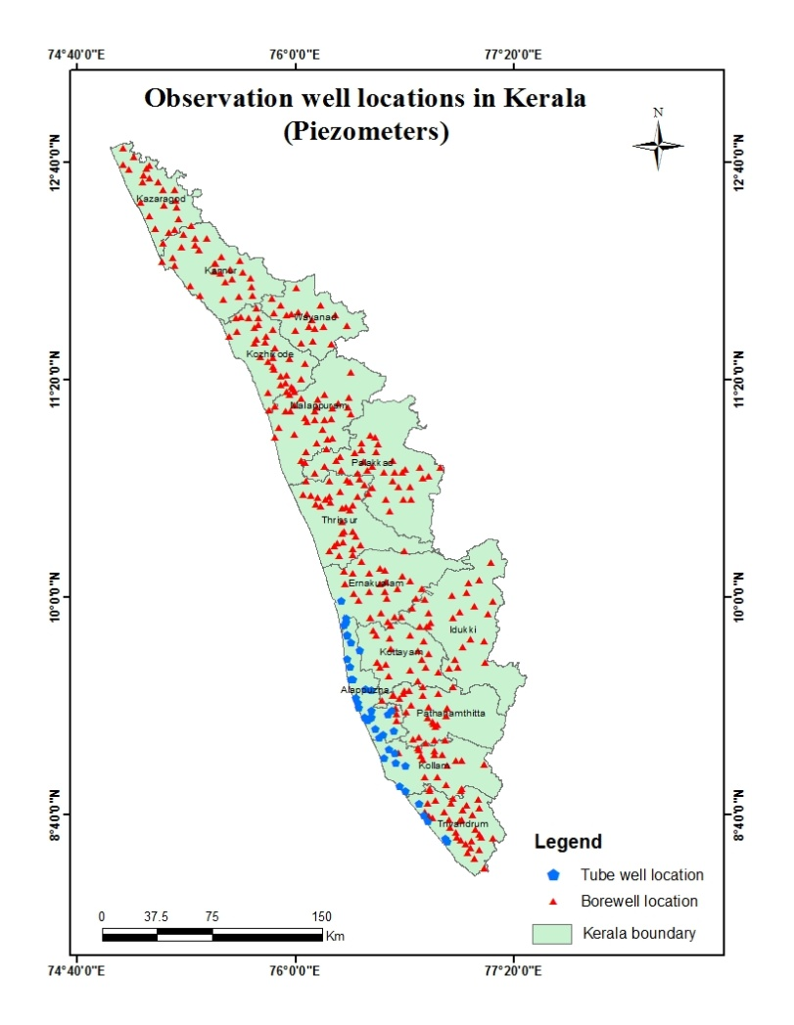
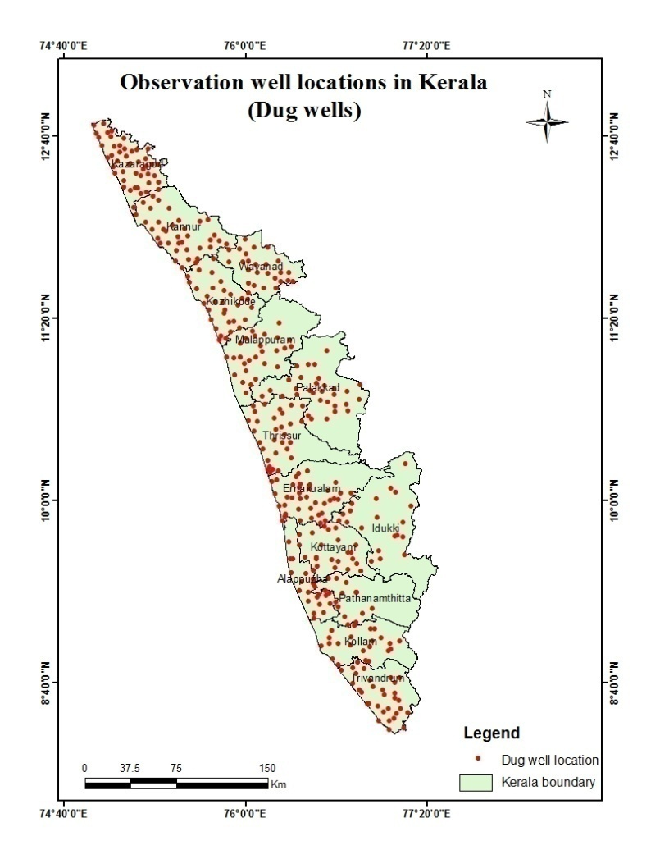
Groundwater Department is maintaining a network of observation wells throughout the state representing various hydrogeological units. Observation wells includes dug wells (owned by public and private) and purpose built piezometers (bore wells and tube wells). Water level data has been collected monthly and water samples collected and analysis done periodically.
Fig:3. Location map of observation dug wells and piezometers (bore wells & tube wells)
Analysis of Groundwater level data – November 2021
During the month of November 2021, groundwater level in 377 dug wells and 387purpose built piezometers (bore wells- 346 and tube wells – 41) has been monitored. The data collected from the observation wells during the month of November 2021has been compared with previous year’s corresponding month data and also with respect to decadal mean data of the corresponding month to assess the groundwater scenario in the state.
- Depth to Groundwater level during November 2021
Dug wells:- The depth to groundwater level in the observation dug wells during the month of November 2021ranges from a minimum of -0.22m (OW-06, Pulinkunnu, Alappuzha) to a maximum of 15.09mbgl (KNR-POW-C8 , Irikkur, Kannur). Out of 377dug wells monitored water level in 27.59% of dug wells (103nos ) showa depth to water level ranges from 0-2 m, 36.87% of dug wells (139nos ) ranges between 2-5 m, 31.03% dug wells (117nos ) ranges between 5-10 m and 4.51% dug wells (17nos ) recorded depth to water level ranges between 10-20 mbgl. Dug wells inThiruvananthapuram Kollam, Pathanamthitta, Kottayam, Idukki, Ernakulam,Thrissur Palakkad and Kozhikkode districts show water level below 10 mtrs.Large excess rain fall received in the state accounts for this shallow depth to water level. None of the wells in the state show water level above 20m. Table showing well frequency during November 2021 is appended. (Annexure-I)

Fig:4. Depth to water level in Dug wells during November2021

Borewells (hardrock terrain):- The depth to groundwater level in the observation bore wells during the month of November 2021 ranges from a minimum of -0.33m in BW 112,Muvattupuzha Municipality,ERNAKULAMto a maximum of 41.94 mbgl in MPM174,Areekode,Malappuram.Out of 346borewells monitored, water level in 13.87% of bore wells (48 nos) show a depth to water level range from 0-2 m, 31.5% dug wells (109 nos) ranges between 2-5 m, 34.68% (120 nos) ranges between 5-10 m, 16.47% of borewells (57 nos ) ranges between 10-20 m, and 3.47% ranges more than 20 m . Borewells in Thiruvananthapuram, Kollam, Pathanamthitta, Alappuzha , Kottayam Ernakulam, Thrissur and Palakkad districts show water level below20 mbgl. Table showing well frequency during November2021 is appended. (Annexure-I)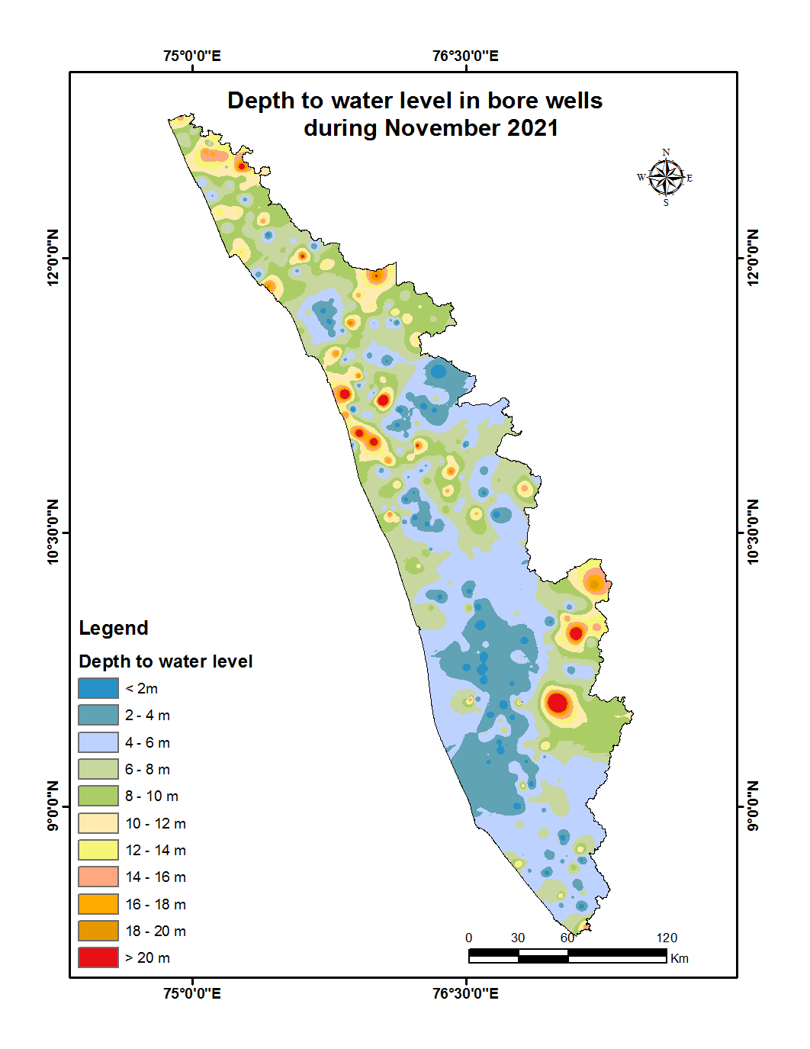
Fig:5. Depth to water level in Bore wells during November 2021
Tubewells (coastal sedimentary terrain):- The depth to groundwater level in the observation tubewells during the month of November 2021ranges from a minimum of 0.41 m to a maximum of 32.35 mbgl. Out of 41 tube wells monitored in the state, water level in 34.15 % of tube wells (14) ranges between 0-2m, 26.83 % of tube wells (11nos) ranges between 2-5 m,29.27% (12 nos) ranges between 5-10 m and2.44%(1no) ranges between10-20 and 7.32%(3 nos) ranges more than 20m.Except 3 tube in Kollam District and 1 well in Alappuzha district all other wells in the state show water level below 10 mtrs.Table showingtube well frequency is appended.(Annexure-I )
II.Comparison of Groundwater level in November2021 with respect toNovember 2020
Comparison of the groundwater level in November2021with respect to the corresponding month in the previous year, indicates that 13% of observation dug wells (49 out of 376) show a fall in water level and 87% of the wells (327 out of376) shows no remarkable change /marginal rise in water level.Dug wells in Kollam, Pathanamthitta, Malappuram and Kozhikkode districts show only rise in water level. This may be due to the Large Excess rainfall received in the state. Out of 13% of the dugwells in the other districts showing falling trend, 76% (37 out of 49) recorded fall in water level less than 0.5m, and no dug wells in the district show a fall in water level more than 2m. Table showing water level comparison of dug wells during November 2021with respect to November 2020is appended. (Annexure-II).
Fig:6. Comparison of water level in Dug wells during November 2021 wrt November 2020

Comparison of the water level in observation bore wells (hard rock terrain in midland and high land areas) in November21with that of the previous year, it has been noticed that12.54% of bore wells (43 nos out of 343) show fall in water level and 87.46% of the wells (300 nos) shows no remarkable change/marginal rise in water level.Out of 12.54 % of the borewells showing falling trend, 44% of the bore wells (19 out of 43) recorded fall in water level less than 0.5m, 22% (11 out of 43)show fall in the range between 0.5 - 1m, 5% of bore wells (4 out of 43) show fall in the range between 1 - 1.5m, 3% of bore wells(2 out of 43) show a fall in range between, 1.5-2m, 15% of bore wells (7 out of 43) show a fall inwater level more than 2m. Borewells in Thiruvananthapuram, Kollam, Kottayam, Alappuzha, Thrissur, Palakad, and Wayanad districts show fall below 1m.Table showing water level comparison of bore wells during November2021with respect toNovember 2020 is appended. (Annexure-II)
Fig:7. Comparison of water level in Bore wells duringNovember2021 wrt November2020

Comparison of the water level in observation tube wells (in the coastal sedimentary areas)during November2021 with that of the previous year reveals that 10 % of tube wells (4 out of 39) recorded a falling trend and 90 % of the wells (35 out of 39) shows no remarkable change /marginal rise of water level.Out of 10% of the tube wells showing a falling trend,50% of wells (2 out of 4) recorded all in range between 0 to 0.5m and no wells show fall above 2m.Tube wells in Thiruvananthapuram and Ernakulam shows only rise in water level. Table showing comparison of water level during November2021 with respect to November2020is appended. (Annexure-II)

III.Comparison of Groundwater level in November 2021 with respect to Decadal mean(2011- 20)
Comparison of the water level in November 2021 with respect to the decadal mean, it has been noticed that 11% of observation dug wells (41 out of 373) recorded a fall in water level and 89% of the wells (332 out of 373) shows marginal rise /no remarkable change in water level.All the open wells in Kollam, Pathanamthitta, Alappuzha, Malappuram and Kozhikkode districts show only rise in water level. Out of 11% of the dugwells showing falling trend, 83% of the dug wells (34 out of41) recorded fall in water level less than 0.5m. No dug wells in the state show a fall in range more than 2m.Table showing water level comparison of dug wells during November2021 with respect to decadal mean is appended. (Annexure-III)

Fig:8. Comparison of water level in Dug wells during November 2021 wrt Decadal mean

Compared water level in the observation bore wells during November 2021 with that of the decadal mean. It has been noticed that 18% of bore wells (63 out of 345) show fall in water level, and 82% of the wells (282 out of 345) shows marginal rise,no remarkable change in water level.Out of 18 % of the bore wells shows a falling trend , 52% (33 out of63) shows a fall in water level less than 0.5m.Table showing water level comparison of bore wells duringNovember 2021with respect to decadal mean is appended. (Annexure-III)
Fig:9. Comparison of water level in Bore wells during November2021 wrt Decadal mean

Comparison of the water level in the observation tube wells during November 2021 with that of the decadal mean reveals that 15 % of tube wells (6 out of 39) recorded a falling trend and85 % of the tube wells (33 out of 39) show marginal rise/no remarkable change in water level.Out of 15 % of the tube wells shows a falling trend, 50% of the tube wells(3 out of 6) show fall in water level less than 0.5m.Table showing water level comparison of tube wells during July 2021with respect to decadal mean is appended. (Annexure-III)

Summary
Rainfall

- Actual Rain fall received in the state during 2021 (1Oct to 1 November) is 600.7 mm which is large excess than the normal(312.1mm).Percentage departure is+92%.
- During October 2020 the state received 239.2mm rainfall which is 16% deficient than the normal rainfall.

Groundwater level
The depth to groundwater level in the observation dug wells during the month of November 2021 range from a minimum of -0.22m (OW-06, Pulinkunnu, Alappuzha) to a maximum of 15.09 mbgl (KNR-POW-C8 , Irikkur, Kannur) in bore wells a minimum of -0.33m in BW 112,Muvattupuzha Municipality,ERNAKULAMto a maximum of 41.94 mbgl in MPM174,Areekode,Malappuram and in the tubewells 0.41m in well no 08 Thrikkunnappuzha, Alappuzha Districtto a maximum of 32.35 mbgl in well no KLM-31, Kollam corporation
- Comparison of the water level inNovember 2021 with respect to the previous year, reveals that 13% of observation dug wells (49 out of 376), 13% of bore wells (43 out of 343) and 10% of tube wells (4 out of 39) recorded a falling trend.Among all the 758 observation wells only 12.66% of wells (96nos) show declining trend. 60%of the observation wells with falling trend (58 out of 96) show decline in water level less than 0.5 m.
- Comparison of groundwater level in November 2021with respect to the decadal mean reveals that 11% of observation dug wells (41 out of 373) ,18% of bore wells (63 out of 345) and 15% of tube wells(6 out of39) recorded falling trend. Among all the 757 observation wells only 14.53% of wells (110 out of 757) show declining trend. 63.63%of the observationwells with falling trend (70 out of110) show decline in water level less than 0.5 m.
- No open wells in the state show water level more than 20 m during November2021. Open wells in nine districts have water level less than 10m. No open wells in the state show more than 2m fluctuation when compared with the November2020 water level data and with decadal mean water level data.

Districtwise Observation well Frequency on November 2021 - Annexure I
District | Well Type | No. of WL measured | DTWL(mbgl) |  | Location |  | Depth range of wells (mts)
 |  |  | Min | Max | Min | Max | 0 to 2 | 2 to 5 | 5 to 10 | 10 to 20 | >20
Thiruvananthapuram | Dug well | 28 | 0.56 | 8.82 | TVM OW15,Chirayinkeezhu,Thiruvananthapuram | TVM OW28,Kazhakkoottam,Thiruvananthapuram. | 6 | 18 | 4 | 0 | 0
Thiruvananthapuram | Bore well | 32 | 0.35 | 15.61 | 31,Vamanapuram,Thiruvananthapuram | 25,Parassala,Thiruvananthapuram | 4 | 12 | 12 | 4 | 0
Thiruvananthapuram | Tube well | 4 | 2.29 | 6.90 | 36,Chirayinkeezhu,Thiruvananthapuram. | 37,Chirayinkeezhu,Thiruvananthapuram | 0 | 1 | 3 | 0 | 0
Kollam | Dug well | 24 | 0.67 | 8.38 | KLM OW 23,Oachira,KOLLAM | KLM OW 24,Munroethuruthu,KOLLAM | 7 | 10 | 7 | 0 | 0
Kollam | Bore well | 15 | 0.28 | 7.65 | KLM/6,Kottarakkara Municipality,KOLLAM | KLM/O7,Piravanthoor,KOLLAM | 1 | 4 | 10 | 0 | 0
Kollam | Tube well | 8 | 1.71 | 32.35 | KLM/17,Kollam Corporation,KOLLAM | KLM-31,Kollam Corporation,KOLLAM | 1 | 0 | 4 | 0 | 3
Pathanamthitta | Dug well | 12 | 0.48 | 6.71 | PTA OW 44,Peringara,PATHANAMTHITTA | PTA OW 43,Kunnanthanam,PATHANAMTHITTA | 3 | 8 | 1 | 0 | 0
Pathanamthitta | Bore well | 24 | 0.18 | 13.37 | PTA/02,Kalanjoor,PATHANAMTHITTA | PTA/15,Chittar,PATHANAMTHITTA | 6 | 9 | 7 | 2 | 0
Alappuzha | Dug well | 20 | -0.22 | 10.01 | OW-06 Pulinkunnu,Champakulam,Alappuzha | OW-02 Kattanam,Mavelikara,Alappuzha | 16 | 2 | 1 | 1 | 0
Alappuzha | Bore well | 2 | 1.76 | 4.07 | 36 Punthala,Chengannoor,Alappuzha | 35 Pennukkara,Chengannoor,Alappuzha | 1 | 1 | 0 | 0 | 0
Alappuzha | Tube well | 28 | 0.41 | 16.52 | 33 Aroor,Pattanakkad,Alappuzha | 04 Charumoodu,Bharanikavu,Alappuzha | 13 | 10 | 4 | 1 | 0
Kottayam | Dug well | 21 | -0.79 | 8.29 | KTM-OW-14,Uzhavoor,Kottayam | KTM-OW-4_,Pallom,Kottayam | 9 | 9 | 3 | 0 | 0
Kottayam | Bore well | 23 | -0.05 | 16.33 | 10,Uzhavoor,Kottayam | 20,Pallom,Kottayam | 10 | 7 | 4 | 2 | 0
Idukki | Dug well | 20 | 0.47 | 7.19 | 73,Santhanpara,IDUKKI | IDK08,Kattappana Municipality,IDUKKI | 8 | 8 | 4 | 0 | 0
Idukki | Bore well | 23 | 1.04 | 35.49 | SO415,Udumbannoor, | SO428,Peermade,IDUKKI | 2 | 9 | 6 | 4 | 2
Ernakulam | Dug well | 38 | -0.75 | 7.58 | E86,Kochi Corporation,ERNAKULAM | GWE-23,Thrikkakkara Municipality,ERNAKULAM | 9 | 14 | 15 | 0 | 0
Ernakulam | Bore well | 25 | -0.33 | 10.24 | BW 112,Muvattupuzha Municipality,Ernakulam. | BW 100,Rayamangalam,Ernakulam | 4 | 12 | 8 | 1 | 0
Ernakulam | Tube well | 1 | 9.57 | 9.57 | TW 01,Kochi Corporation,Ernakulam | TW 01,Kochi Corporation,Ernakulam | 0 | 0 | 1 | 0 | 0
Thrissur | Dug well | 31 | 0.28 | 9.20 | TSROW16,Talikkulam,Thrissur | TSROW12,Chowwannur,Thrissur | 11 | 8 | 12 | 0 | 0
Thrissur | Bore well | 37 | -0.07 | 18.77 | TSR124,Puzhakkal,Thrissur | TSR136,Kandanassery,Thrissur | 5 | 8 | 18 | 6 | 0
Malappuram | Dug well | 26 | 0.29 | 11.66 | MPM OW 5A,Tirurangadi,Malappuram | MPM.OW24,Kuttippuram,Malappuram | 6 | 11 | 7 | 2 | 0
Malappuram | Bore well | 30 | -0.10 | 41.94 | MPM178,Wandoor,Malappuram. | MPM174,Areekode,Malappuram | 5 | 14 | 5 | 2 | 4
Palakkad | Dug well | 31 | 0.11 | 8.60 | PKD S-7,Chittur,Palakkad | PKD S-10,Sreekrishnapuram,Palakkad | 8 | 15 | 8 | 0 | 0
Palakkad | Bore well | 34 | 0.63 | 19.37 | 149,Kollengode,Palakkad | 157,Ottappalam,Palakkad | 4 | 11 | 14 | 5 | 0
Kozhikkode | Dug well | 18 | -0.60 | 9.40 | KKDOW 019,Melady,Kozhikode | KKDOW 020,Thuneri,Kozhikode | 4 | 9 | 5 | 0 | 0
Kozhikkode | Bore well | 34 | -0.07 | 28.65 | KKDPZ 197,Kozhikode,Kozhikode | KKDPZ 202,Perambra,Kozhikode | 4 | 12 | 10 | 5 | 3
Wayanad | Dug well | 26 | 0.11 | 11.42 | SOW-1,Vythiri,WAYANAD | SOW-4,Nenmeni,WAYANAD | 6 | 9 | 10 | 1 | 0
Wayanad | Bore well | 19 | 1.34 | 20.34 | WYD216,Muttil,WAYANAD. | WYD223,Thirunelly,WAYANAD | 1 | 3 | 7 | 7 | 1
Kannur | Dug well | 36 | 0.18 | 15.09 | KNR-POW-C23,Koothuparamba,Kannur | KNR-POW-C8,Taliparamba,Kannur | 8 | 10 | 16 | 2 | 0
Kannur | Bore well | 27 | 0.84 | 21.80 | KNRPz239,Taliparamba,Kannur. | KNR-Pz228,Irikkur,Kannur. | 1 | 4 | 12 | 9 | 1
Kasaragod | Dug well | 46 | 1.30 | 14.98 | 199,Kanhangad,Kasaragod | 200,Karadka,Kasaragod | 3 | 8 | 24 | 11 | 0
Kasaragod | Bore well | 21 | 3.03 | 22.20 | PZKGD241,Parappa,Kasaragod | PZKGD242,Karadka,Kasaragod | 0 | 3 | 7 | 10 | 1

Comparison of Water level November 2021 with respect toNovember 2020 - Annexure II
District | Well Type | No. of WL Measured | Water level | Total | 0 - 0.5 m | 0.5 - 1 m | 1-1.5m | 1.5 - 2 m | >2 m
 |  |  |  |  | No. | No. | No. | No. | No.
Thiruvananthapuram | Dug well | 31 | Rise | 27 | 10 | 2 | 4 | 2 | 9
Thiruvananthapuram | Dug well | 31 | Fall | 4 | 3 | 1 | 0 | 0 | 0
Thiruvananthapuram | Bore well | 32 | Rise | 30 | 7 | 4 | 4 | 6 | 9
Thiruvananthapuram | Bore well | 32 | Fall | 2 | 2 | 0 | 0 | 0 | 0
Thiruvananthapuram | Tube well | 4 | Rise | 4 | 3 | 0 | 0 | 0 | 1
Thiruvananthapuram | Tube well | 4 | Fall | 0 | 0 | 0 | 0 | 0 | 0
Kollam | Dug well | 23 | Rise | 23 | 4 | 4 | 4 | 4 | 7
Kollam | Dug well | 23 | Fall | 0 | 0 | 0 | 0 | 0 | 0
Kollam | Bore well | 15 | Rise | 14 | 1 | 6 | 4 | 2 | 1
Kollam | Bore well | 15 | Fall | 1 | 1 | 0 | 0 | 0 | 0
Kollam | Tube well | 8 | Rise | 7 | 2 | 1 | 1 | 2 | 1
Kollam | Tube well | 8 | Fall | 1 | 1 | 0 | 0 | 0 | 0
Pathanamthitta | Dug well | 11 | Rise | 11 | 1 | 2 | 5 | 2 | 1
Pathanamthitta | Dug well | 11 | Fall | 0 | 0 | 0 | 0 | 0 | 0
Pathanamthitta | Bore well | 24 | Rise | 23 | 2 | 7 | 1 | 1 | 12
Pathanamthitta | Bore well | 24 | Fall | 1 | 0 | 0 | 0 | 0 | 1
Alappuzha | Dug well | 20 | Rise | 17 | 10 | 7 | 0 | 0 | 0
Alappuzha | Dug well | 20 | Fall | 3 | 3 | 0 | 0 | 0 | 0
Alappuzha | Bore well | 2 | Rise | 1 | 0 | 0 | 1 | 0 | 0
Alappuzha | Bore well | 2 | Fall | 1 | 1 | 0 | 0 | 0 | 0
Alappuzha | Tube well | 26 | Rise | 23 | 19 | 3 | 0 | 1 | 0
Alappuzha | Tube well | 26 | Fall | 3 | 1 | 0 | 1 | 1 | 0
Kottayam | Dug well | 21 | Rise | 19 | 5 | 3 | 3 | 1 | 7
Kottayam | Dug well | 21 | Fall | 2 | 1 | 1 | 0 | 0 | 0
Kottayam | Bore well | 24 | Rise | 21 | 4 | 2 | 4 | 3 | 8
Kottayam | Bore well | 24 | Fall | 3 | 2 | 1 | 0 | 0 | 0
Idukki | Dug well | 20 | Rise | 17 | 10 | 3 | 3 | 1 | 0
Idukki | Dug well | 20 | Fall | 3 | 3 | 0 | 0 | 0 | 0
Idukki | Bore well | 23 | Rise | 16 | 6 | 3 | 4 | 2 | 1
Idukki | Bore well | 23 | Fall | 7 | 3 | 2 | 1 | 0 | 1
Ernakulam | Dug well | 38 | Rise | 35 | 18 | 9 | 5 | 2 | 1
Ernakulam | Dug well | 38 | Fall | 3 | 1 | 0 | 1 | 1 | 0
Ernakulam | Bore well | 22 | Rise | 19 | 8 | 4 | 2 | 2 | 3
Ernakulam | Bore well | 22 | Fall | 3 | 2 | 0 | 0 | 0 | 1
Ernakulam | Tube well | 1 | Rise | 1 | 0 | 1 | 0 | 0 | 0
Ernakulam | Tube well | 1 | Fall | 0 | 0 | 0 | 0 | 0 | 0
Thrissur | Dug well | 31 | Rise | 26 | 11 | 11 | 1 | 1 | 2
Thrissur | Dug well | 31 | Fall | 5 | 4 | 0 | 0 | 1 | 0
Thrissur | Bore well | 37 | Rise | 36 | 6 | 7 | 11 | 3 | 9
Thrissur | Bore well | 37 | Fall | 1 | 0 | 1 | 0 | 0 | 0
Malappuram | Dug well | 26 | Rise | 26 | 6 | 9 | 5 | 2 | 4
Malappuram | Dug well | 26 | Fall | 0 | 0 | 0 | 0 | 0 | 0
Malappuram | Bore well | 30 | Rise | 28 | 7 | 4 | 7 | 4 | 6
Malappuram | Bore well | 30 | Fall | 30 | 0 | 0 | 0 | 1 | 1
Palakkad | Dug well | 31 | Rise | 30 | 9 | 10 | 9 | 1 | 1
Palakkad | Dug well | 31 | Fall | 1 | 1 | 0 | 0 | 0 | 0
Palakkad | Bore well | 33 | Rise | 30 | 5 | 10 | 3 | 5 | 7
Palakkad | Bore well | 33 | Fall | 3 | 2 | 1 | 0 | 0 | 0
Kozhikkode | Dug well | 17 | Rise | 17 | 1 | 9 | 5 | 1 | 1
Kozhikkode | Dug well | 17 | Fall | 0 | 0 | 0 | 0 | 0 | 0
Kozhikkode | Bore well | 33 | Rise | 30 | 7 | 8 | 5 | 5 | 5
Kozhikkode | Bore well | 33 | Fall | 3 | 1 | 0 | 0 | 0 | 2
Wayanad | Dug well | 26 | Rise | 20 | 13 | 2 | 2 | 1 | 2
Wayanad | Dug well | 26 | Fall | 6 | 2 | 3 | 1 | 0 | 0
Wayanad | Bore well | 19 | Rise | 17 | 11 | 3 | 3 | 0 | 0
Wayanad | Bore well | 19 | Fall | 2 | 1 | 1 | 0 | 0 | 0
Kannur | Dug well | 35 | Rise | 29 | 15 | 7 | 4 | 1 | 2
Kannur | Dug well | 35 | Fall | 6 | 6 | 0 | 0 | 0 | 0
Kannur | Bore well | 28 | Rise | 23 | 7 | 5 | 5 | 2 | 4
Kannur | Bore well | 28 | Fall | 5 | 3 | 1 | 1 | 0 | 0
Kasaragod | Dug well | 46 | Rise | 30 | 17 | 9 | 2 | 1 | 1
Kasaragod | Dug well | 46 | Fall | 16 | 13 | 2 | 1 | 0 | 0
Kasaragod | Bore well | 21 | Rise | 12 | 6 | 2 | 1 | 0 | 3
Kasaragod | Bore well | 21 | Fall | 9 | 1 | 4 | 2 | 1 | 1

Comparison of Water level November 2021 with respect to 10 yrs mean-Annexure III
District | Well Type | No. of WL Measured | Water level | Total | 0 - 0.5 m | 0.5 - 1 m | 1 - 1.5 m | 1.5 - 2 m | <2 m
 |  |  |  |  | No. | No. | No. | No. | No.
Thiruvananthapuram | Dug well | 31 | Rise | 29 | 5 | 4 | 7 | 4 | 9
Thiruvananthapuram | Dug well | 31 | Fall | 2 | 1 | 0 | 0 | 1 | 0
Thiruvananthapuram | Bore well | 32 | Rise | 30 | 5 | 3 | 9 | 4 | 9
Thiruvananthapuram | Bore well | 32 | Fall | 2 | 2 | 0 | 0 | 0 | 0
Thiruvananthapuram | Tube well | 4 | Rise | 3 | 1 | 1 | 1 | 0 | 0
Thiruvananthapuram | Tube well | 4 | Fall | 1 | 1 | 0 | 0 | 0 | 0
Kollam | Dug well | 23 | Rise | 23 | 2 | 8 | 4 | 3 | 6
Kollam | Dug well | 23 | Fall | 0 | 0 | 0 | 0 | 0 | 0
Kollam | Bore well | 15 | Rise | 13 | 5 | 1 | 5 | 1 | 1
Kollam | Bore well | 15 | Fall | 2 | 2 | 0 | 0 | 0 | 0
Kollam | Tube well | 8 | Rise | 7 | 1 | 1 | 1 | 1 | 3
Kollam | Tube well | 8 | Fall | 1 | 0 | 1 | 0 | 0 | 0
Pathanamthitta | Dug well | 11 | Rise | 11 | 3 | 3 | 4 | 0 | 1
Pathanamthitta | Dug well | 11 | Fall | 0 | 0 | 0 | 0 | 0 | 0
Pathanamthitta | Bore well | 24 | Rise | 22 | 5 | 4 | 3 | 4 | 6
Pathanamthitta | Bore well | 24 | Fall | 2 | 1 | 0 | 0 | 0 | 1
Alappuzha | Dug well | 17 | Rise | 17 | 12 | 4 | 1 | 0 | 0
Alappuzha | Dug well | 17 | Fall | 0 | 0 | 0 | 0 | 0 | 0
Alappuzha | Bore well | 2 | Rise | 1 | 0 | 1 | 0 | 0 | 0
Alappuzha | Bore well | 2 | Fall | 1 | 1 | 0 | 0 | 0 | 0
Alappuzha | Tube well | 26 | Rise | 22 | 12 | 5 | 5 | 0 | 0
Alappuzha | Tube well | 26 | Fall | 4 | 2 | 0 | 1 | 0 | 1
Kottayam | Dug well | 21 | Rise | 17 | 5 | 2 | 3 | 2 | 5
Kottayam | Dug well | 21 | Fall | 4 | 3 | 0 | 1 | 0 | 0
Kottayam | Bore well | 24 | Rise | 22 | 4 | 7 | 5 | 0 | 6
Kottayam | Bore well | 24 | Fall | 2 | 1 | 1 | 0 | 0 | 0
Idukki | Dug well | 20 | Rise | 18 | 10 | 5 | 2 | 1 | 0
Idukki | Dug well | 20 | Fall | 2 | 2 | 0 | 0 | 0 | 0
Idukki | Bore well | 23 | Rise | 14 | 4 | 3 | 1 | 1 | 5
Idukki | Bore well | 23 | Fall | 9 | 5 | 1 | 1 | 0 | 2
Ernakulam | Dug well | 38 | Rise | 29 | 18 | 6 | 4 | 0 | 1
Ernakulam | Dug well | 38 | Fall | 9 | 7 | 1 | 0 | 1 | 0
Ernakulam | Bore well | 23 | Rise | 20 | 9 | 6 | 3 | 0 | 2
Ernakulam | Bore well | 23 | Fall | 3 | 2 | 0 | 0 | 0 | 1
Ernakulam | Tube well | 1 | Rise | 1 | 1 | 0 | 0 | 0 | 0
Ernakulam | Tube well | 1 | Fall | 0 | 0 | 0 | 0 | 0 | 0
Thrissur | Dug well | 31 | Rise | 27 | 15 | 9 | 2 | 0 | 1
Thrissur | Dug well | 31 | Fall | 4 | 3 | 0 | 1 | 0 | 0
Thrissur | Bore well | 37 | Rise | 28 | 10 | 5 | 7 | 1 | 5
Thrissur | Bore well | 37 | Fall | 9 | 6 | 3 | 0 | 0 | 0
Malappuram | Dug well | 26 | Rise | 26 | 1 | 10 | 8 | 6 | 1
Malappuram | Dug well | 26 | Fall | 0 | 0 | 0 | 0 | 0 | 0
Malappuram | Bore well | 33 | Rise | 28 | 3 | 6 | 8 | 3 | 8
Malappuram | Bore well | 33 | Fall | 5 | 1 | 1 | 0 | 0 | 3
Palakkad | Dug well | 31 | Rise | 27 | 6 | 8 | 8 | 3 | 2
Palakkad | Dug well | 31 | Fall | 4 | 4 | 0 | 0 | 0 | 0
Palakkad | Bore well | 33 | Rise | 28 | 3 | 6 | 8 | 3 | 8
Palakkad | Bore well | 33 | Fall | 5 | 1 | 1 | 0 | 0 | 3
Kozhikkode | Dug well | 17 | Rise | 17 | 0 | 5 | 9 | 2 | 1
Kozhikkode | Dug well | 17 | Fall | 0 | 0 | 0 | 0 | 0 | 0
Kozhikkode | Bore well | 34 | Rise | 28 | 5 | 9 | 7 | 2 | 5
Kozhikkode | Bore well | 34 | Fall | 6 | 3 | 0 | 0 | 1 | 2
Wayanad | Dug well | 26 | Rise | 22 | 8 | 9 | 0 | 1 | 4
Wayanad | Dug well | 26 | Fall | 4 | 3 | 0 | 1 | 0 | 0
Wayanad | Bore well | 19 | Rise | 17 | 7 | 5 | 3 | 2 | 0
Wayanad | Bore well | 19 | Fall | 2 | 2 | 0 | 0 | 0 | 0
Kannur | Dug well | 36 | Rise | 34 | 14 | 7 | 10 | 2 | 1
Kannur | Dug well | 36 | Fall | 2 | 2 | 0 | 0 | 0 | 0
Kannur | Bore well | 28 | Rise | 21 | 6 | 5 | 4 | 3 | 3
Kannur | Bore well | 28 | Fall | 7 | 4 | 2 | 1 | 0 | 0
Kasaragod | Dug well | 45 | Rise | 35 | 21 | 6 | 4 | 3 | 1
Kasaragod | Dug well | 45 | Fall | 10 | 9 | 1 | 0 | 0 | 0
Kasaragod | Bore well | 21 | Rise | 15 | 9 | 4 | 1 | 1 | 0
Kasaragod | Bore well | 21 | Fall | 6 | 1 | 1 | 3 | 0 | 1

Observation well frequency on November 2021 Abstract I
Well Type | No of WL measured | DTWL (mbgl) |  | Location |  | Depth range of wells (m)
 |  | min | max | min | max | 0 to 2 | 2 to 5 | 5 to 10 | 10 to 20 | >20
Dug well | 377 | -0.79 | 15.09 | KTM-OW-14,Uzhavoor,Kottayam | KNR-POW-C8,Taliparamba,Kannur | 104 | 139 | 117 | 17 | 0
 |  |  |  |  |  | 27.59% | 36.87% | 31.03% | 4.51% | 0.00%
Bore well | 346 | -0.33 | 41.94 | BW 112,Muvattupuzha Municipality,ERNAKULAM | MPM174,Areekode,Malappuram | 48 | 109 | 120 | 57 | 12
 |  |  |  |  |  | 13.87% | 31.50% | 34.68% | 16.47% | 3.87%
Tube well | 41 | 0.41 | 32.35 | 08 ,Thrikkunnappuzha,Harippad,Alappuzha | KLM-31,Kollam Corporation,KOLLAM. | 14 | 11 | 12 | 1 | 3
 |  |  |  |  |  | 34.15% | 26.83% | 29.27% | 2.44% | 7.32%

Comparison of Water level November 2021 with respect to November 2020 Abstract II
Well type | No. of WL Measured | Water level | Total | 0 - 0.5 m | 0.5 - 1 m | 1 - 1.5 m | 1.5 - 2 m | >2 m
Dug well | 376 | Rise | 327 | 130 | 87 | 52 | 20 | 38
Dug well | 376 | % | 87% | 40% | 27% | 16% | 6% | 12%
Dug well | 376 | Fall | 49 | 37 | 7 | 3 | 2 | 0
Dug well | 376 | % | 13% | 76% | 14% | 6% | 4% | 0%
Bore well | 343 | Rise | 300 | 77 | 65 | 55 | 35 | 68
Bore well | 343 | % | 87% | 26% | 22% | 18% | 12% | 23%
Bore well | 343 | Fall | 43 | 7 | 2 | 4 | 11 | 19
Bore well | 343 | % | 13% | 16% | 5% | 9% | 26% | 44%
Tube well | 39 | Rise | 35 | 24 | 5 | 1 | 3 | 2
Tube well | 39 | % | 90% | 69% | 14% | 3% | 9% | 6%
Tube well | 39 | Fall | 4 | 2 | 0 | 1 | 1 | 0
Tube well | 39 | % | 10% | 50% | 0% | 25% | 25% | 0%

Comparison of Water level November 2021 with respect to 10 yrs mean Abstract III
Well type | No. of WL Measured | Water level | Total | 0 - 0.5 m | 0.5 - 1 m | 1 - 1.5 m | 1.5 - 2 m | >2 m
Dug well | 373 | Rise | 332 | 120 | 86 | 66 | 27 | 33
Dug well | 373 | % | 89% | 36% | 26% | 20% | 8% | 10%
Dug well | 373 | Fall | 41 | 34 | 2 | 3 | 2 | 0
Dug well | 373 | % | 11% | 83% | 5% | 7% | 5% | 0%
Bore well | 345 | Rise | 282 | 77 | 63 | 60 | 27 | 55
Bore well | 345 | % | 82% | 27% | 22% | 21% | 10% | 20%
Bore well | 345 | Fall | 63 | 33 | 11 | 5 | 2 | 12
Bore well | 345 | % | 18% | 52% | 17% | 8% | 3% | 19%
Tube well | 39 | Rise | 33 | 15 | 7 | 7 | 1 | 3
Tube well | 39 | % | 85% | 45% | 21% | 21% | 3% | 9%
Tube well | 39 | Fall | 6 | 3 | 1 | 1 | 0 | 1
Tube well | 39 | % | 15% | 50% | 17% | 17% | 0% | 17%

